Akibul Hoque

NEA project word document

2018/19/20

Project Idea – 2D Adventure RPG

# Section 3 – Implementation

## Start:

The module in python that I will be using to code up my game is called pygame.

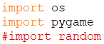

After my main loop, I start my OOP by make the pygame window (Screen) into a class where all the methods change the state of the screen:

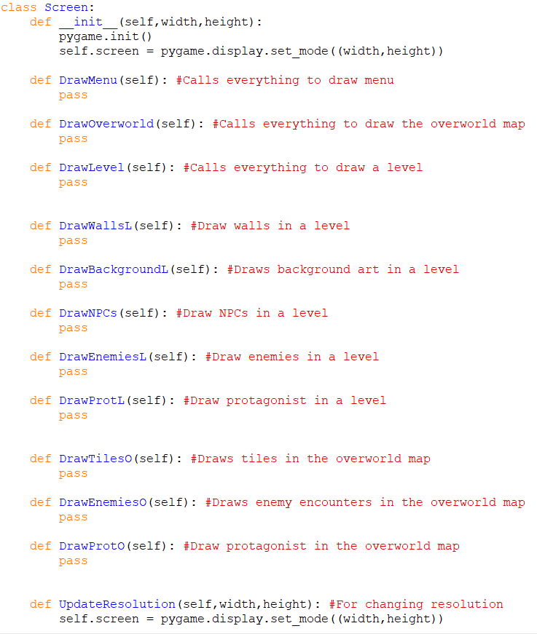

## Main menu

### Title Text

I started by drawing text to the screen.

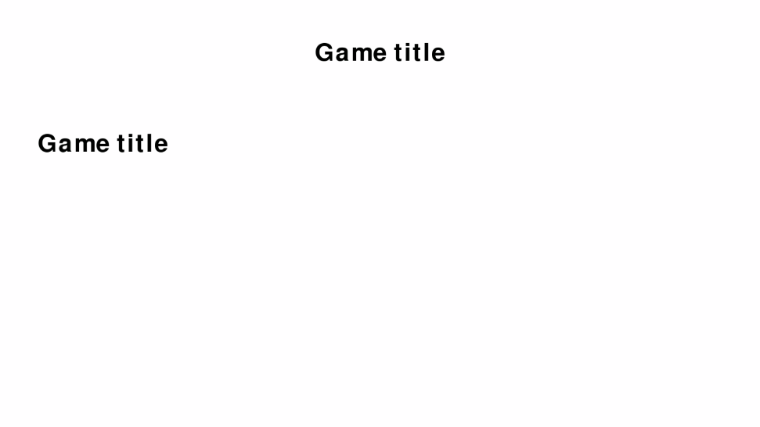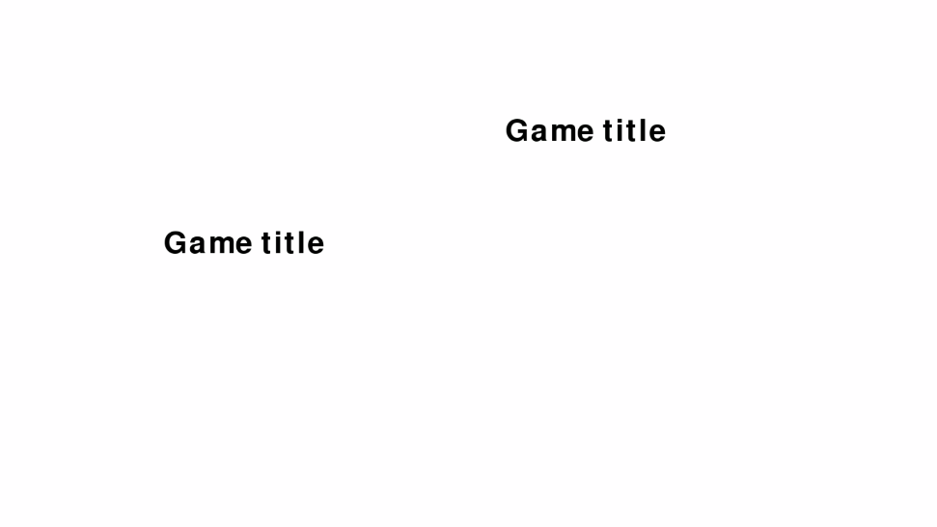Whilst I was testing this, I came across a problem where the screen position and resolution would change if I tabbed out of the window and back into (Noting this is when the pygame is full screened):

This should not happen as it is set to my native resolution and is centred to my screen.

I found the issue and it was with the fact that my laptop scales everything to 125% rather than 100% in my display settings. To fix this I went online to look for a solution to the problem if anyone else had the same problem and I came across this:

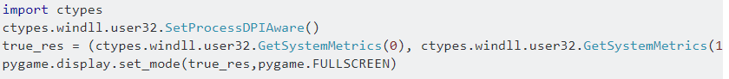

(From stackoverflow, index at bottom of document)

I added this into my code as such:

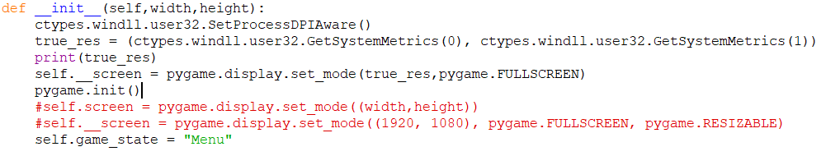

### Buttons

I need buttons on my screen, I decided to make a new class to create interactable buttons, and I used OOP for this.

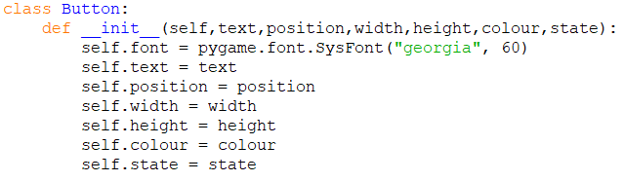

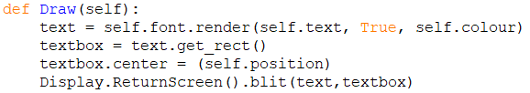

Now with this I can instantiate all the buttons in the previous class like this:

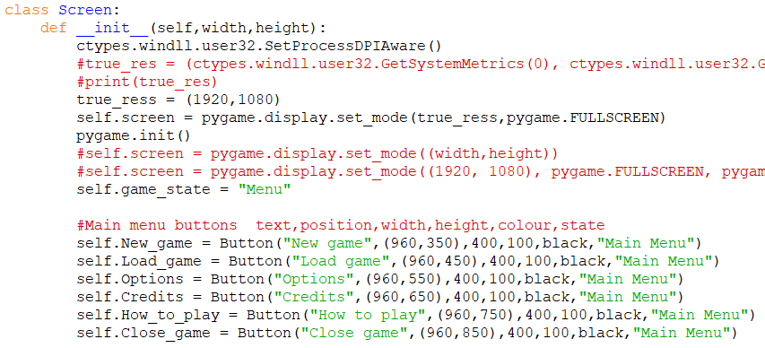

And then draw each of the buttons in the correct menu:

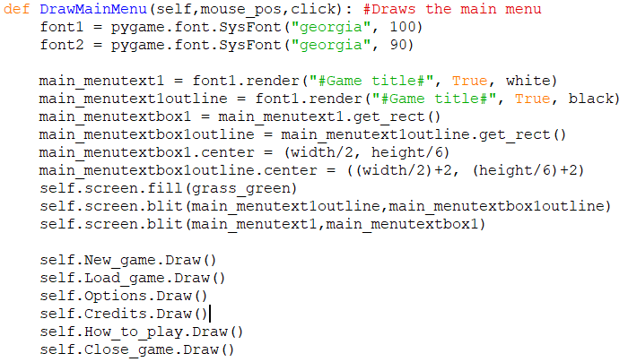

Then a method to check if it is clicked.

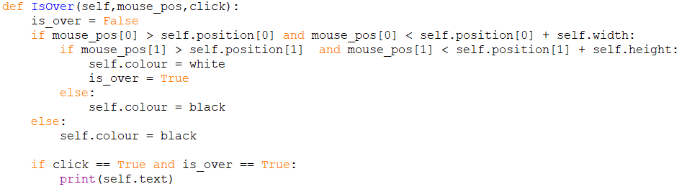

### Options Menu

#### Sub-menus and attribute changers

My buttons currently are only there to navigate through menus and not to perform any other functions. So, because of this and the kinds of buttons that I will have throughout my project I have decided to attempt to make a new class for certain buttons and make use of **inheritance** for drawing the buttons and also for helping to instantiate them. So the mother class Button would contain the method to draw the button and hold the attributes of the button that control the visuals and position of the button, while the subclasses control the functions that each button carry out.

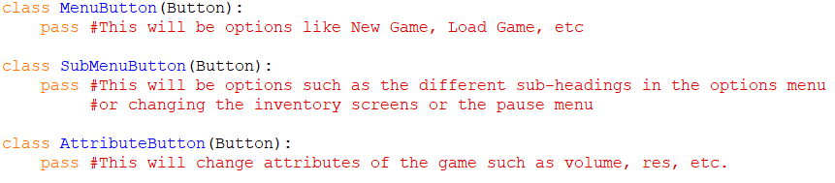

I moved the IsOver subroutine into the subclass as it will be customised in this subclass while the draw function will stay inside the parent class. By splitting into two classes to map a button requires me to call each button using two lines of code each now as the class does not call the next subroutine on its own as it did previously, and I have changed that so I am able to make it interchangeable, like this:

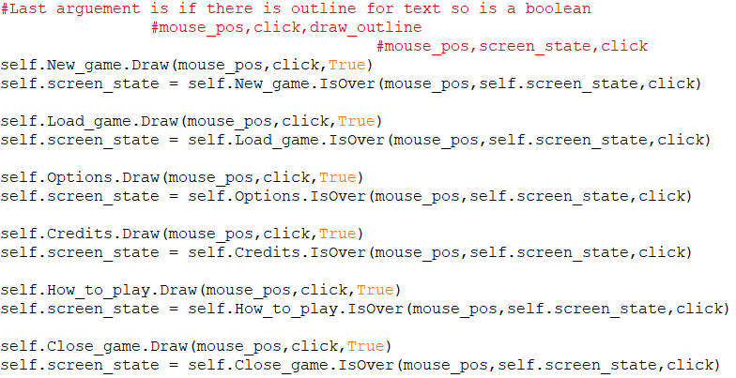

Since these buttons are for changing the screen, the return value of the button being clicked is put into “self.screen_state”.

Now to make the sub menus inside the options screen. I make the class for these sub buttons similar to the menu changing buttons but with the main difference of the value that is returned being different therefore the program would interact differently from this button being clicked.

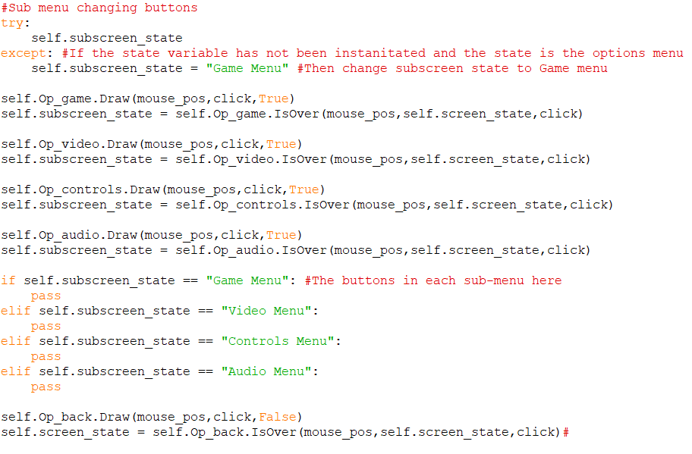

This would be what is happening inside the options subroutine to display each screen, with the “pass” being the options inside each sub menu.

Positioning the submenu buttons here is what it looks like:

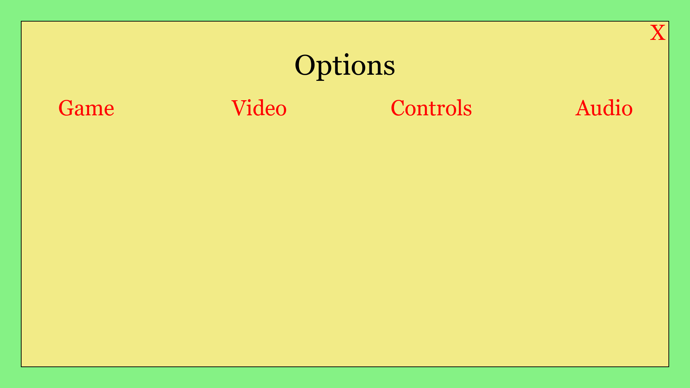

Now to make buttons that change attributes:

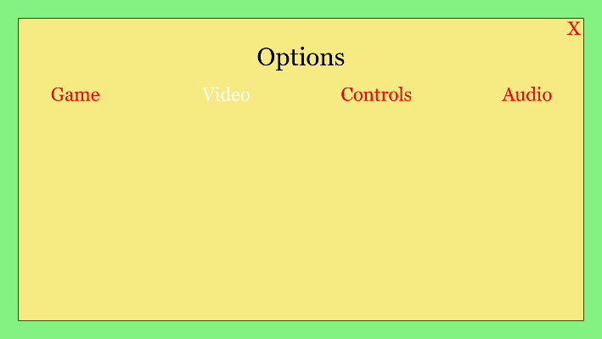This time the button returns “attribute_change”, this variable is then checked at the end of a cycle of the game loop so if it is not the value of “None” the value is corresponded to the correct function to change whatever is changed and then when the loop is reset, the value of “attribute_change” is set back to None to avoid double inputs. To test this works I made some buttons and checked they are in the right screen:

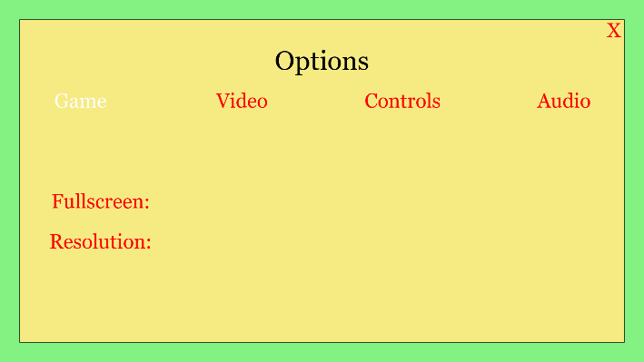

Here we can see that these buttons only appear when in the correct submenu.

#### Controls settings (Partial)

For my controls menu I need a database to hold all the information that is to be stored in controls, I started this on a separate python file as I have not used SQLite before and I want to have an OOP structure to handle my databases.

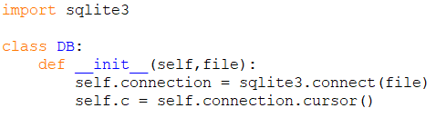

This is a depiction of how my controls table would hold data:

|  |  |  |
| --- | --- | --- |
| **Control** | **First Key** | **Alternative Key** |
| Jump | W | Up Arrow |
| Move Left | A | Left Arrow |
| … | … | … |

To update a field:

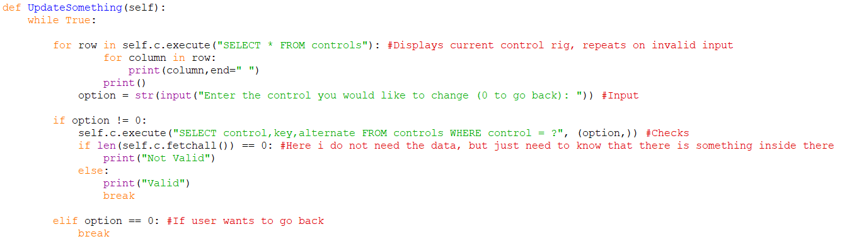

The controls are displayed and the user is asked for an input, the input is checked to be valid, which in this case means that there is fetched data (Not empty which is where the len(self.c.fetchall()) == 0 comes in) from the database using the input as a query. If the input is invalid, the control rig is printed again and the user is asked for another input until it is valid. Now to make something for when the input is valid and here is what I came up with:

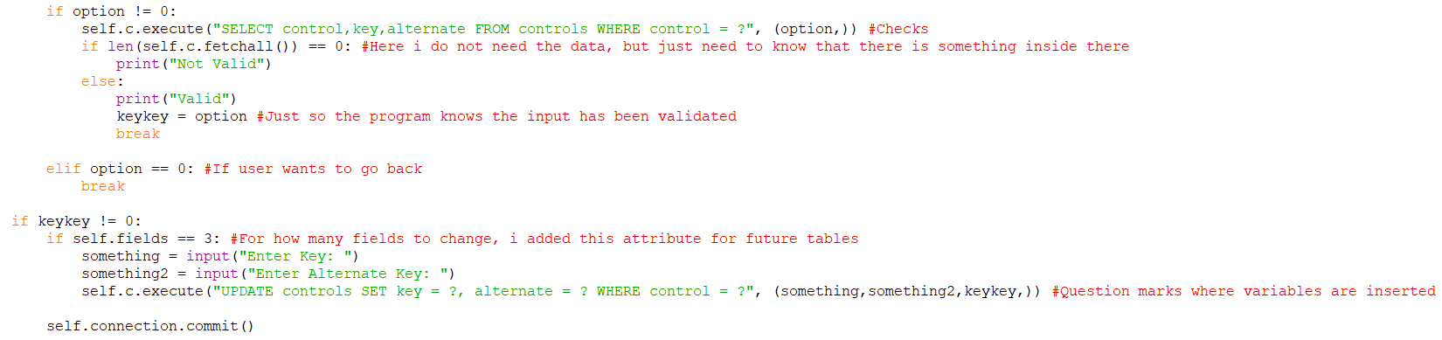

Self.fields for this table has been instantiated as 3, for tables with more fields in the future I will have them instantiated with this attribute of how many fields. But for this appended code, I tested out changing some fields:

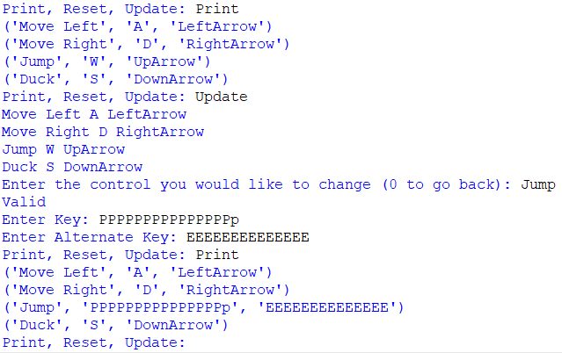

The record after

The record before

My input

And on a side note, I also tested that resetting works and it does as demonstrated:

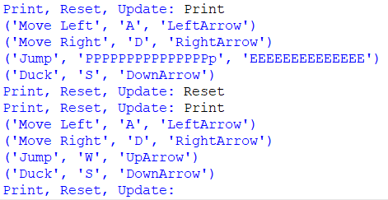

Now, since my “PrintTable” function will serve as an output of the database, I need to change it to more specialised querying from outside of the class:

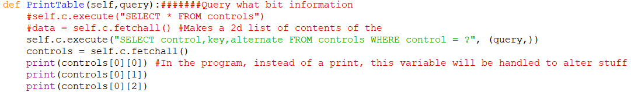

Tested:

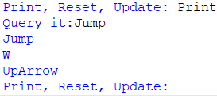

Now I get each field of a record and I can now sort them into variables to handle in my program as I please.

Looking at this I have realised that if I am to have multiple tables in a database file, I will need to change around my methods inside this class so multiple different tables can be navigated through. How I am thinking of doing this is with the use of **inheritance** to have one class contain attributes and methods of the database file while a child class will create objects of each table in that database to handle separately to the mother class:

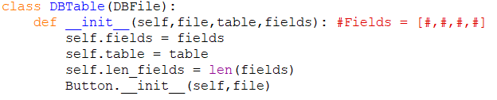

Here I will move all the methods that I have already created into this new child class. Along with that I have decided that I want to have all default fields for the tables saved in a separate table, here is how the tables would look like in DB browser:

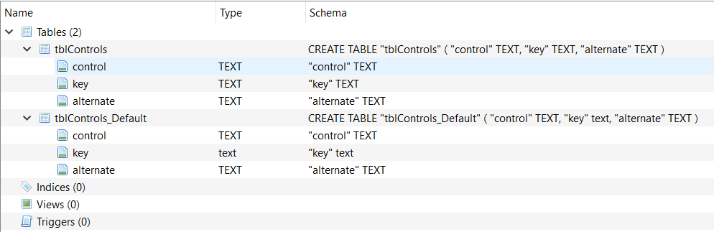

So, tblControls_Default will be a read only table while tblControls will be read and write table while both having the same fields.

What I want to have is a full database system that is automated for future databases I create that I can cross reference between tables, so I will be using a lot of variables (attributes in this case) in the querying, here is my first attempt at having gotten the data for the matching controls from “tblContents_Default”:



But this did not work as I wanted it to, giving this error:



I tried to fix it by changing around the dot, I tried to make local variables, store the attributes for those and then put those into the variable clump but this did not work either even though the way it was written has the query taken exactly as the SQL query should be taken. After a couple of days of I came across this page on stack overflow. From this I tried a different way of writing the code:



It is just all the variables written out in a “+…+” where the variables I want to be and it printed some values for me:



To make sure that this was printing exactly what I wanted (Which was the controls from default that were the same as from the normal table), I added a field to both tables with the same value for “control” but different value for “key” and what I want it to do is to print the record that I just added with the same control, here is the database values:

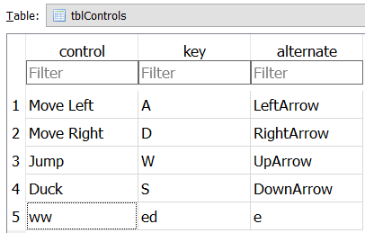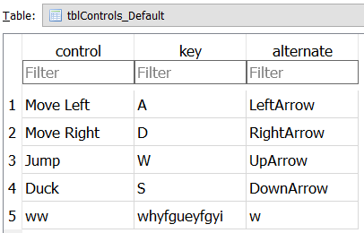

And my program prints:



This is good, but I need to check if it is just printing all of “tblControls_Default” or if it is actually printing the controls that are common in both tables so I changed the values to this:

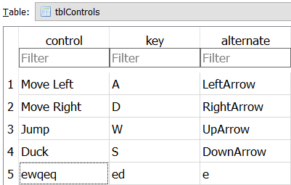 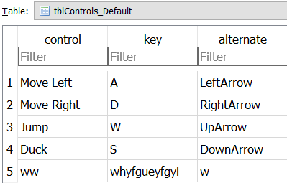

And this is what is printed: 

Leaving out the field that is not common which is exactly what I want so this is a success. Now to actually change code into resetting “tblControls” to its default values. Here is my first attempt:



But I get this error:



Which is an error with my data as I have not written “Left” anywhere in my code, I changed the bit where “Left” is put into the code into this:



And this time get a different error:



This shows that the program passes my variables weirdly into the SQL statement so I looked back at my last research source in stack overflow and decided to use “?” for values and “%s” for table column as such:



And it did not return an error so too test that the program was doing what I wanted I went to my DB reader and I changed my default keys and ran the program to see if the controls on my main database change to the defaults:

Before:

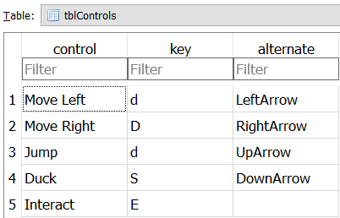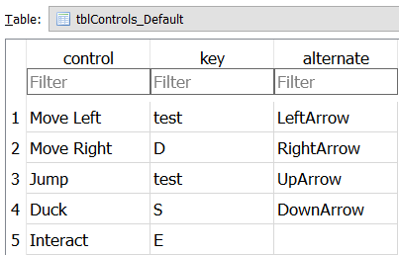

After program is ran:

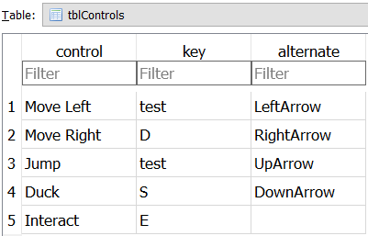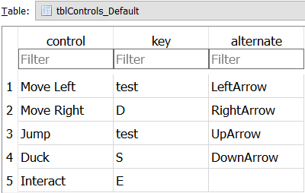

I also tested this by adding a record into “tblControls” that wasn’t in the default table and the program ran fine, I also changed the values in alternate and it still changed the “tblControls” table into the default as desired.

Now I want to alter my “UpdateRecord” method so that I pass in 3 arguments (how many columns are present). For this to work for different tables with different number of columns, I need to have different methods for different argument lengths, so here it will be UpdateRecord3. Using what I previously have created to update a table I came up with this:



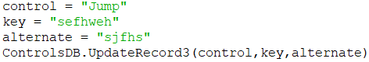

And the result of the database is this (Which is good):

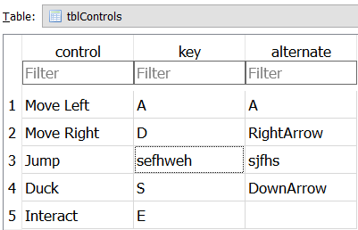

Now I want to be able to query records, either I can load the entire SQL table into the python file and handle it as a list or I can query individual specific records based on the control key. Even though I would prefer to do the other I am going to go with loading the entire SQL table onto python as this way, if I change the control key column in the database, this would immediately update the python code to be handling the new control key whereas if I do it the other way I have mentioned, the program will need to pre-emptively know what the control key is without going onto the table which requires **more maintenance** for the same effect:

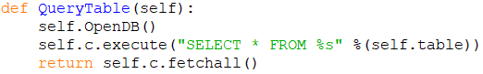

>>>



Final thing right now is to have the python file create all the SQL tables if it isn’t on the user’s computer. Here is what I came up with:

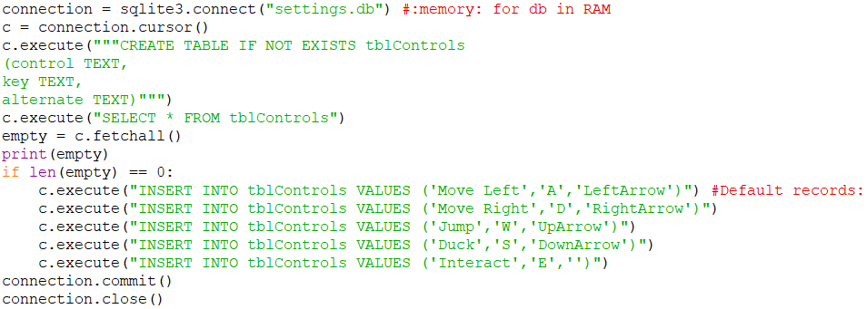

I repeat this for each table and their contents. I tested it by deleting the database file and then running my program and the table was created with all the records as it should. Once I add the tables for the rest of my options I will start to integrate this into my main program:

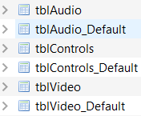

#### Database implementation

Since I have already got some options inside “Video Settings” I want to first fix up these menus to work with the database before I move onto the control settings.

Now I’ve added the code into my main program, I started by adding a reset to defaults button for every page:

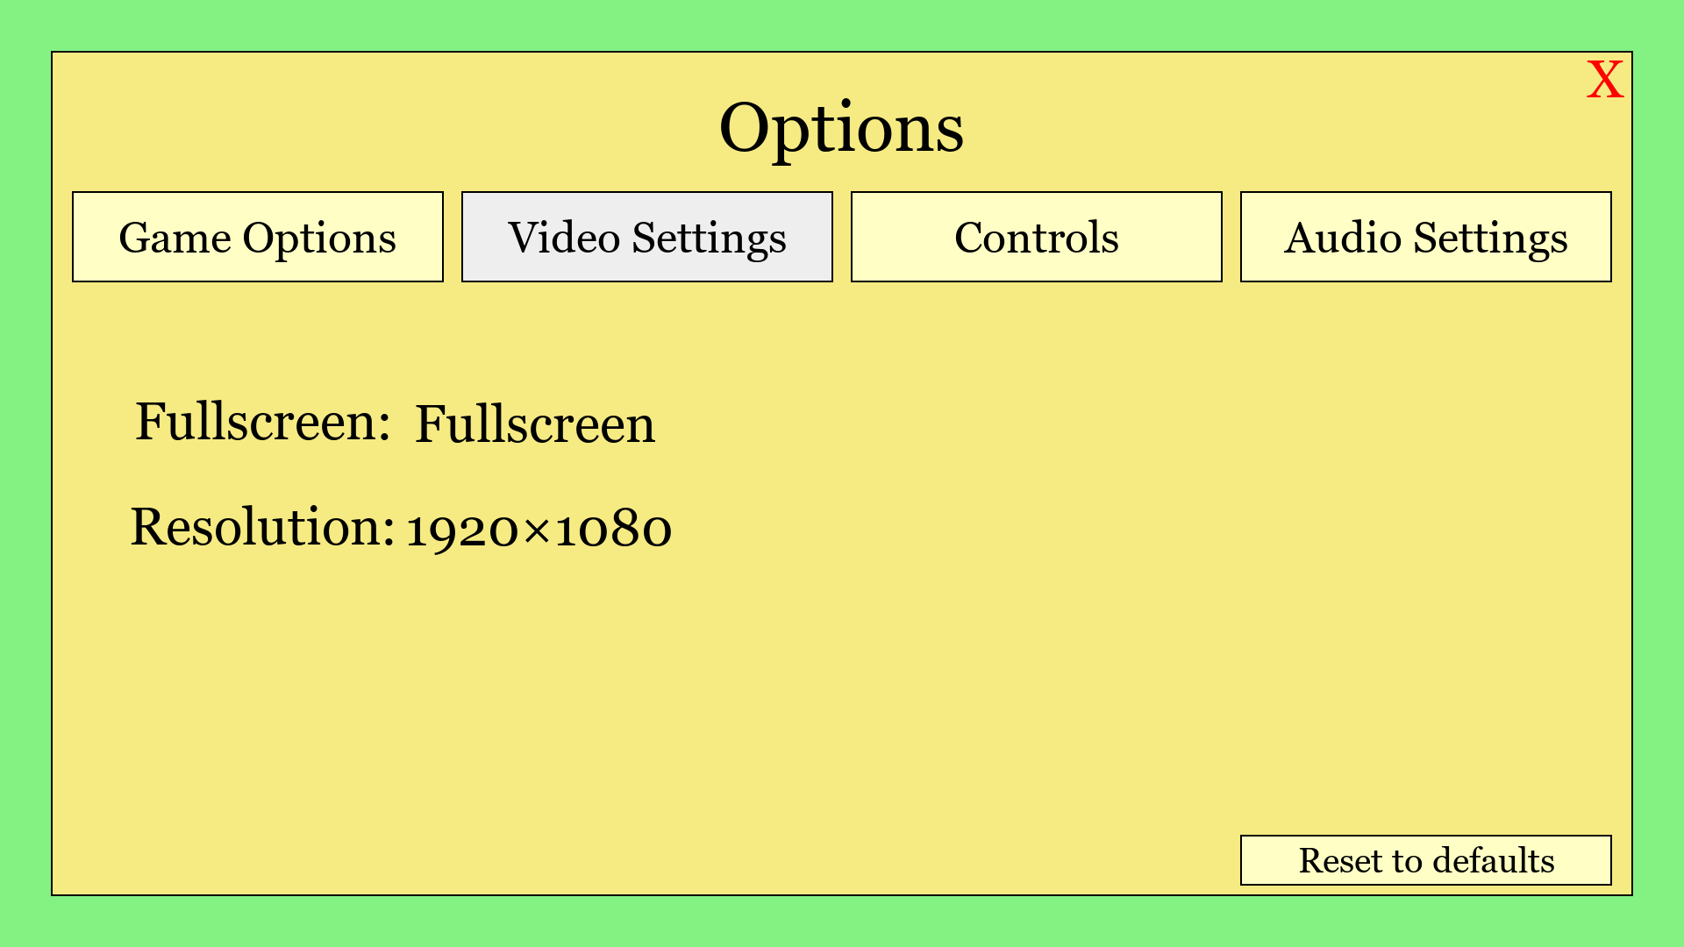

Next, I want to have the database start on windowed on Fullscreen depending on what the user last had, so when I instantiated the class I implemented this:

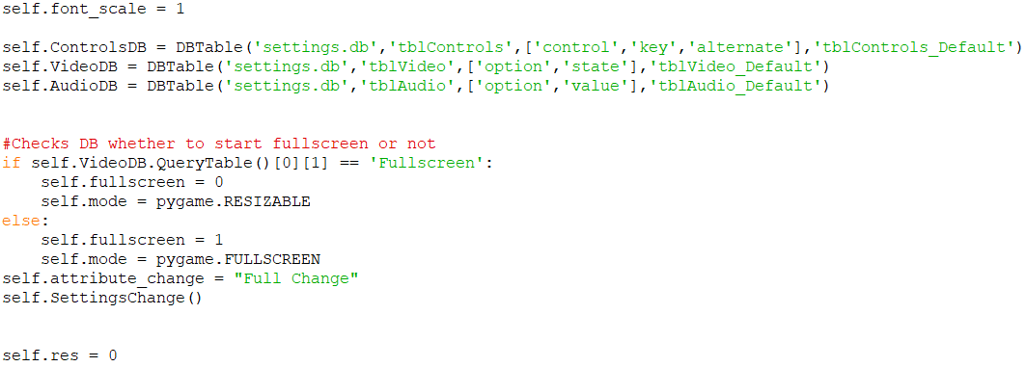

This is what queries the DB file

And it works so if I played as windowed last, the game launches in windowed mode. Now for the resolution:

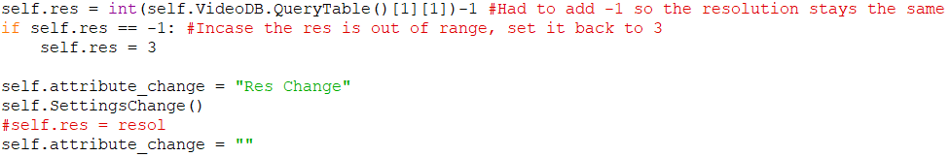

Now to get the reset to default buttons working. I want to first start with the video settings button as that is the easiest one to test (as I can see the physical changes). Currently I have the buttons when clicked return these values into the “Settings change” method:

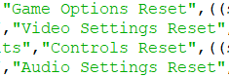

So in the method I added these:

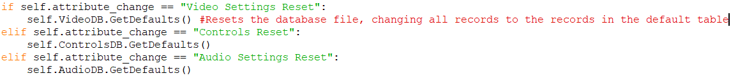

But when I tested this, nothing happens to the program as soon as I click reset to defaults as it changed the database but doesn’t update the program so when I reopened the program, the defaults were in effect. So to update the program I did what I did at the start of the program to update the screen:

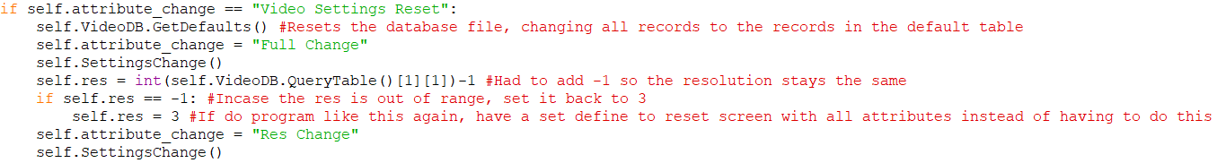

And so now as soon as I click the reset to default button the screen updated and the screen went to fullscreen and resolution of “1920x1080”:

Before clicking: After clicking:

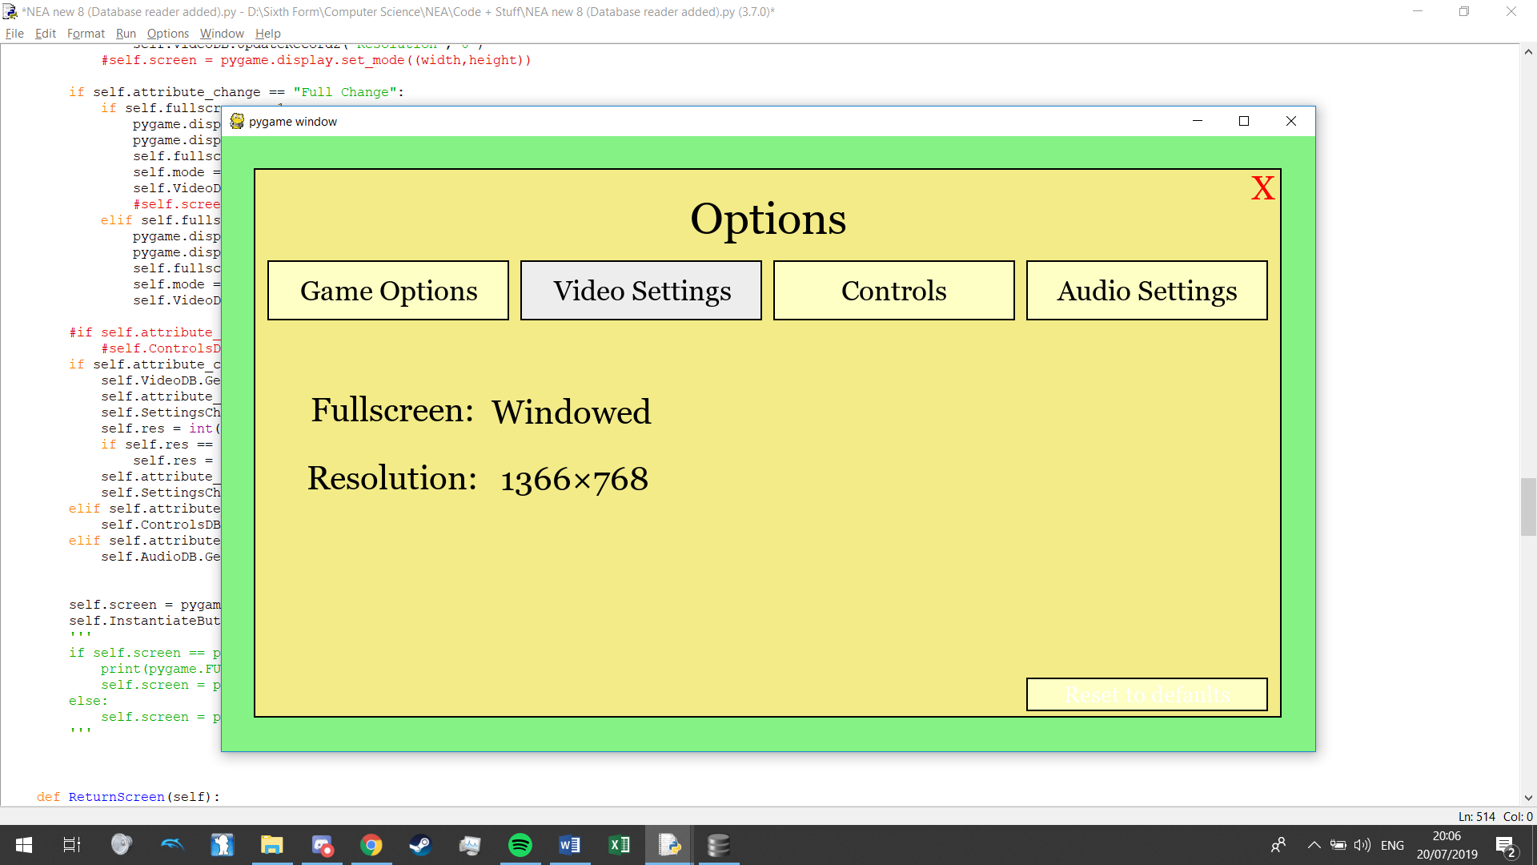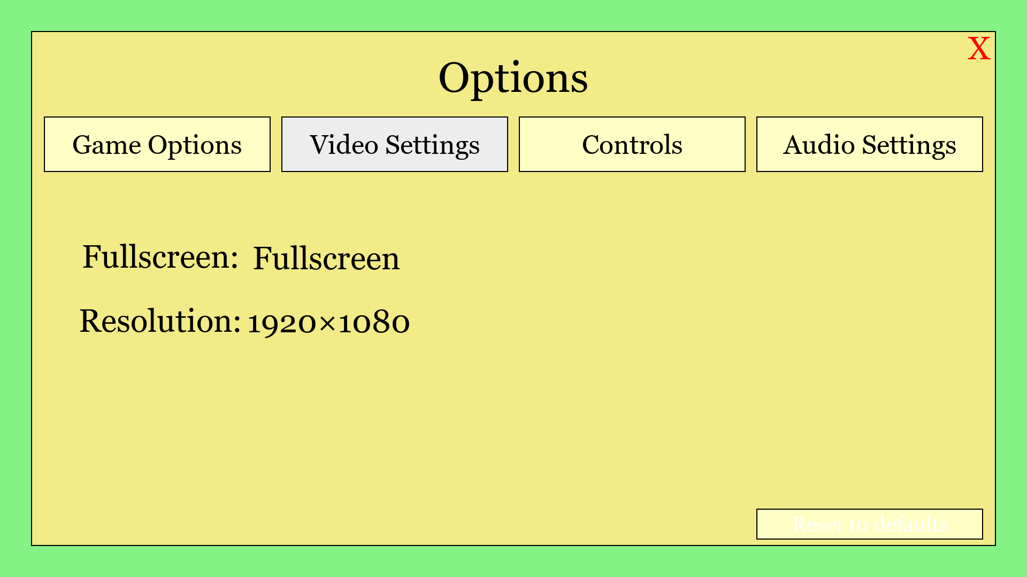

I tested the reset button for the other databases and clicking the buttons in the different sub-menus do in fact reset the databases back to their defaults.

#### Controls settings

Since the code for the controls will be pretty big, I will have a separate method just to draw all them.



Also, since I will need to instantiate my buttons based entirely on my database, I create another method to instantiate the buttons in my control menu:



To find out the position of all my buttons I first played around with rectangles and their coordinates:

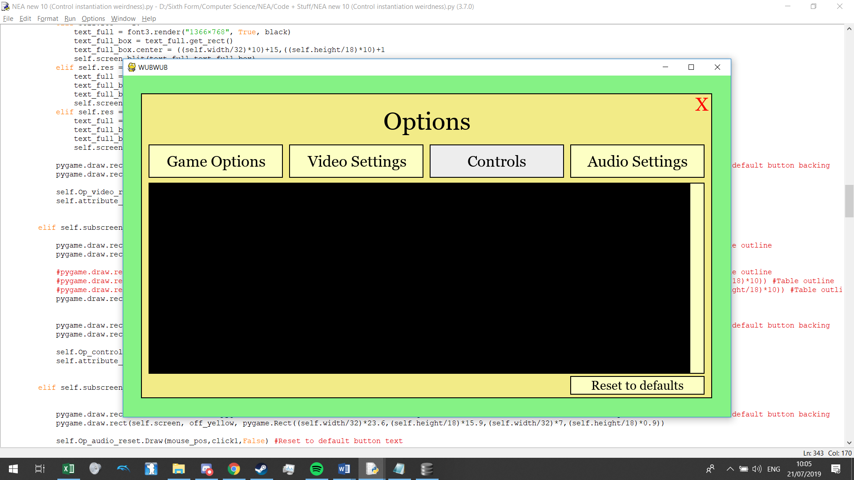

Space for scroll bar

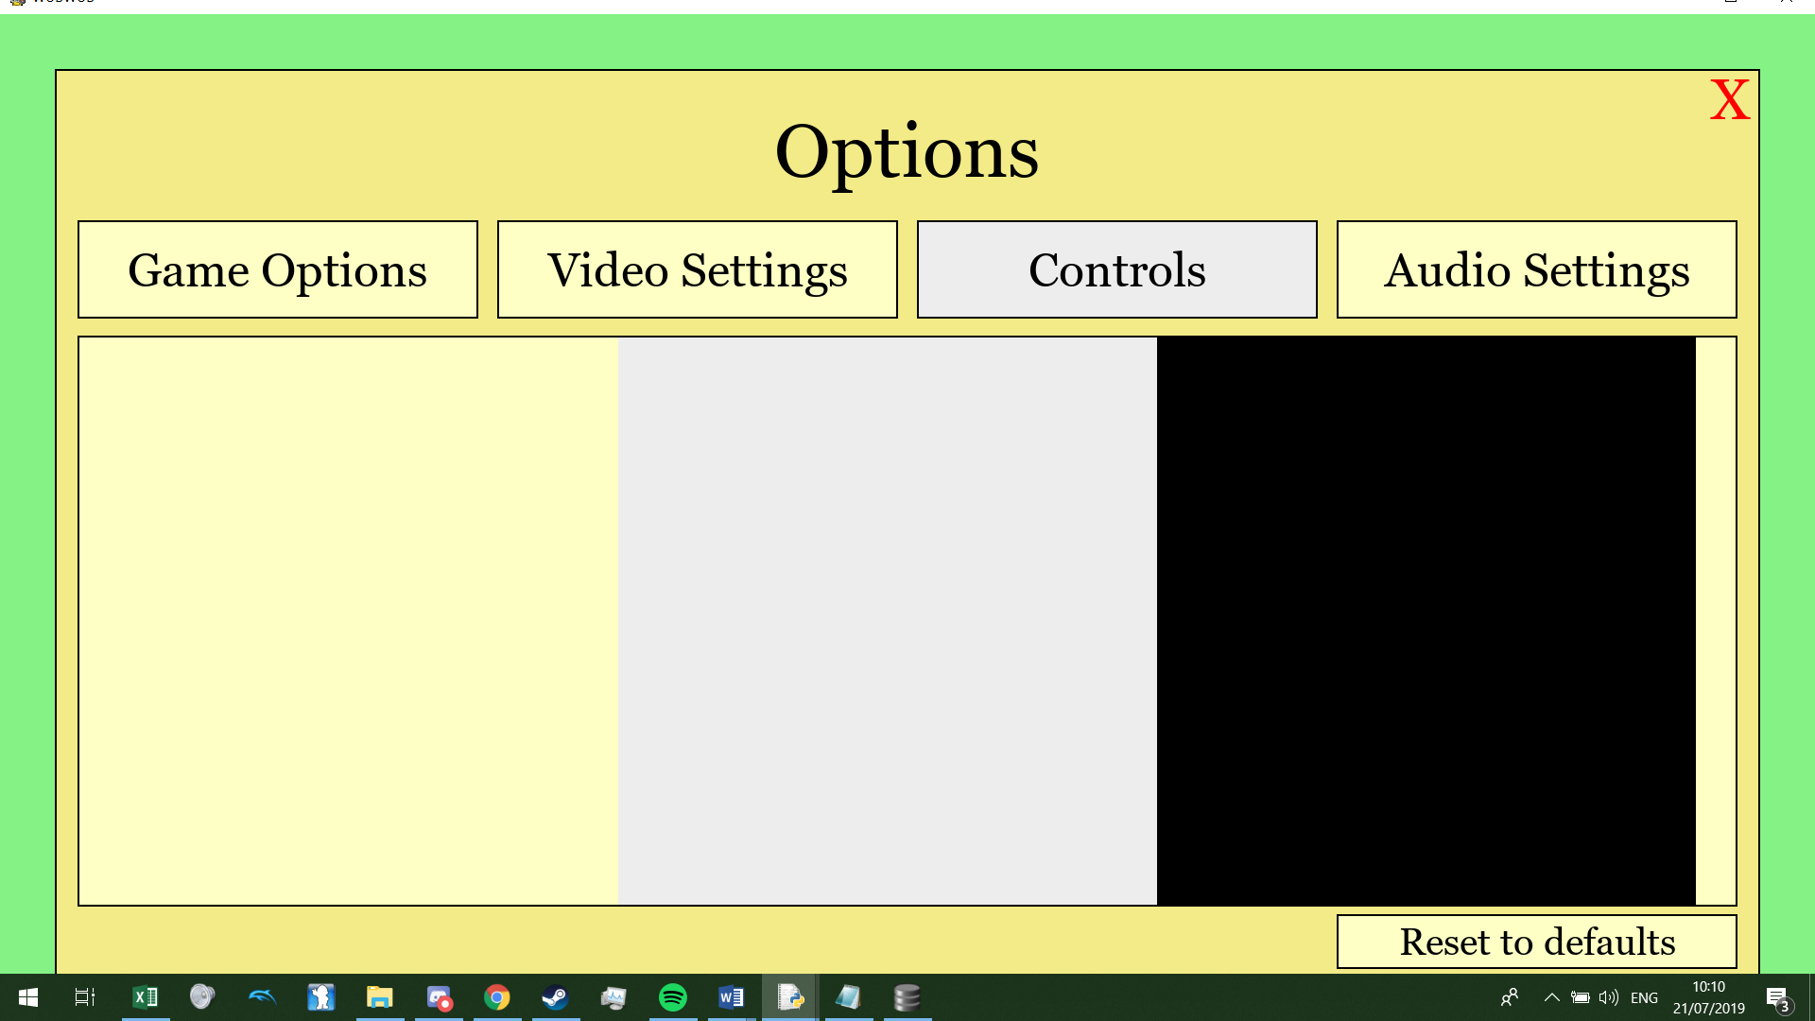

3 columns for 3 buttons a row

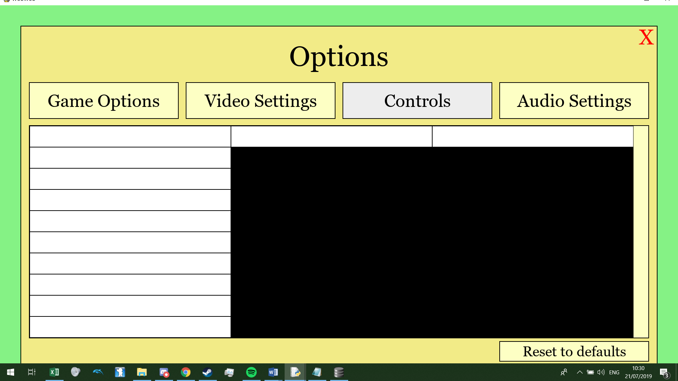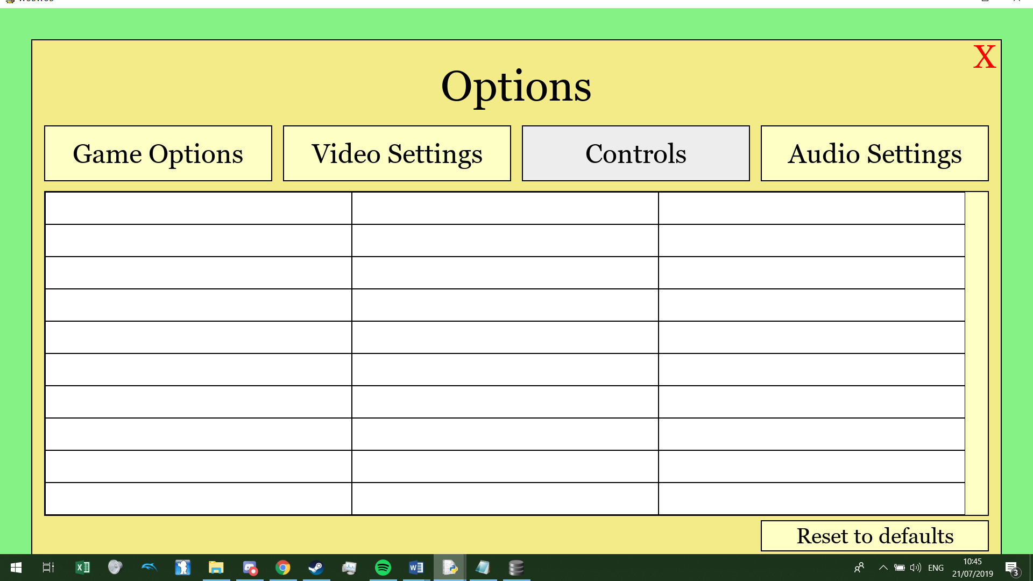

So now that I’ve got my positioning done, it’s time to make the buttons. The first column will not be buttons as they are just text but since I have decided to make them buttons but just not interactable as I already have the functions created to draw the on and all I need to do is enter the attributes of the text such as it’s centre, font size, etc:



(For each button) And then draw them in “DrawControls”:

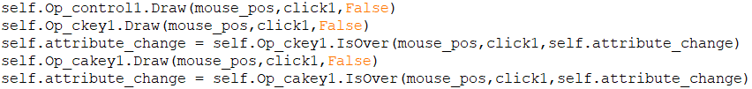

I repeated this 9 times for each row in the database and here is the result:

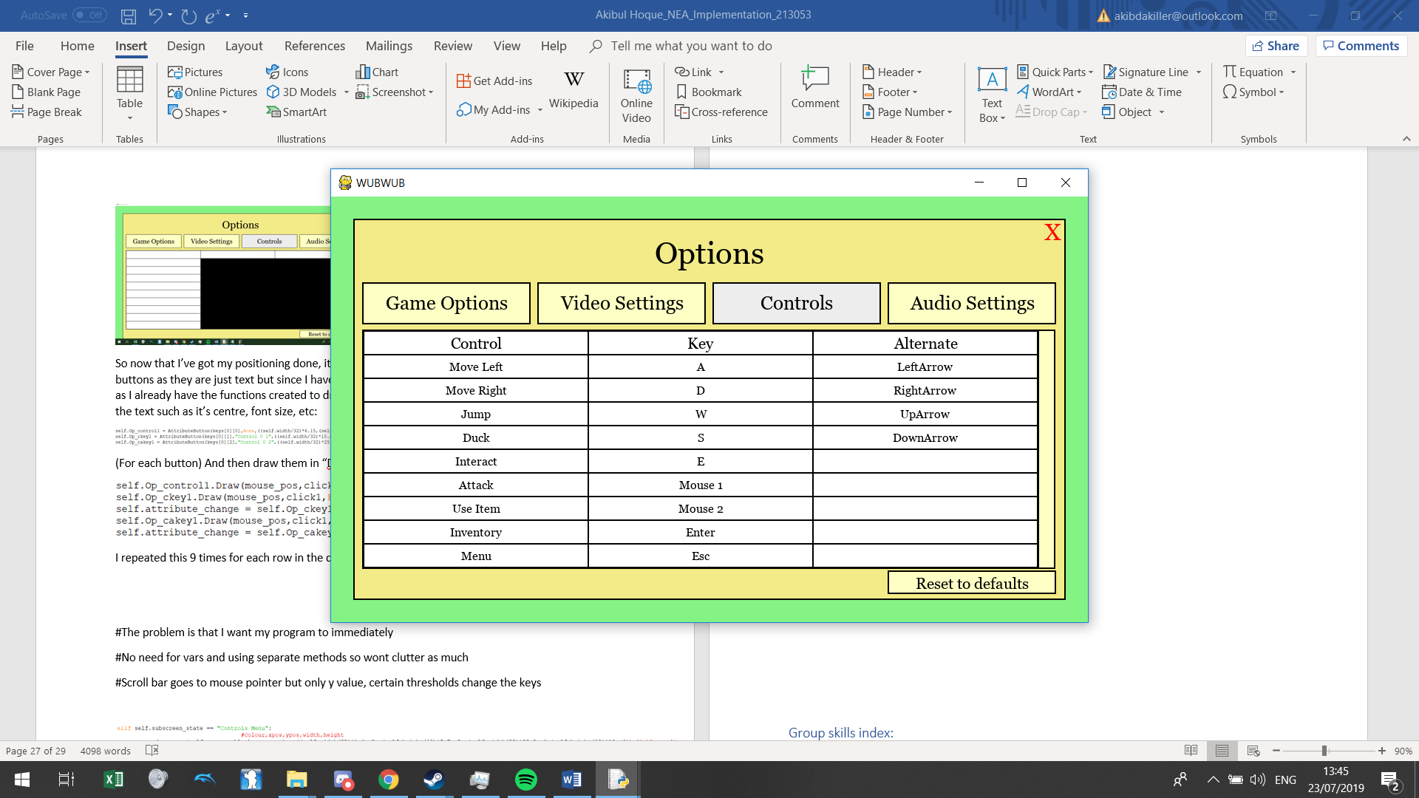

Now I want to work with a scroll bar, for this I would need the position of the scroll bar to change and so how I would do this is to instantiate it repeatedly dependant on a variable for it’s y position which updates dependant on where the user’s mouse moves whilst clicking the bar.

Since currently my buttons only ever give an output when the mouse button is released over them, I need to change the program into being able to give an output when the mouse button is held down as you drag a scroll bar. So, I made a new event function:

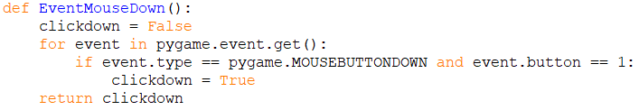

But the issue with this is that it only registers the mouse being held down for one frame and not for the duration of the mouse button being held down, I realised I could fix this pretty easily:

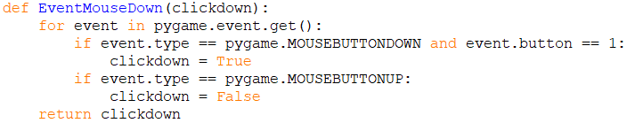

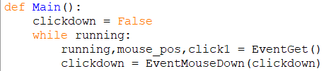

But whilst testing this I realised this was very inconsistent in checking the inputs and I realised that this is happening because I’m checking for inputs different in two separate frames instead of all in one so to solve this I adapted my single “EventGet” function to have this code inside it so that user inputs are only handled by 1 function so it is handled by that function every frame:

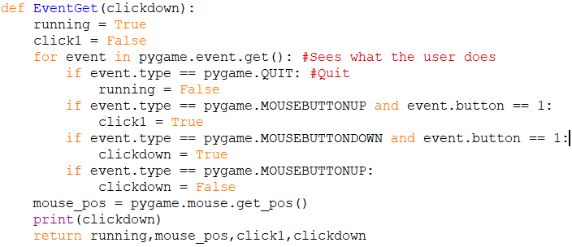

So now the scroll bar goes to the y position of the mouse when the user is holding down the click button:

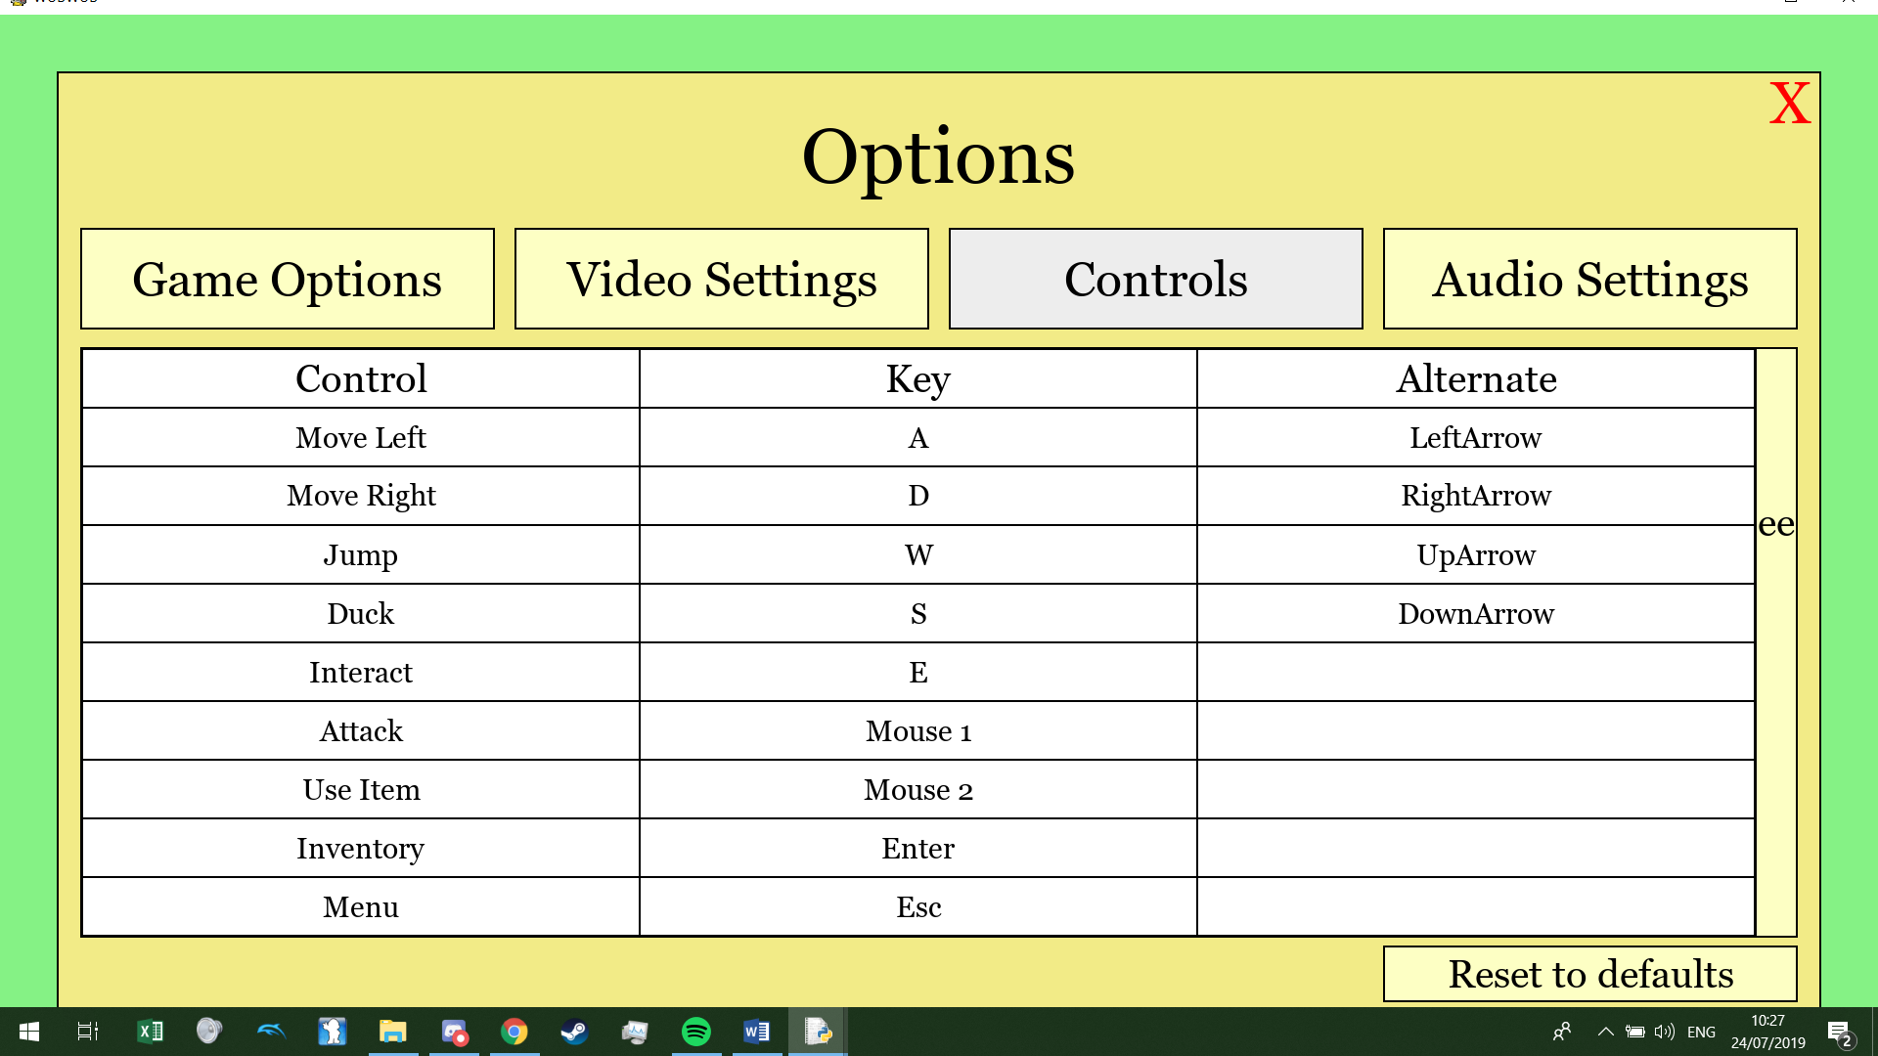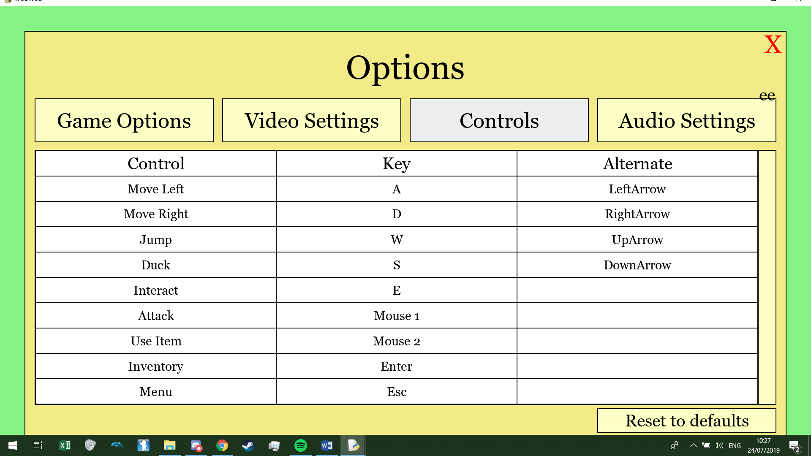

So now to set some rules for the scroll bar (And to actually make it a scroll bar). First I made the bar appropriate and possibly interactable, so I made a black box whilst also changing the current text to be a blank text but have the hitbox being the same size as the box:

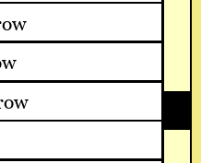

Both a rectangle and a blank button makes this up. It is also the same height as one of the buttons (On the left).

For my scroll bar to effect my controls buttons I had to change the way my control buttons were positioned, from being pre-set to being determined by a variable:



Self.cscroll is set to 1 as default, so without the scroll changing the button is $\frac{7.2}{18}$ ths down the page which is where I set it before, and since each button has the height of one, when I scroll down by 1, the button will move 1 up to the next slot, since this is the first button and it disappears on first scroll I made sure it was not drawn after the scroll became bigger than 1 (And repeated the same procedure for all the buttons):

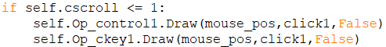

Now for the actual bar, I set caps of where the scroll bar could go, since the rectangle and button inside the scroll bar are positioned different on the screen (The rectangle being positioned from it’s top left corner while the button being positioned from it’s centre) I had to compensate:

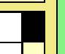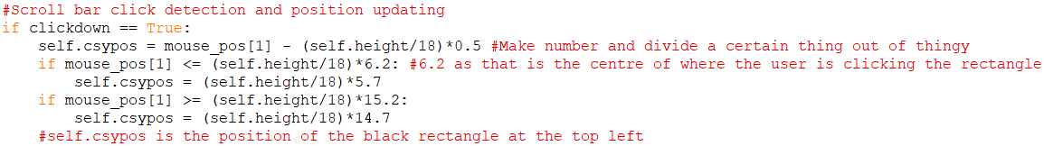

This is what height (self.height/18)*5.7 is referring to

This is what height (self.height/18)*6.2 is referring to



Now I have the basis for this scroll bar to be functional, so first if I have one option off screen, I want the table to scroll when it is $\frac{1}{2}$ way down, and if there are 2 off screen options, scroll when $\frac{1}{3}$ th down, etc. So, a way to track this is that the amount of hidden options are the amount of records in the database minus 9. So, if I had 11 options, there are 2 hidden options meaning I want it to scroll when a third down so I could just minus the amount of records by 8 to get the direct amount of when the table should scroll. But to help find out the amount of records in the database I used the **aggregate SQL function** of COUNT to find the amount of records in the database so I made a method in the DBTable class:

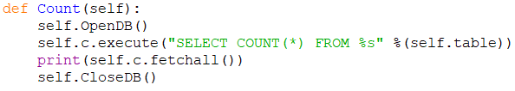

When printing this the output is in this format:



So, I altered the method to this:

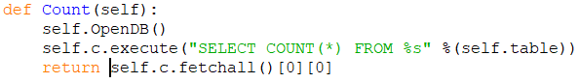

So now I can use this method to calculate how many items are off screen:



Now for the checker to see where the scroll bar is and to update the controls on screen dependant on it’s position:



Now the controls update whenever my bar is scrolled appropriately down the page, shown here with an example including 12 records (All screen captured just as they scrolled):

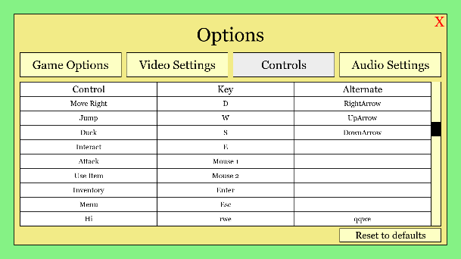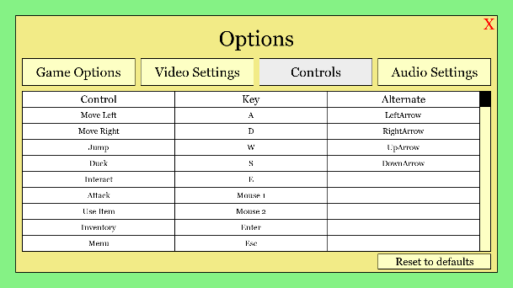

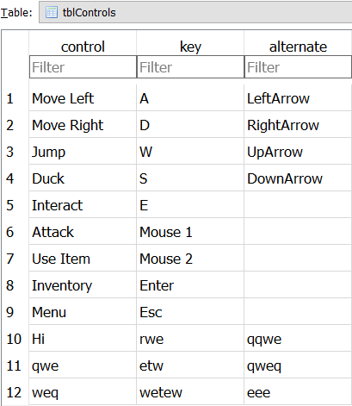

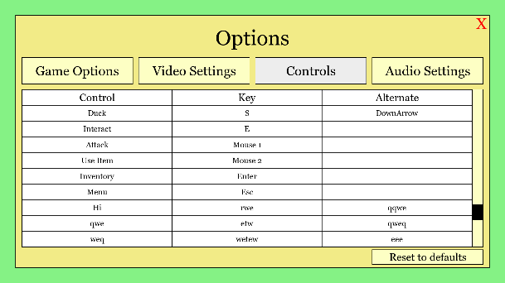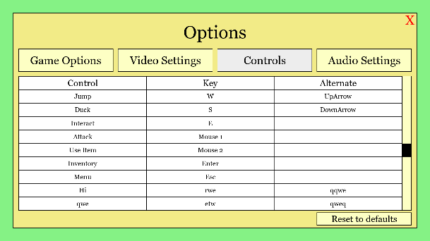

This is the exact effect that I desired. But right now the scroll bar goes to the mouse whenever left click is held down so now I need to have a proper dragging effect on it. Right now my buttons only react when the left click is lifted rather than held down but I since I have the click detection as a Boolean that is passed into the method to check if mouse is over the button while the click Boolean is true, I could change that “click1” Boolean into my “clickdown” Boolean variable which is set to true for as long as the mouse button is held down and then I could use the method “SettingsChange” to make set a variable to true under certain conditions:





And now with this variable I can do this in some previous code:

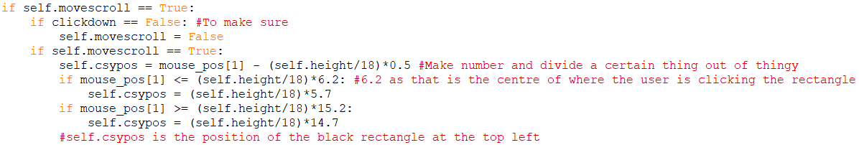

When I run this code I have an issue however, as when I click on the scroll bar, the bar moves to my cursor for one tick, my screen flashes black and then the scroll bar refuses to follow the mouse. The problem I found out was that whenever I clicked the scroll bar, “clickdown” was set to False (I tested using print statements here):

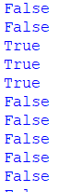

But when I seem to click anywhere else, the output is True for the duration of my click.

Eventually I figured out that what the screen flashing was, was my python screen’s display mode being reset as that is what happens every time I call the function “SettingsChanger” and this seems to pass as a “MouseUp” (Letting go of the mouse button) into pygame which is what was setting “clickdown” to False. I fixed this by just allowing an exception to when the set mode is carried out so it does not happen when the scroll bar button is clicked:

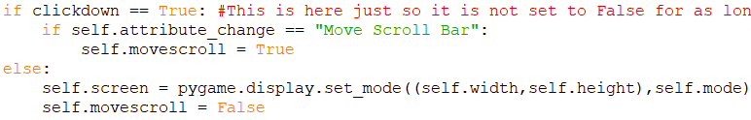

Now the scroll bar is fully functional and only moves when it is dragged by the user. Now to move onto the actual buttons themselves. To test that these new buttons are correctly interactable I printed the output when I correctly click them:

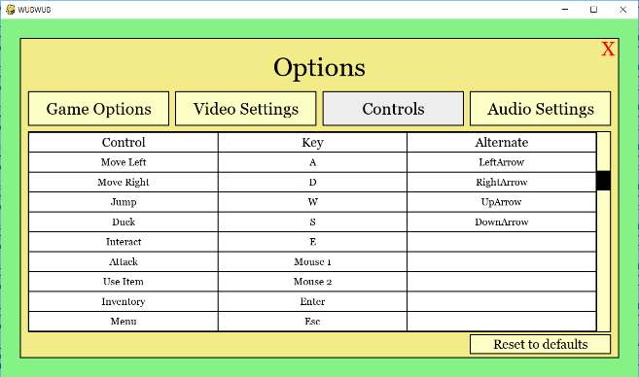

Clicking this I expect:

Output:

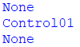

Testing a button I need to scroll for:

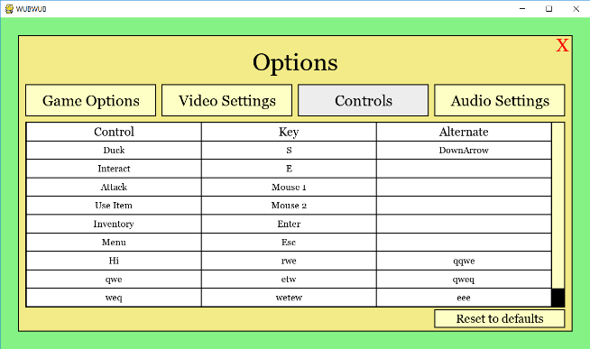

Clicking this I expect:

Output:

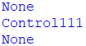

I needed to find out how to get clean keyboard inputs from pygame as I do not want to use selection to decide which key the user is pressing as this would require an if statement for every single keyboard key. I tried to see what “pygame.event.get()” and got stuff like this:



I tried to get the key that was pressed out as a single variable but I couldn’t so I went online to research about the function more and other possible functions. Also I have realised that I don’t want a continuous amount of inputs but instead I want the program to wait for one input and so I found this piece of code from poketcode.com:

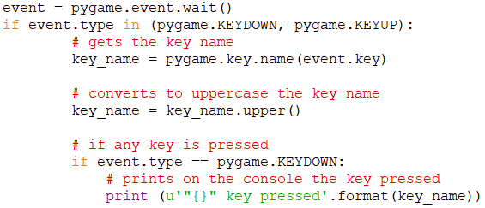

And I tried:

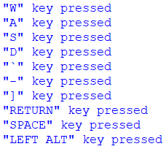

I wanted this to also include any mouse buttons, and for this I used selection to set the variable:

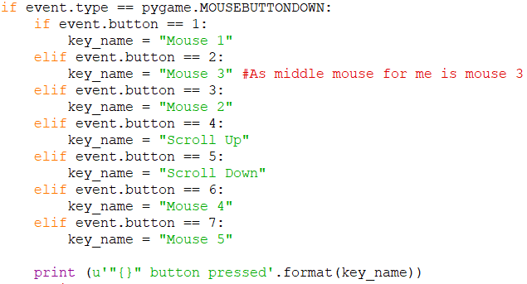

Now that I have a single variable for an input, I can now set up the functionality of my controls menu, first I want a prompt to appear when a one of the buttons is clicked and I used string manipulation to help (Since all my self.attribute_change for these buttons start with “Control”):



I think made the prompt similar to what happens when you click close game when you are at the main menu so I copied some of that code and just changed the text:

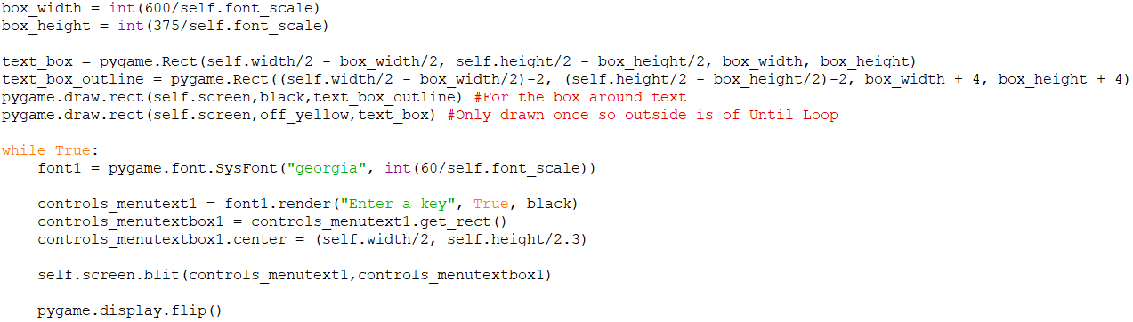

>>>

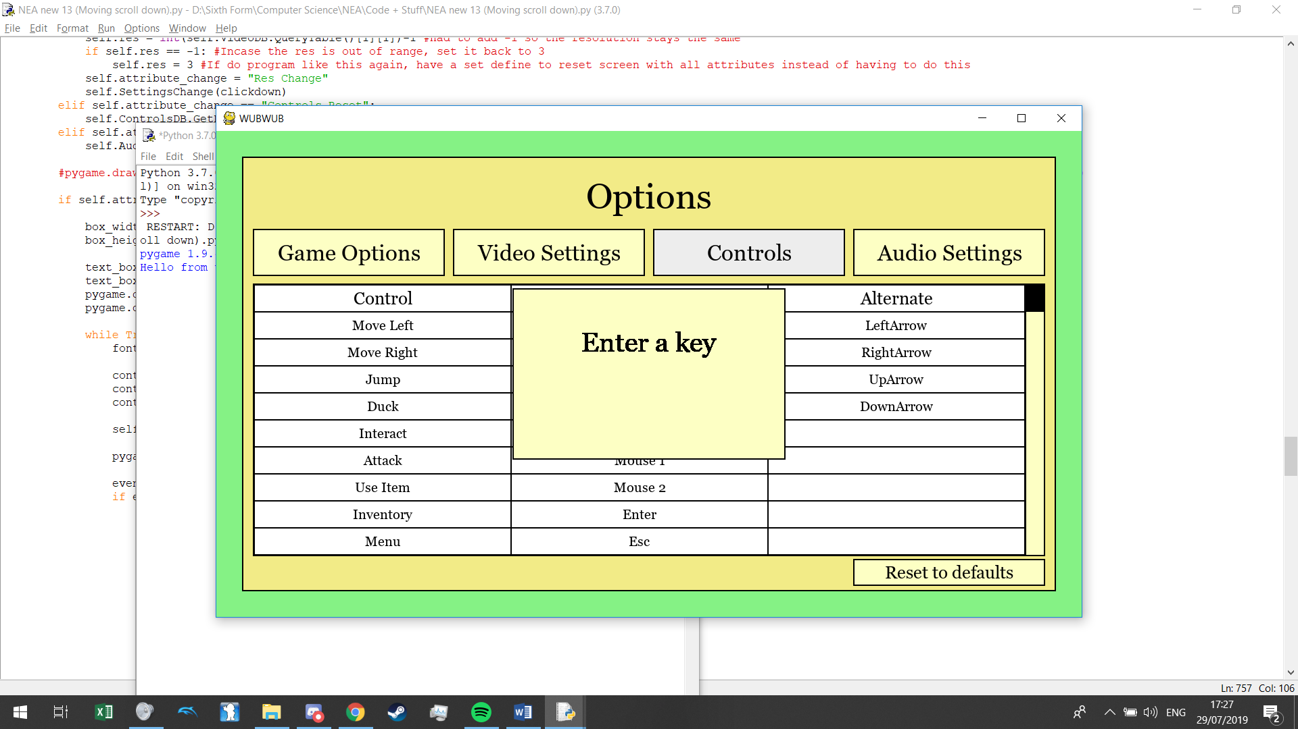

Then I added my code for the input with pygame.event.wait (Which halts the program which is the desired effect). Since moving my mouse counts as an input, I had to make an else condition which sets the variable “key_name” to “None” and then with this I had the program check if the user input is already taken, if it is then write “Invalid Key” on the screen:

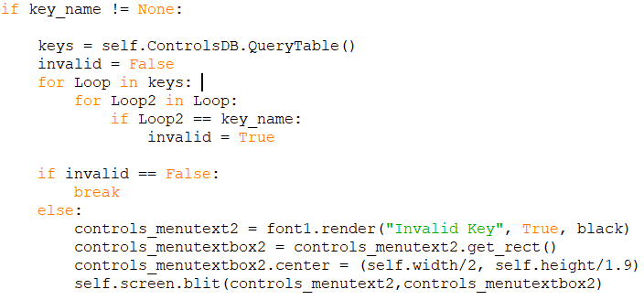

And with this any input that is already in the database leads to the program saying that it is an “Invalid Key”, but vanishes when a new key is pressed:

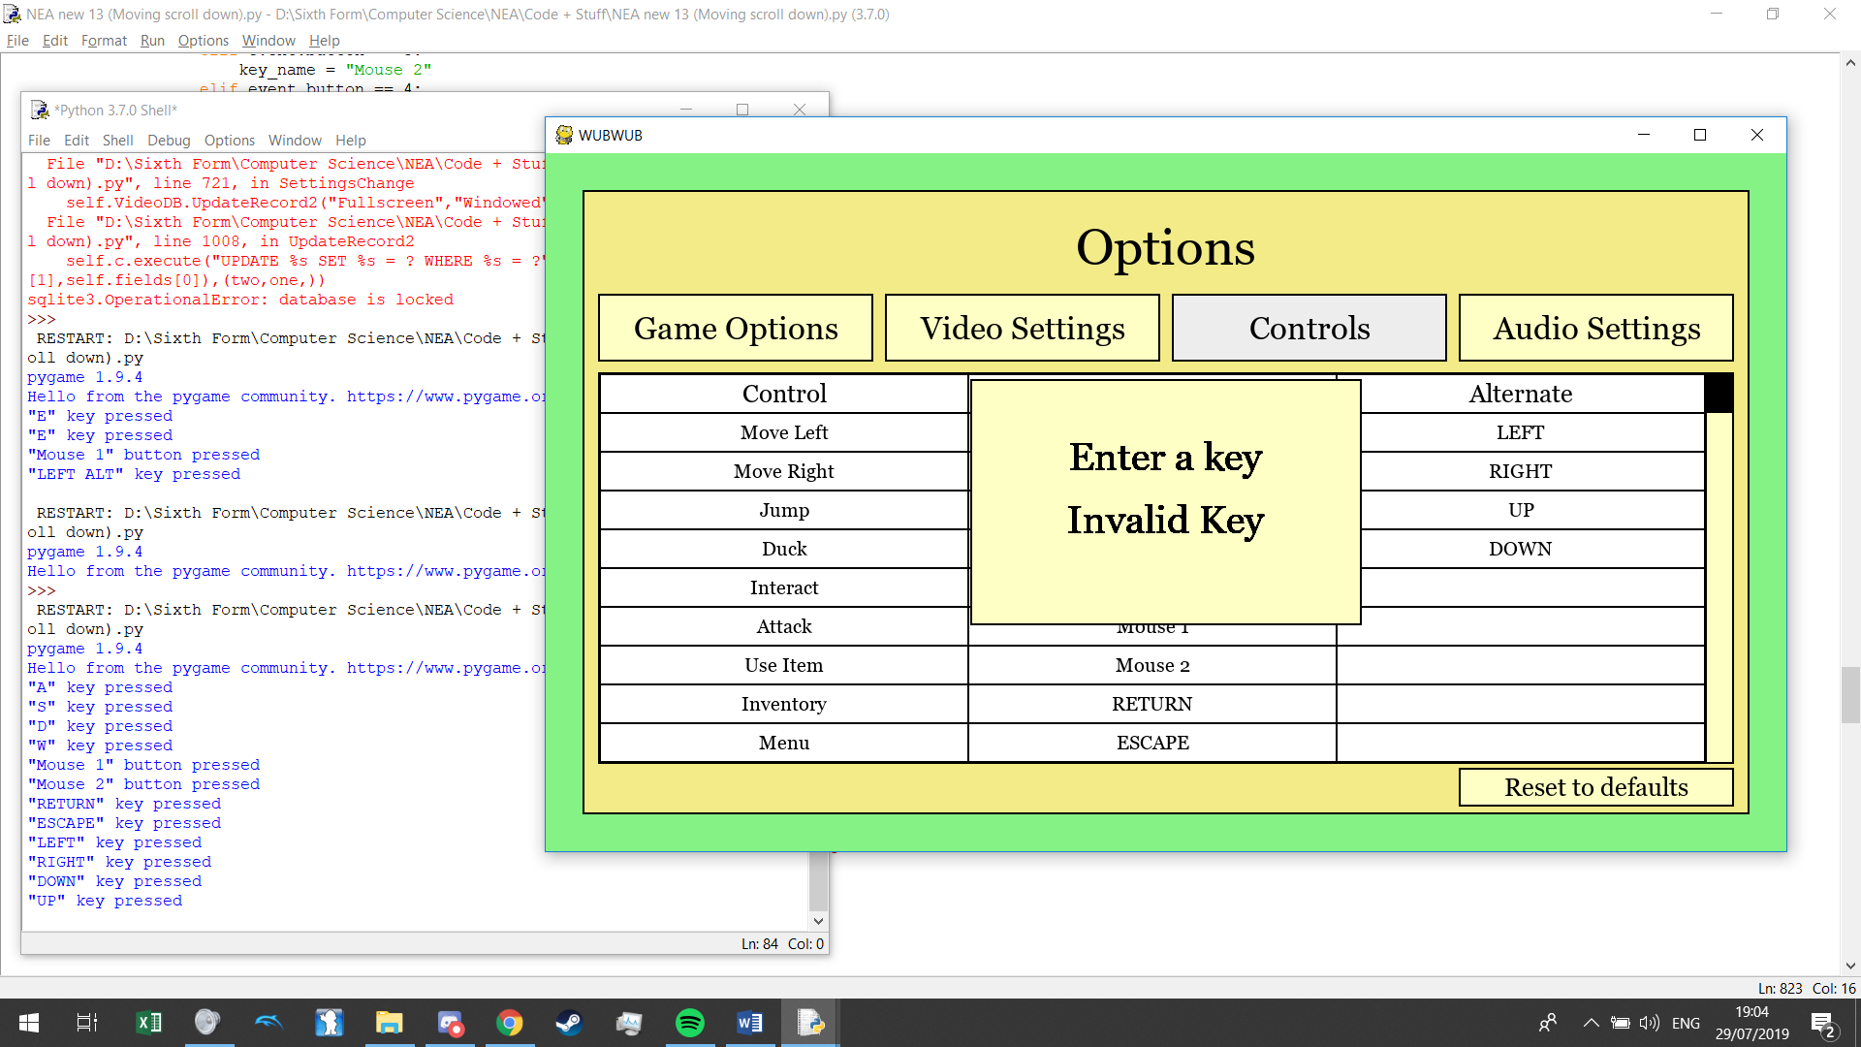

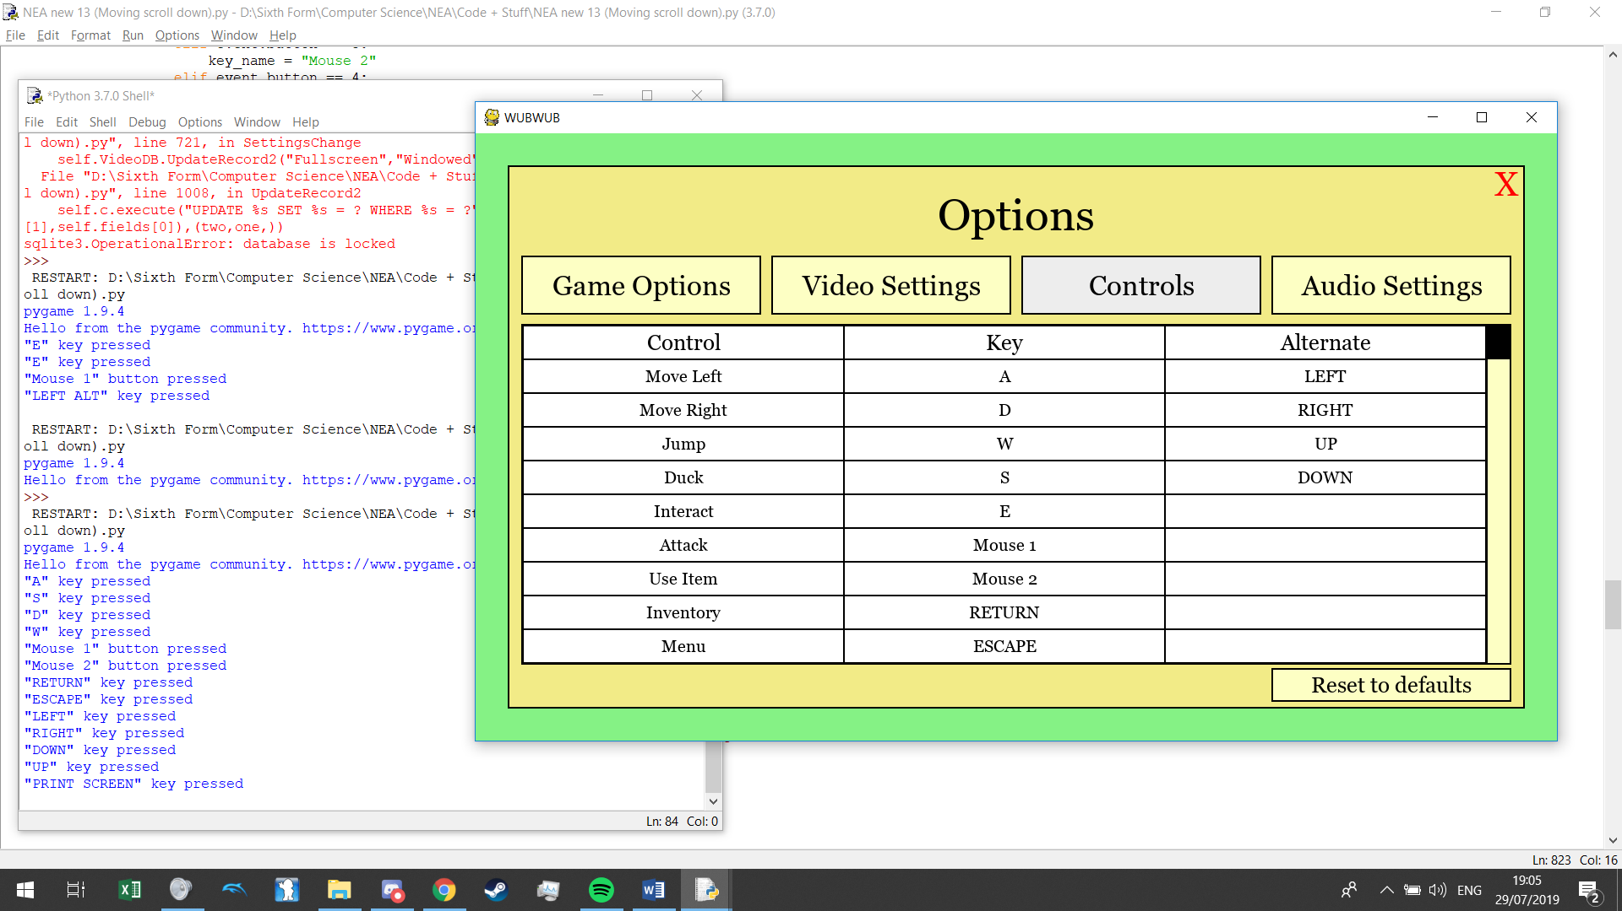

But I don’t want the key that the user has already chosen to be considered an invalid key:

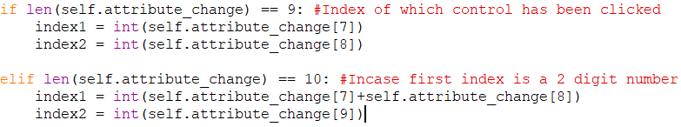

And:

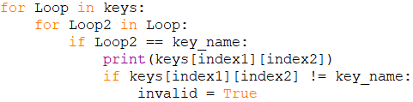

Now to make the program update the database, when all conditions are met for the control to change what my program does is check which column the user has selected and then replaces the column selected by the user input and replaces the other column by the control that is currently in there:



Now it works:

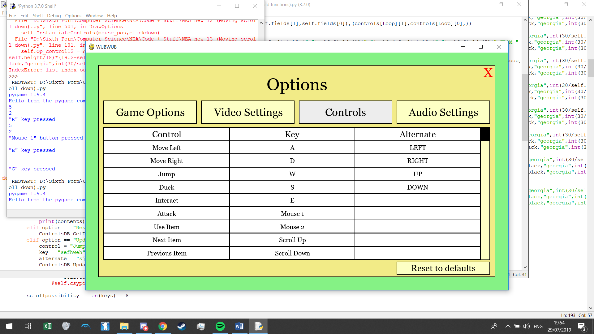

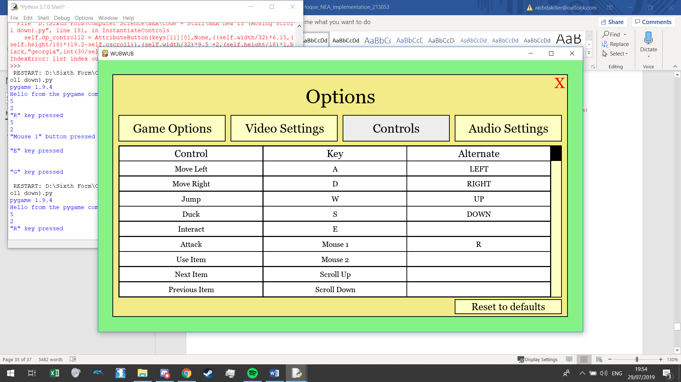

#### Audio settings

For my audio settings, I want volume sliders. And since I have just created a scroll bar in my controls menu, I have the basis on how I will do this. I have 3 settings for audio so first I made the static things on the screen:

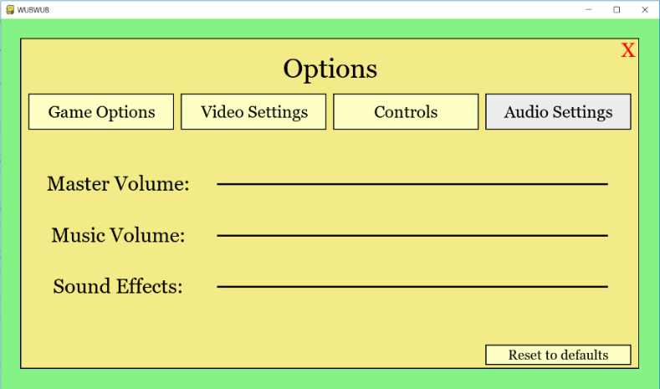

Where you slide the volume button along.

I then made a new method called “UpdateAudioMenu”:



Added the values of the audio database (And shift the lines above so it fits on the right):

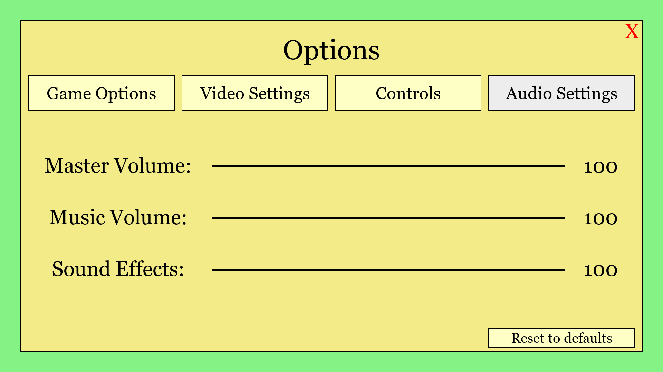

When instantiating my slider I used this variable to update the x position of the slider:

“as1xpos”:

“a” – Audio, “s” - slider, “xpos” - x positon.

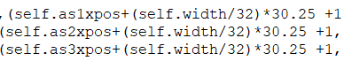

The rest of this is copying and pasting similar code and just changing around a couple of numbers so that the sliders work horizontally compared to my scroller in the controls menu which works vertically:

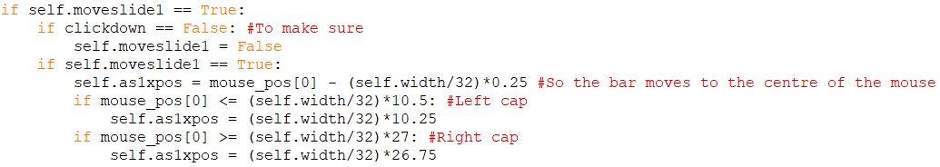

And:

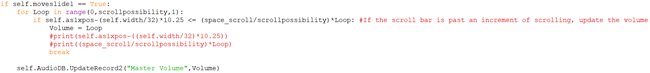

And adding the rest of almost duplicate code left me with this effect:

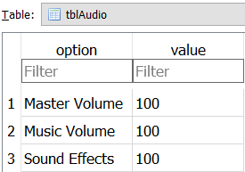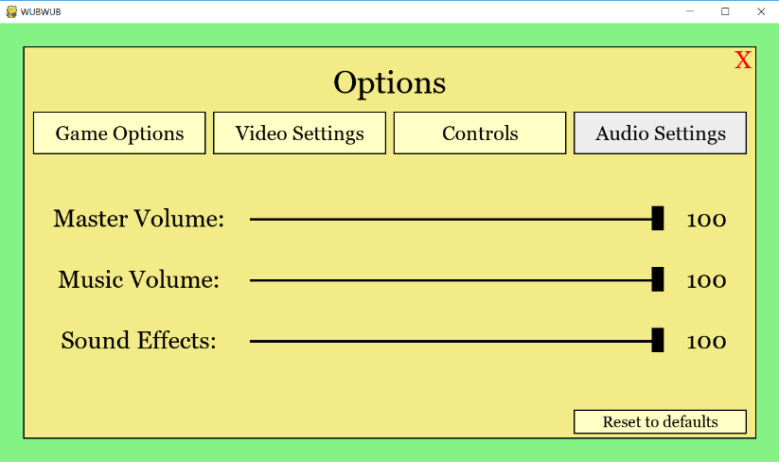

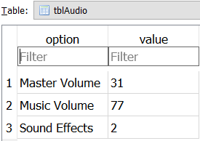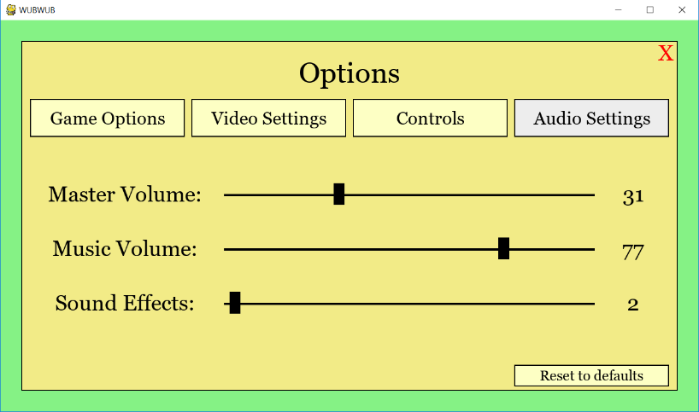

#### Game options

Right now the only thing I know I will have in my game options is the difficulty varying from Easy, Medium, Hard and Impossible which all effect stats from exp gain from enemies, enemy damage, enemy health, etc. For this I just made 2 buttons, one that I interact with that changes the database file and the other is just text which displays what is in the database file and I set an attribute of “self.difficulty” to whatever that difficulty is:



Plus:

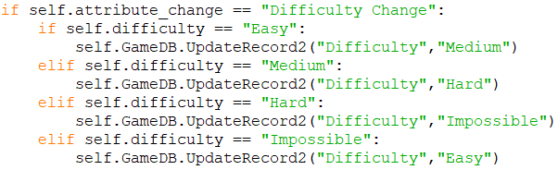

And the option is done.

### New Game

I will leave my credits and how to play for when I have finished my game as then I would have better references for that. To start on the new game I first measured up the sizes for 3 different profiles:

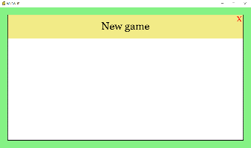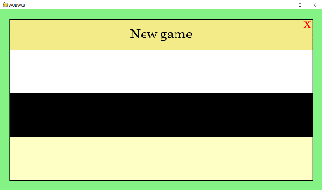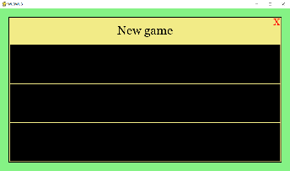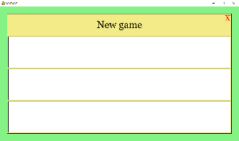

So my mock up of the new game looked like this:

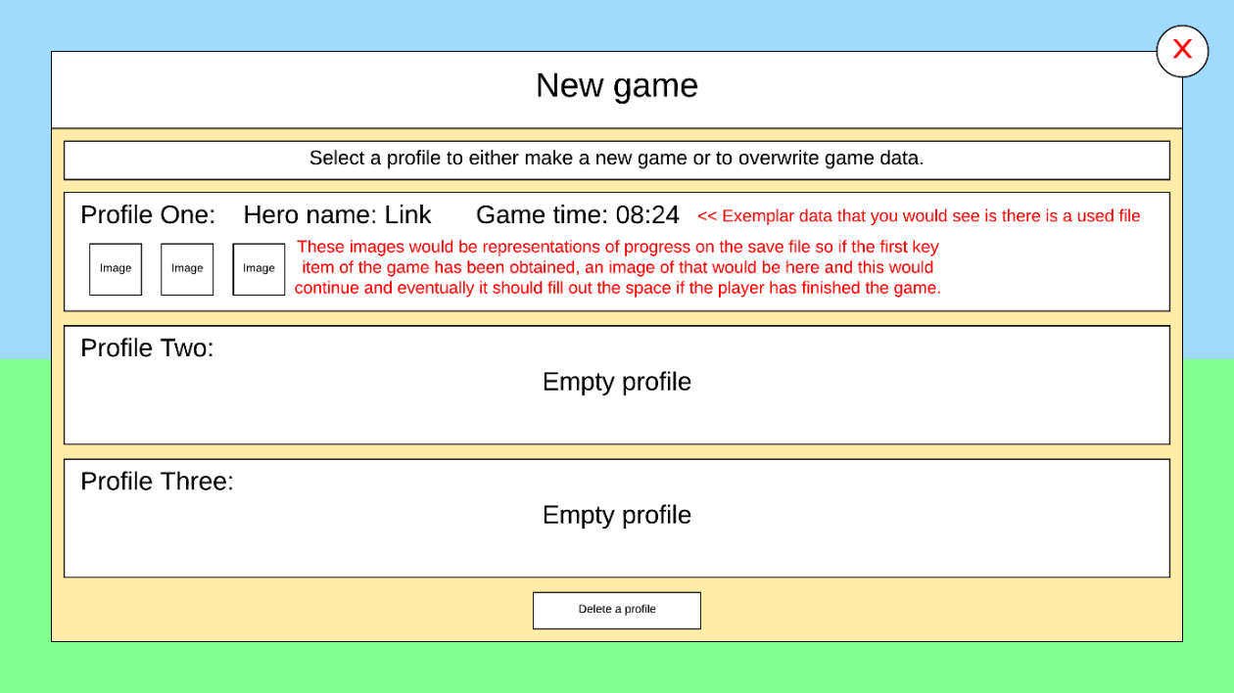

But I’ve decided to change it up a little bit, so that on the bottom right of a profile will be a “Start” button and I will also not include the “Delete a profile” button on this page (Only on load game menu) as well as instead of having profile one, two or three I will just have numbers:

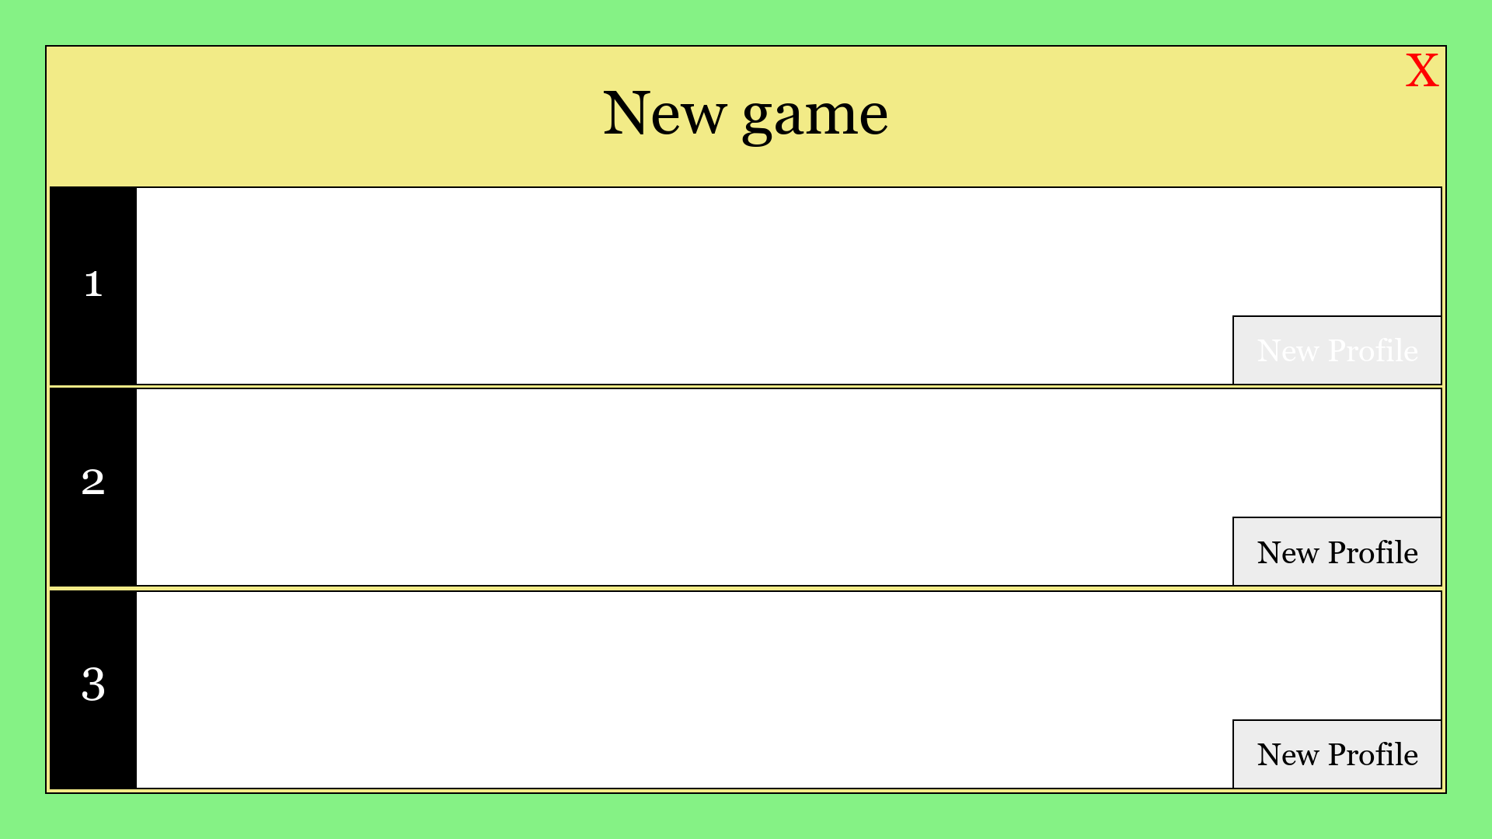

Save profiles will be saved into text files (Inside in a profiles folder). I created 3 empty text files in the profiles folder:

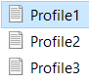

And had the program check if it they are empty, if so then the profile will display “Empty profile”:

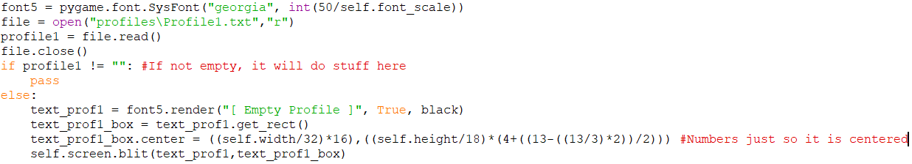

>>>

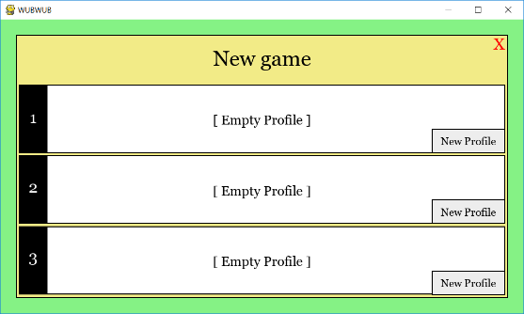

When the player clicks new profile I want a prompt to come up for the player to chose their name, first I made the New Profile a menu changing button and then have the method take these parameters:



Since a new profile will need a new name, I started experimenting with keyboard inputs but this time it being continuous as I want the user to be able to leave the menu whenever so this time instead of “pygame.event.wait()” I used “pygame.event.get()” and using print statements to determine what the function did to inputs and such:



A-Z is ascii 97-122 and is not effected by capitals.

When letter is capital, “mod” is equal to 8192, else is zero.

A space is ascii 32 which I want to include.

So I came up with this:

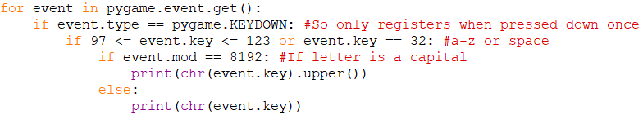

And that prints the select inputs that I want, so I’m moving it to my main program. I used a **stack**for the user entering their desired character name as it is the most appropriate data structure for this kind of input. Along with the above code I added this:

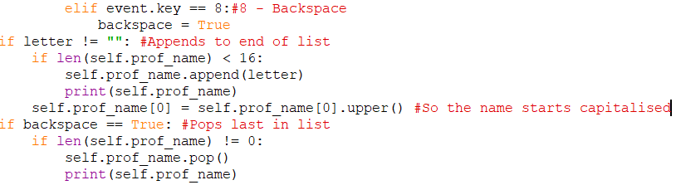

But I ran into a problem where inputs where very slow (I used these print statements to find this out). This was because the game was looping through many of my functions just to get to this section of code to take an input therefore it would skip a lot of inputs so to avoid this I made this section of code a loop so for the time the user was on this page, only this function in the code was run repeatedly which fixed my problem but made another problem. Since my program was only staying in this loop it meant that the parameters “mouse_pos” and “click1” never updated so I had to update these within the loop as well to make sure the user was not stuck in this menu. But when I tried to call the same function that I already used to map click1, I had the same kind of delay. I realised that the missed inputs only happen when the program is trying to take an input in 2 different places simultaneously so I used the same event function in this loop to determine click1 and I set mouse_pos to what it is with the pygame function.

So, I have made sure this input only takes:

* Letters A-Z for character name (Append to letters list)
* Space for character name (Append to letters list)
* Backspace to take away letters on name (Pop last letter in list)
* Click (To see if the user is clicking on the screen)
* Mouse position (To see if it is above the “X” or the confirm button that I will add later)

So, this input cannot be exploited as it does not take any other kind of input. Now I want the program to display the list as letters typed on the screen, so I made a procedure for that:

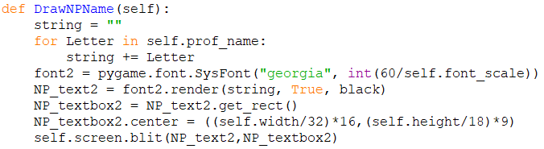

>>>

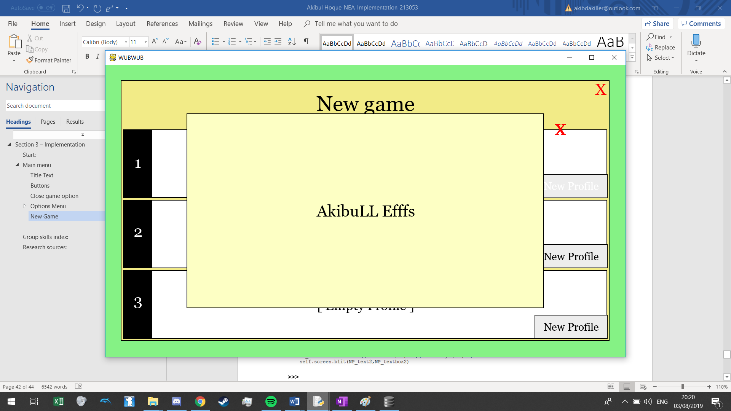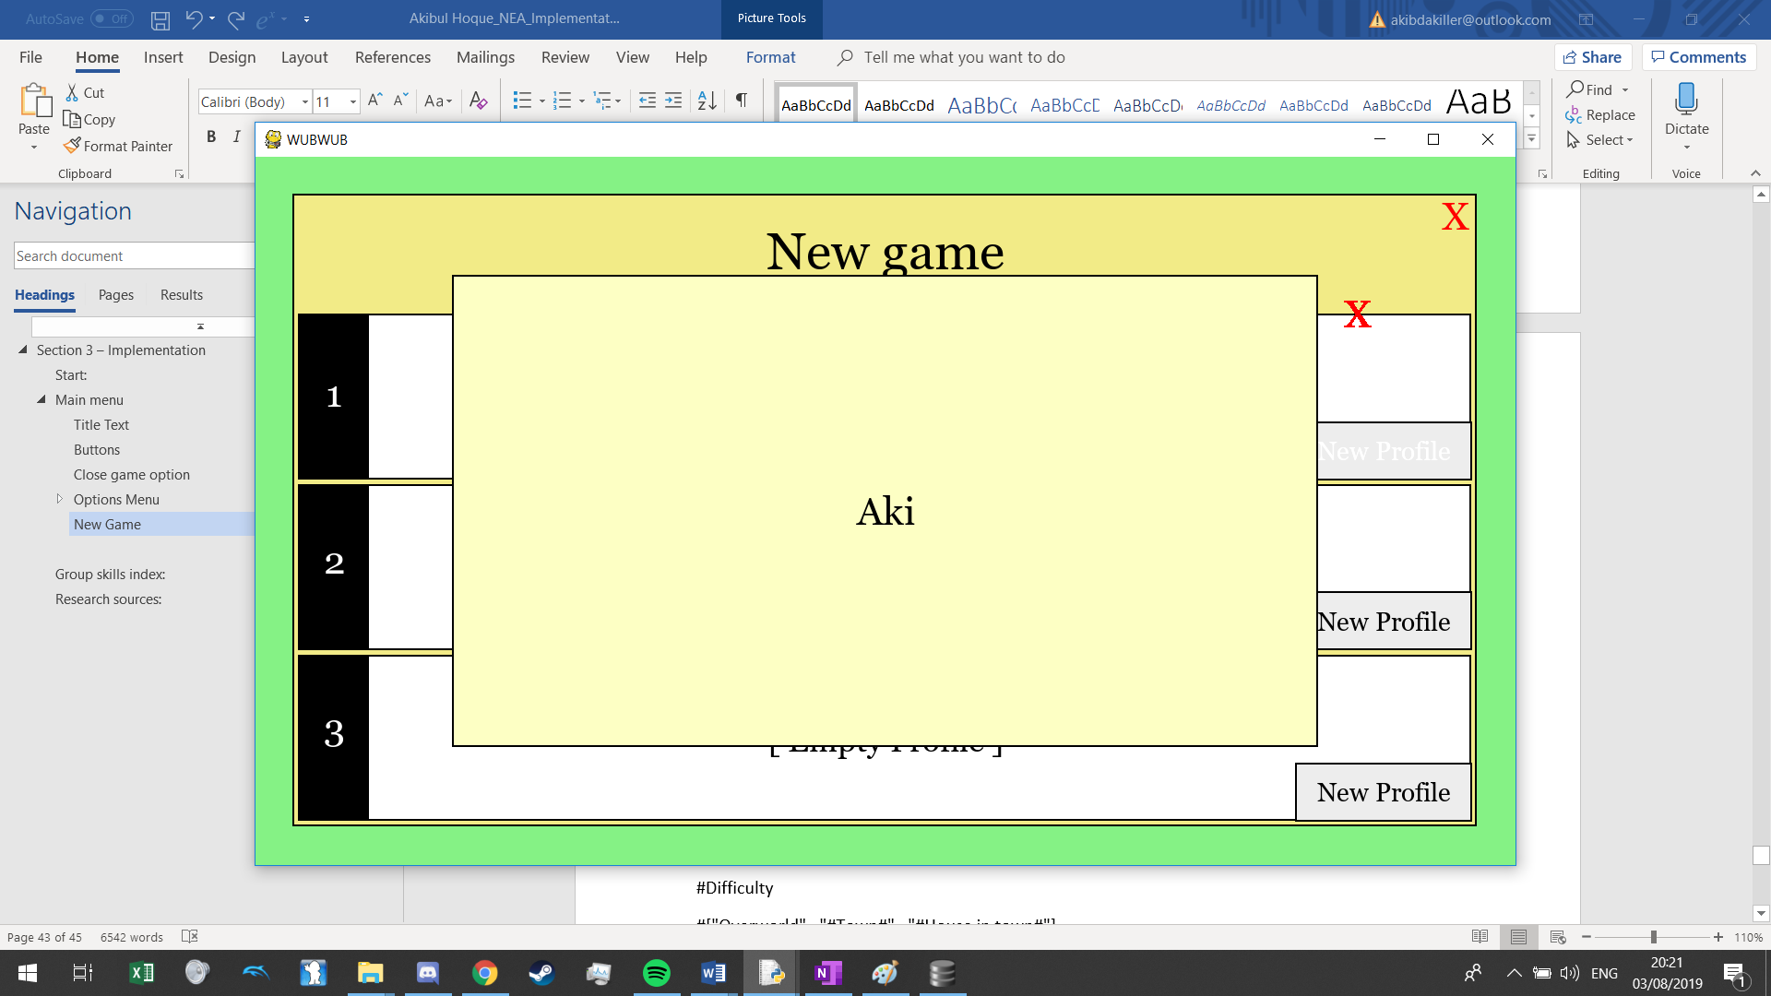

I cleaned this up and adding a confirmation button, which when clicked with a name (Of length 1 or more) starts a new profile:

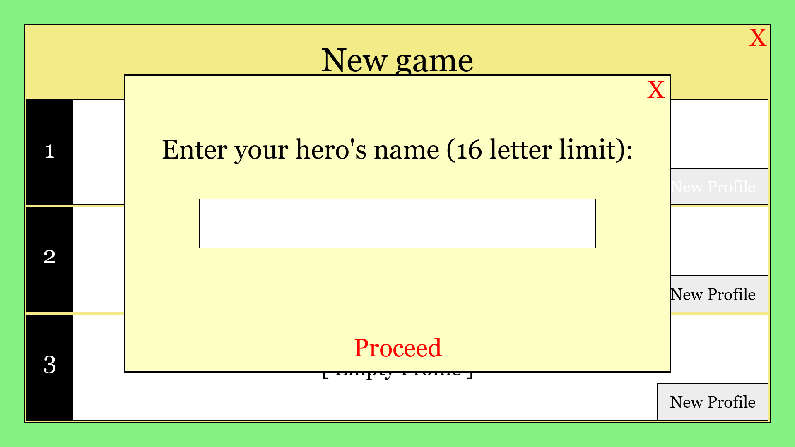

Before I make that proceed button functional, I must make my game.

## Game

First, I want a main game class to keep track of everything from player progress to the time stamp. I want this central class so that when I want to save a player’s data to a file, all the attributes that are needed to record progress would be attributes of this class. Before I create this class, I must make a list of everything that constitutes a user’s playthrough and everything necessary for a game to be loaded based on some variables saved to a file:

The main being:

* Timecode **FLOAT**
* Character Name **STR**
* Stack for location – So if the user is in a house it is effectively [“Overworld”,”#Town Name”,”#House name#”] **LIST OF INT (Used with dictionary)**
* X and Y position **FLOAT**
* Level **INT**
* Exp **INT**
* Skill points along with strength, resilience and speed **INTS**
* Items obtained **DICTONARY**
  + Amount of bombs and arrows **DICTIONARY**
* Events triggered (Such as main cutscenes or talking to important people) **LIST OF INT (Used as dictionary in program but stored as list)**
* Bosses beat **LIST OF INT (Used with dictionary in program but stored as list)**

Other necessary parameters:

* Which save profile

When starting a new profile I essentially want the player to load a game but with all the default values and also to start off on a cutscene trigger, so if the program detects that the list of events triggered is empty then it should play the start cutscene.

Here is the beginning of the game class:

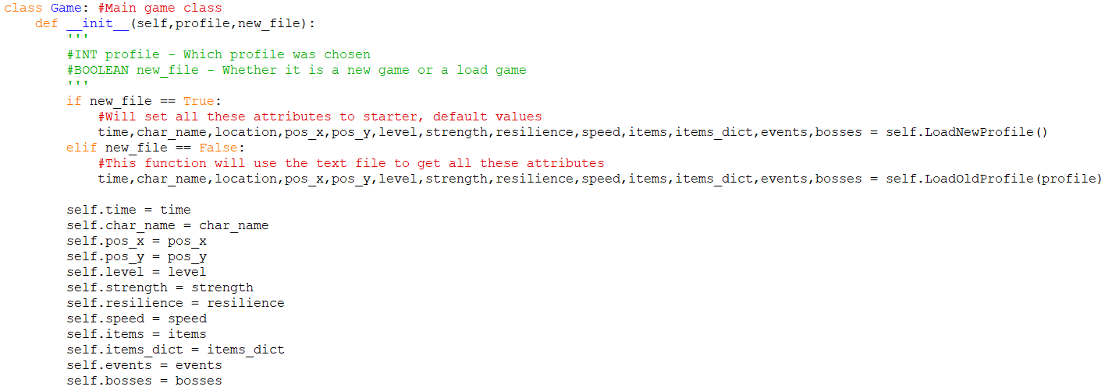

Then I need a static dictionary to convert locations to a number because when I create a level, I don’t want the name of the level to be affiliated with (On) the text file in case of changes and so the files are organised in chronological order rather than alphabetical:

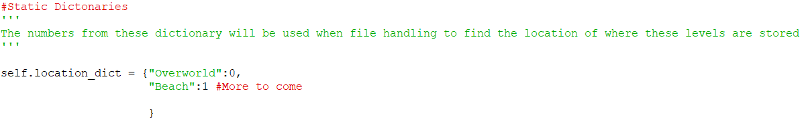

I have written down my story and so right now the player starts on a beach, but I will focus more on this when I have a running game engine.

I made the “LoadNewProfile” method with these values as defaults:

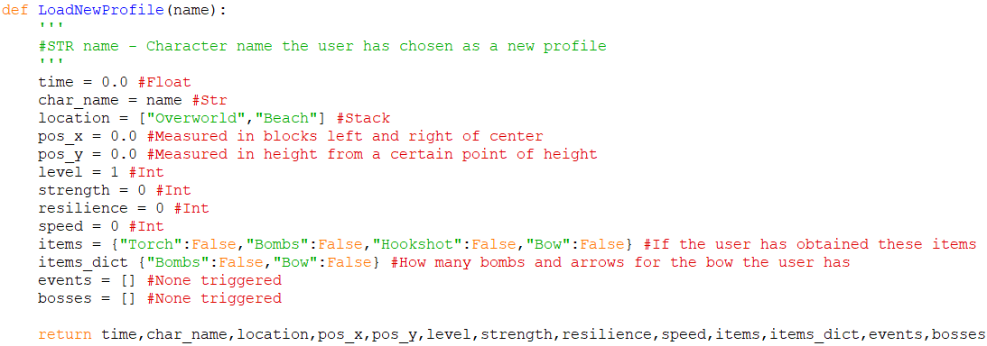

Before I can implement a lot of this I need to make my levels, and since one of my design objectives is to create a level creator/editor, that is my next step currently:

### Level creator/editor

#### Blocks

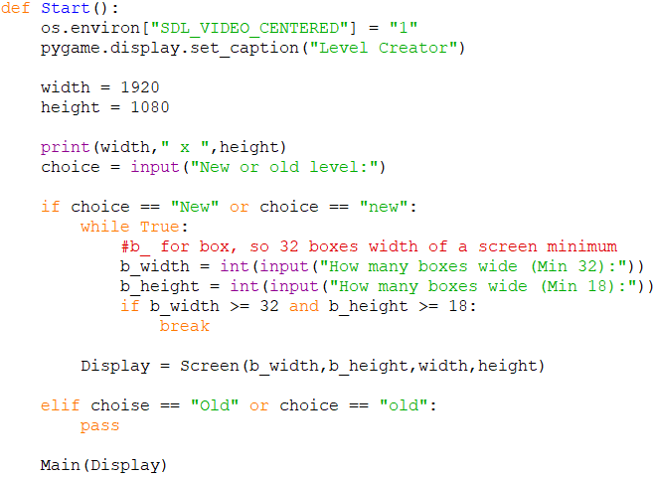

I want to make each wall an object but declaring each wall an object manually seems too far fetched so I went researching to see if there was an easier way to do such a thing. My teacher had given me a resource that seems to help in this regard (**Research source**). How it is done in this program is that an empty list is created called “walls”, and in a list representing the walls of a level is iterated through to pick each wall, and when the x and y is determined for that wall, the wall class is called and in the class, the object appends itself to the list:

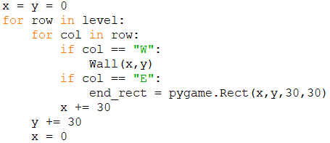

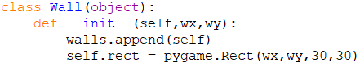

And when drawn, a rectangle is drawn using the self.rect (wall.rect as it is outside of the class).

This kind of drawing could suit my game, but I need to alter this method a little as I want to be able to scroll offscreen if the player moves that far. This means I need **2 types of variable for position** of a wall, one being a **hypothetical position** related to the box length such as if the x is 0, it would be in the centre of the screen and if x is 16 (32 box width/2 as on one edge of the screen), then the box is at the end of the screen while the other variable is the **actual** pixel where it is drawn on the screen as an x of 0 would be on the very left and this variable would be entirely determined on the previous variable.

First, I made a function to create a new text file and return the name of that new file:

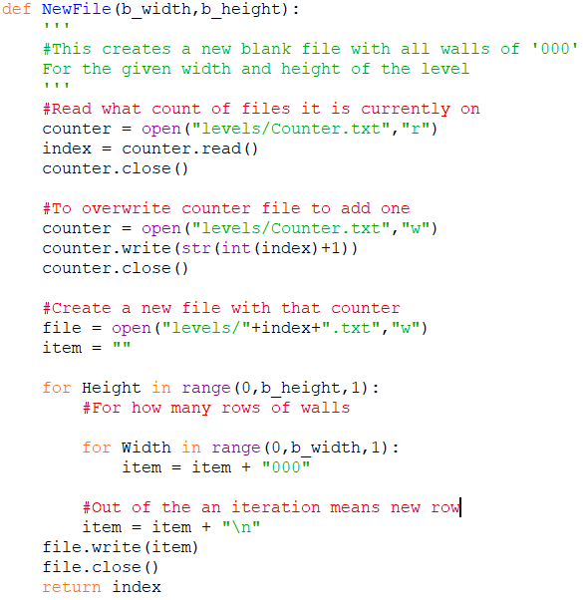

An empty “Sky” block (File name)

File with 32 sets of “000” across and 18 lines down and named:

This is what I will link to my static dictionary in my main program as 1 will be “Beach”.

Then I created another function that returns the width and height of an existing file and is only called if the file exists:

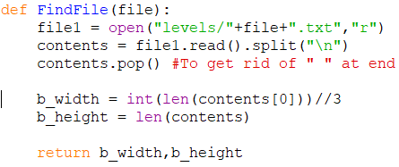

+

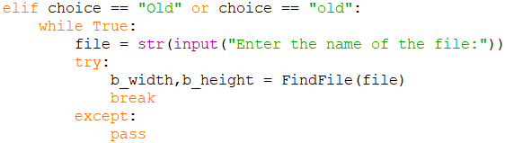

Then I created a class for my screen:

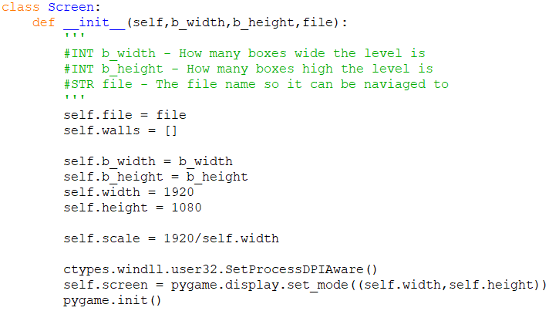

The purpose of this class will be to hold all the methods to draw the screen on so that’s where I started. Before I can create a procedure to draw all the blocks, I need 2 functions to help the procedure to both import the data of the locations of the walls and which blocks as well as one function to get the actual image file to help blit it to the screen:

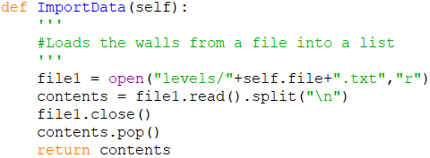

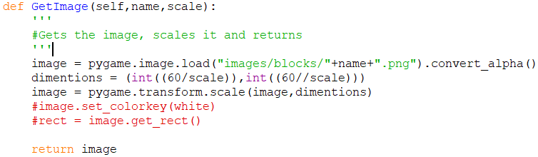

With these I then made the “DrawScreen” procedure, similar in structure to the one I researched but adapted so that instead of rectangles being drawn to the screen, it is instead images that have been scaled according to the resolution scaling:

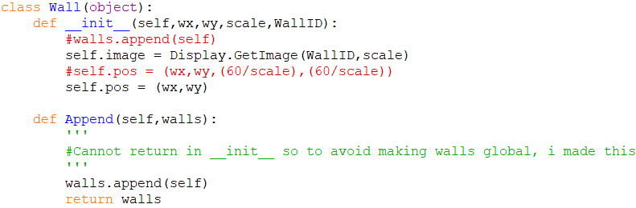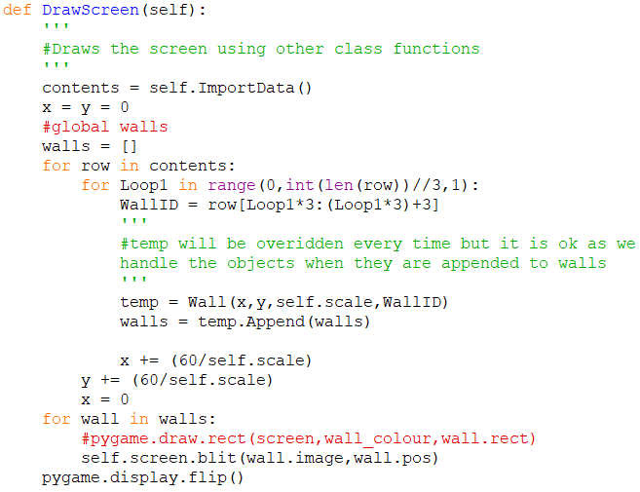

I adapted the wall class to instead have the image and the position as attributes as that is what drawing an image needs.

The code above is an example of **Dynamic generation of objects**.

Now if I run the program and input these:

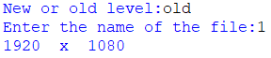

I get this drawn to the pygame screen (Not in Fullscreen):



This is good as the file is currently only occupied with one repeated block so I decided to go into the text file and change around a couple of blocks to see if the screen would change:

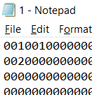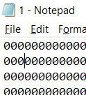

With my image file looking like:

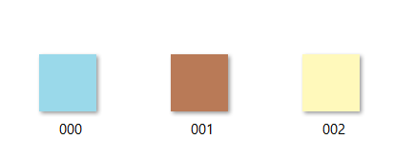

Running the program this is what I got:

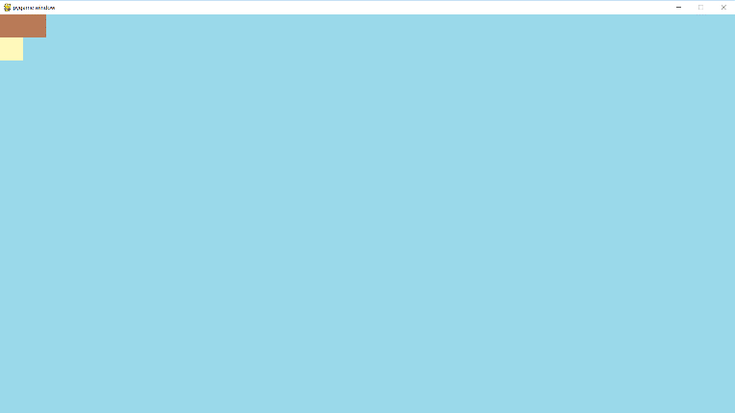

Checking how this works when scaling I tested out all my resolutions and came across this:

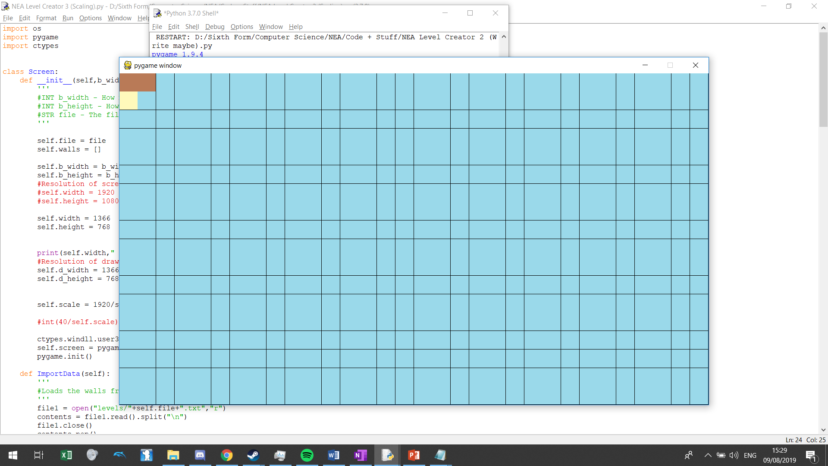

This happened when I made the resolution of my game 1366 x 768. I tested out the program for my even lower resolutions but did not have the same program. I realised that this was happening because scaling my blocks did **not allow for a float value** and since I turned them into integers, sometimes the difference was off by a couple of pixels as this resolution does not comply as a 16:9 resolution, so this means that I will **scrap this resolution all together** as this incompatibility will make a lot of the things in my program not look good.

The last part of the reading portion of this program is to incorporate scrolling to the editor as I am going to have levels longer than one screen. First left and right scrolling and I made a diagram to help understand how to do this:

Hidden level

Displayed screen

Centre: 16

48

32

0

But if we scroll:

Displayed screen

Hidden level

48

0

16

Centre: 32

Before when we didn’t have scrolling, the program just read from indexes 0-31 (32 walls) from the text file, but here we have indexes 0-47 (48 walls) and can only show 32 on the screen. Looking at my program, the centre shifts by 16 from one end of the screen to the other (48 minus 32), so when generating the level onto my pygame screen, I can change the way the indexes are read so that when centre = 16, then I add nothing to the indexes so the first 32 walls are read but when I scroll to the end and centre is 32, I add 16 to the indexes so the first wall that is read would be the 16th wall and that would be on the far left of the screen. I did this in my program but cut out a step by making centre 0-16 (for 48 walls) so I can use that number immediately:



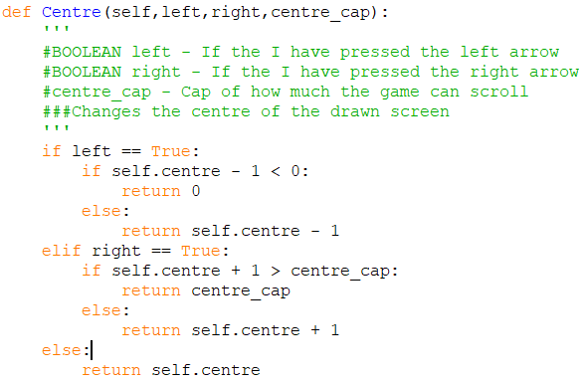

And then I have changed this part of my code to:



I tested this on a file with 48 width, and the scrolling works. Note that I cannot have this sort of rendering the walls in my actual game as this will not take float values to draw something like half a block if the player is on half a block as a wall on this program is either fully shown or not shown at all. Now I also need to be able so scroll up and down using the same concepts.

Now that I’ve got the read part of this program correct, I have to alter the program for the writing to element. One way to fit other buttons without obscuring the screen is to have the walls drawn on a smaller resolution while the pygame screen is on a bigger resolution:

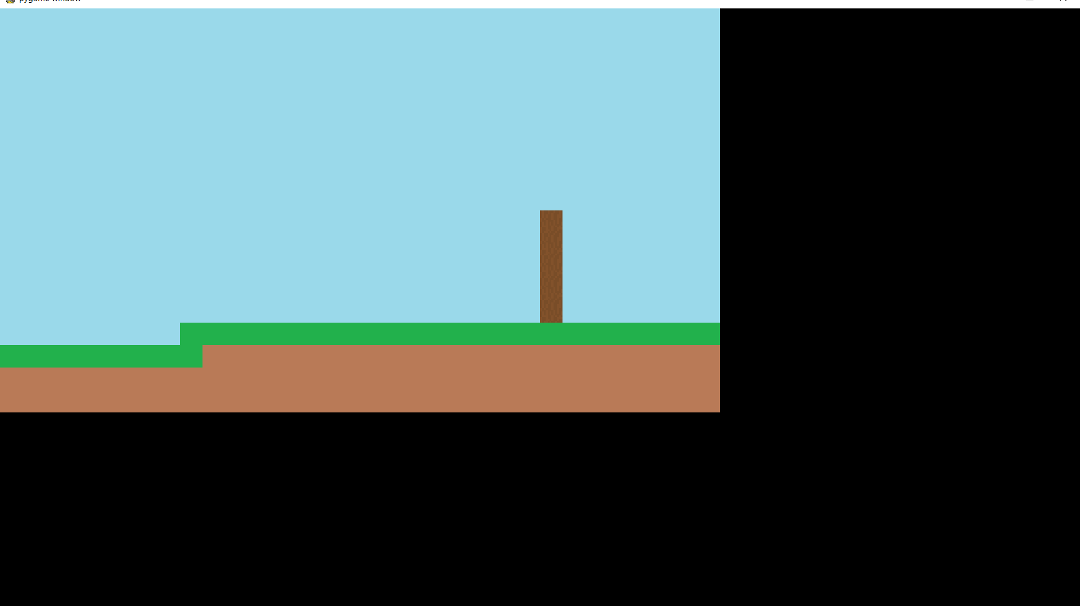

I can put options in the black space on how I want to edit my level now, such as changing blocks that I am drawing with, etc. Since the program draws on the screen by continually reading the text file for a certain level, how we will be editing levels is by each change altering the text file directly and that in turn changing what is drawn on the screen. This means each change to a level will be permanent unless it is re-drawn which is ok in my project as there is not a big setback for making one error.

I want the first buttons in the black space to be the other blocks that I have drawn and placed in the blocks folder. I realised that this can be done similarly to the techniques of the “Wall” class I had just learned, in terms of using a list to hold all the objects as the criteria to be able to do this are met:

* I have a method to use iteration to get each of the identifiers (as my file names are 000,001,002, etc.
* They will be drawn on the screen in the same way
* I want each to be an object so I can have functions to interact with each object

This is how I started it, with the most alteration being adding “IsOver”:

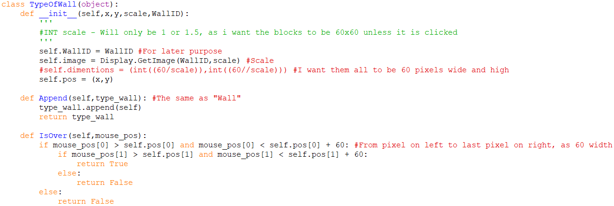

Along with this I had to also make a method in “Screen” similar to “DrawScreen”. The two methods are very similar:

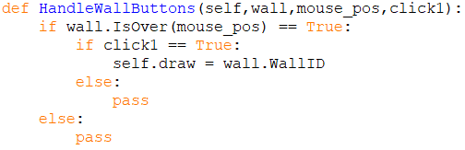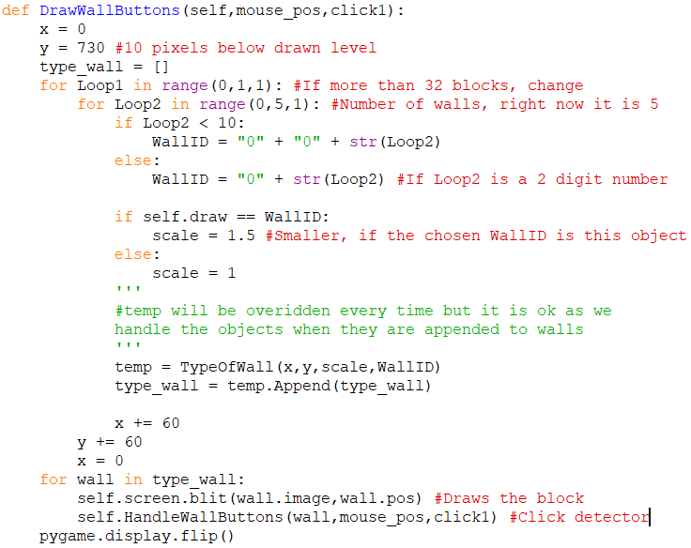

This part configures “WallID” to the for-loop variable so that every single block can be instantiated.

Not 60/scale, as I want all blocks to be 60x60.

Now when I launch my pygame I get this (whilst printing “self.draw”, and clicking the buttons):

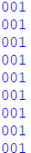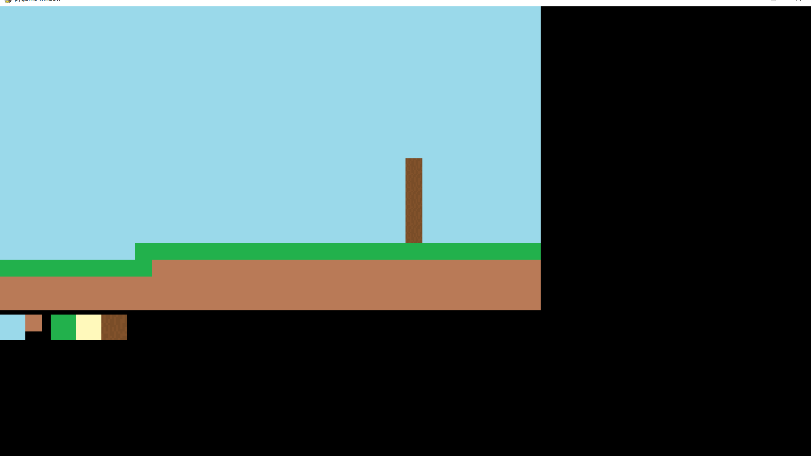

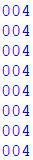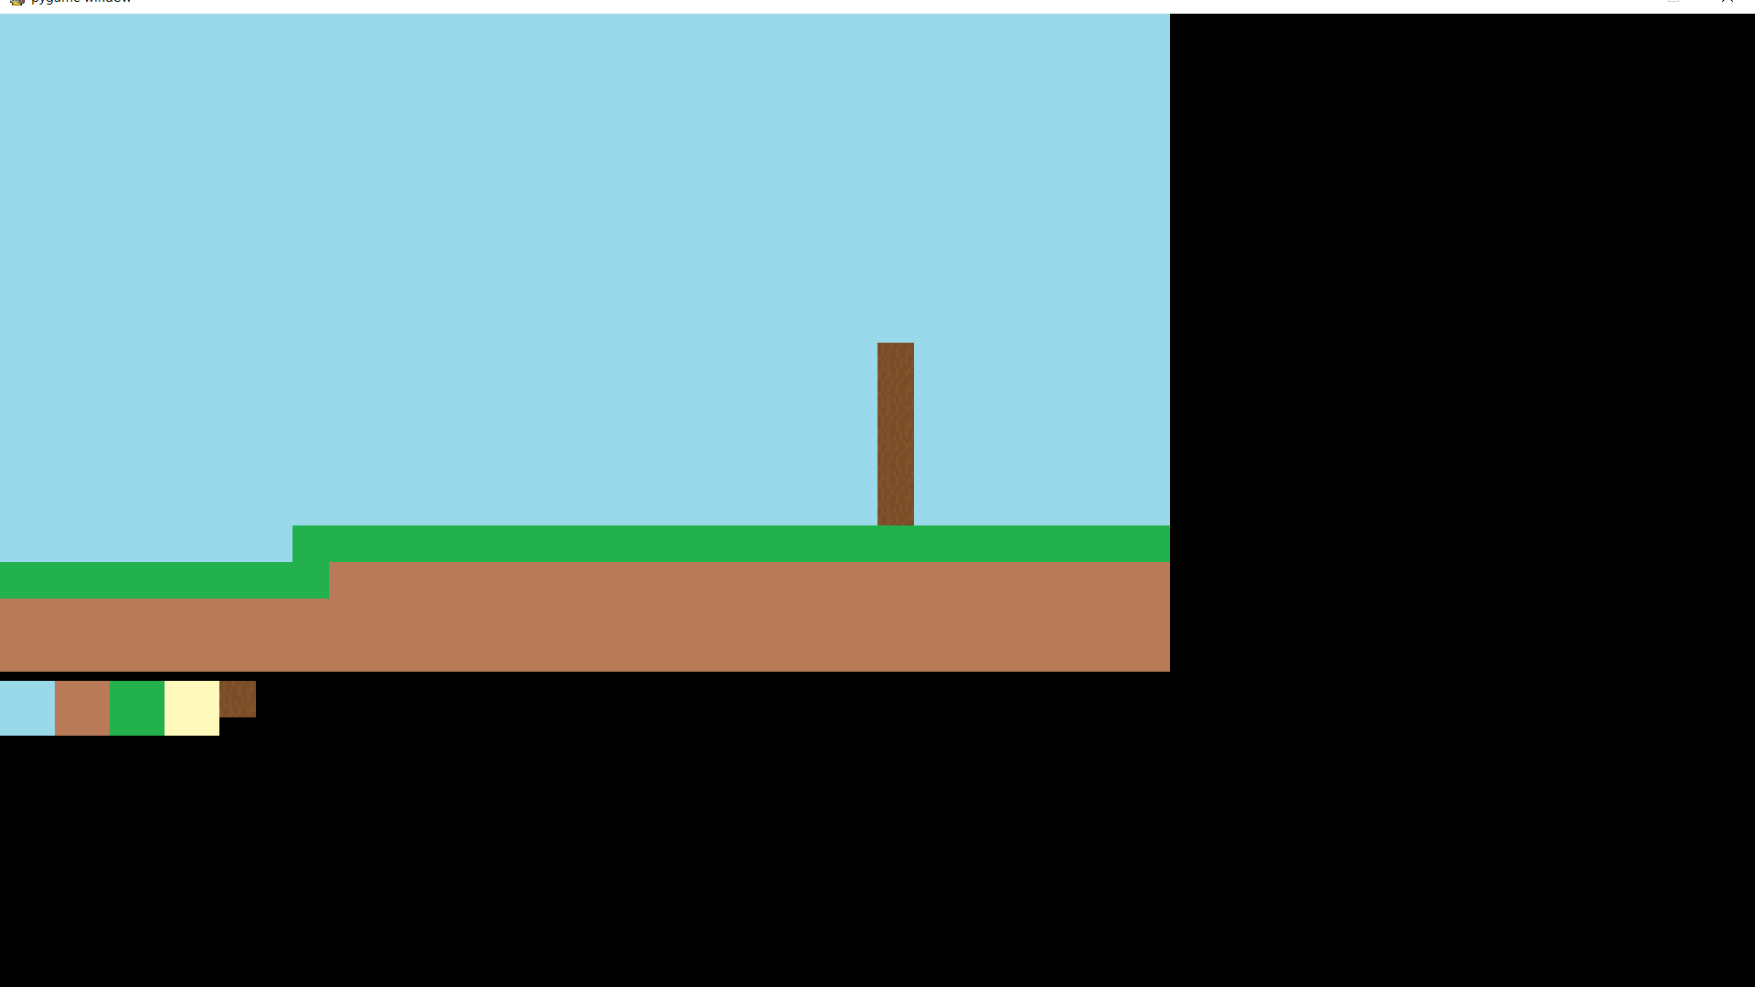

Now that the program knows what to draw (using self.draw) when I want to click a block, I need to have the actual block change when it is clicked. For this I can just add “IsOver” to the class of “Wall” so that it has the same click detection and then work up from there:

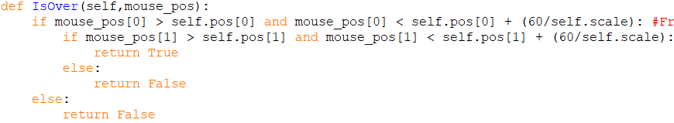

I need to store the index of the block:

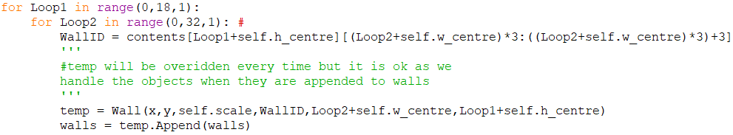

Then:

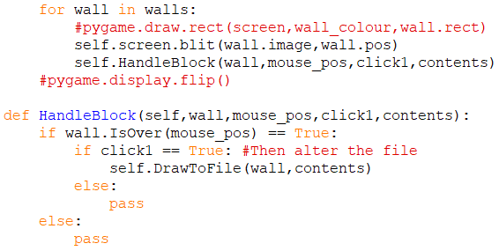

My text file imported to my python program is a 1D list, with each line being one item. This means that if I want to change something in the middle of a block of walls, I will need to do some string manipulation and so the way I have handled it is to first get the row that the desired block change is on and then make a temporary string where all the blocks before the wall is written to, then the code for the new block and then all of the blocks after the altered wall. This is then put back into the list of imported data from the text file and then the whole text file is re-written:

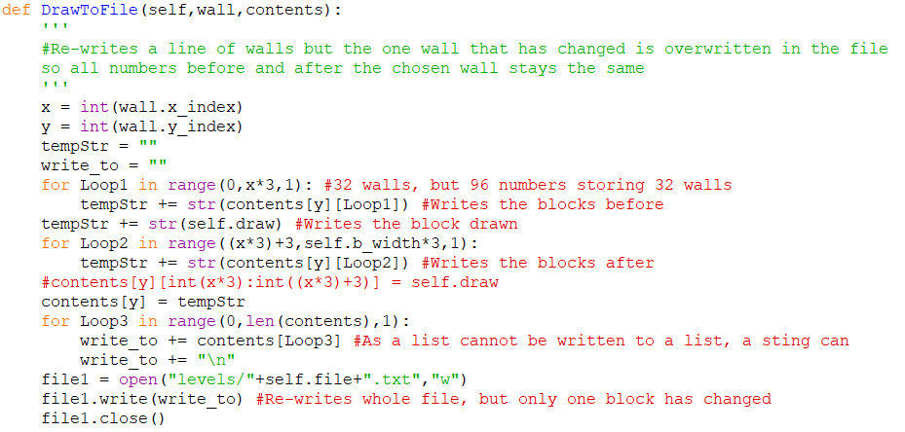

Now I can draw on the pygame prompt:

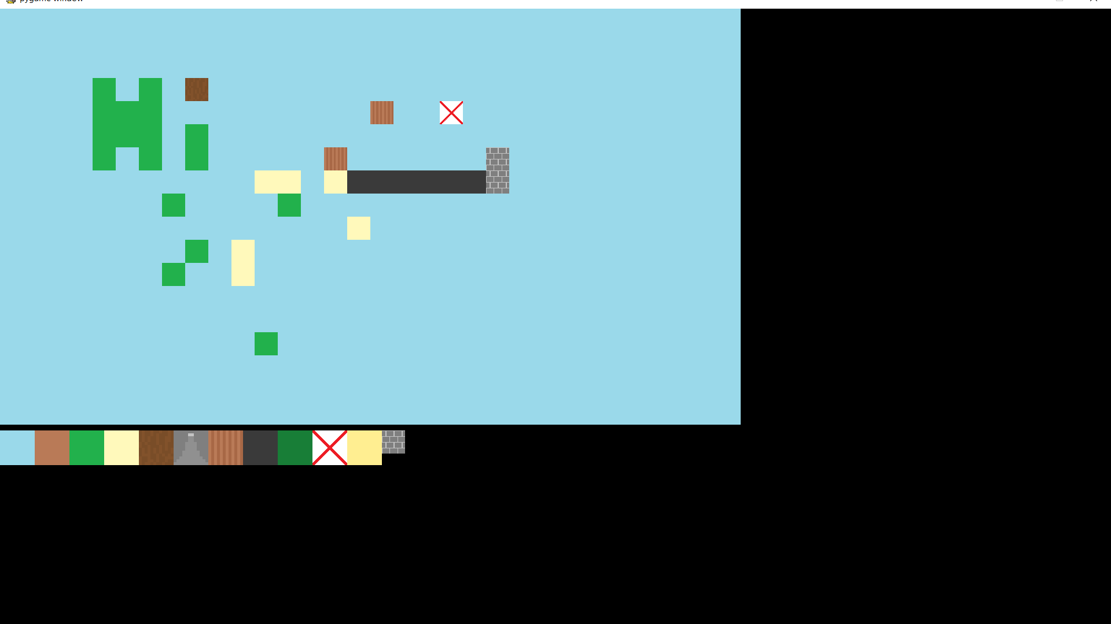

With this functional I now got to work on some of my levels.

Fast forwarding sometime of creation I got my first iteration of my overworld complete with a file that is 128 blocks by 128 blocks. This image is a bunch of screenshots sown together but is the whole map (the user will move block by block):

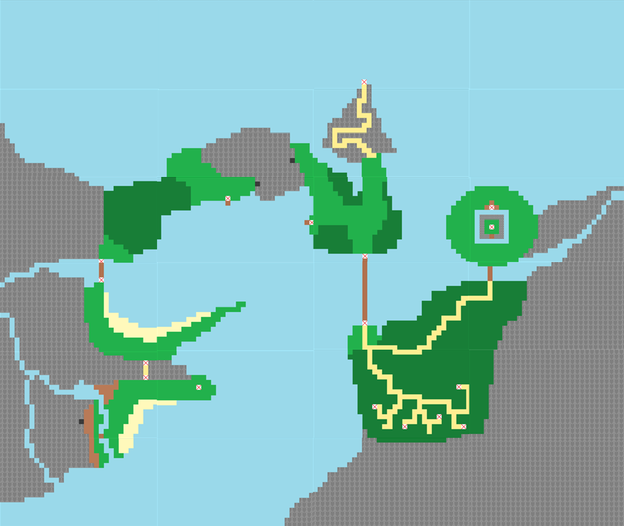

This is the final area and where the game ends.

The user start here in a new game

#### Background decoration

Before I start making my playing screen in my main program, I want to be able to add decorations to the level editor so I can add things to levels such as cacti, paintings, etc. (All uninteractable but helping the game look less bland).

This will handled **differently** than my level as in, instead of the text file storing every single block on the screen, it will just hold a set amount of items each corresponding to 1 decoration, so **5 lines in the file means there will be 5 decorations** in that level. For this I will set my program to ask at the start whether I want to open the level in block mode or in decoration mode and this is what the text file would look like:

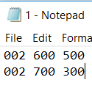

To interpret this data I split it into a 2D list split from line by line and then space by space:

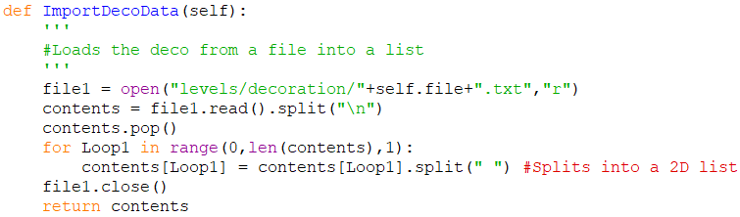

For this I also had a system of **dynamic object generation** similarly but this time instead of having a set amount of objects being generated (before it was 32 * 18), now it is dependant on how many lines there are in the text file that is linked to this level:

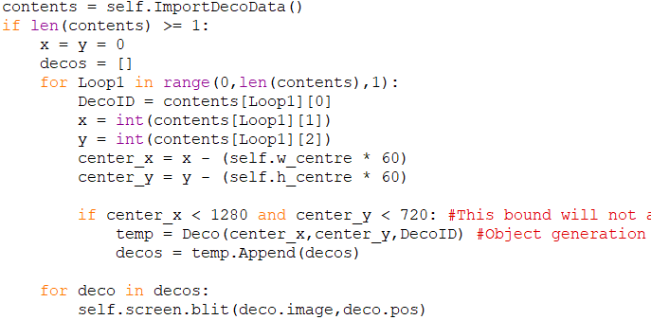

Loops for how many lines are in the text file (As contents is a 2D list split first by lines). Each iteration an object is created (then appended to a list using append(self) which is what the function Append() does.

A lot of rest of the coding was the same as the blocks other than what I have shown so I skipped documenting it. Now I can decorate my levels and add new images in my decorations folder, allowing for scrolling as well:

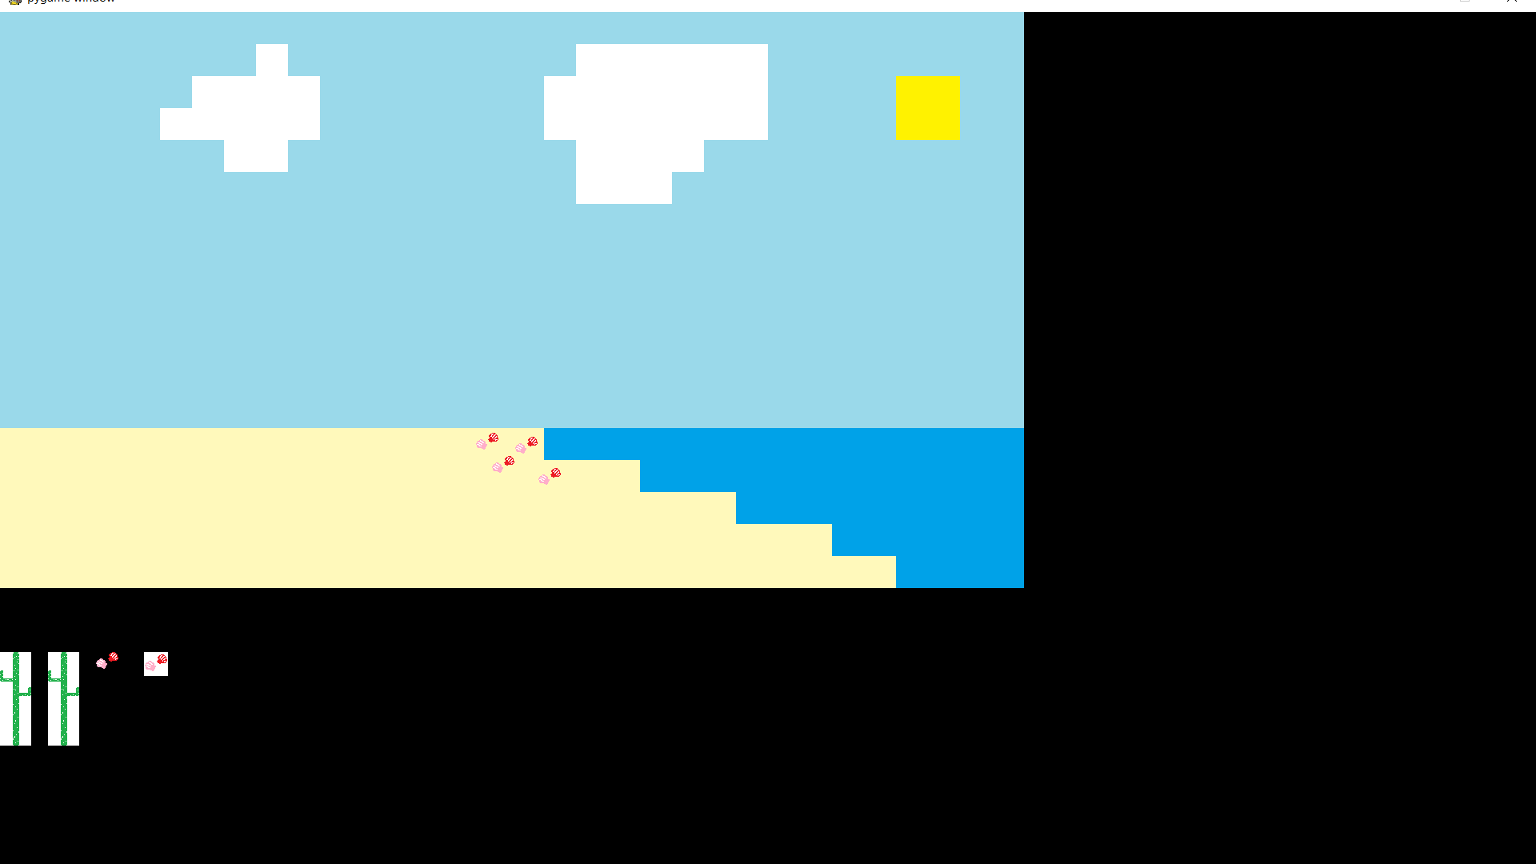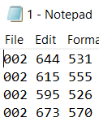

One final thing that my level editor would be able to do in the final version is to be able to add enemies in a similar way, but right now I feel I need to add the initial functionality of the game with the main player before I work on that.

### Main (in) game loop

The main loop will contain a lot of things so listing them would be appropriate:

* Draw Blocks and Decoration
* Draw Interactables (Doors, signs, etc)
* Draw Enemies > Enemy class
  + + Draw their projectiles
* Draw Player > Player class
  + + Draw their projectiles
* EventGet() – Different than current method to accommodate all inputs
* IF ACTUAL VALUE Relate that input event to the SQL file with all controls
* Player – Move Command
* Player – Collision Check
  + Collide with walls?
  + Collide with enemies?
  + Collide with projectiles?
* Player Shield Collision
  + If that collided with the potential damage
  + Player can’t move while using shield
* Player – Attack/item
  + Stops to use sword, can use mid-air though
  + Can move while using certain items
* Player Attack – Collision
  + Pushes user and enemy back if hit (and mid air)
* Player – Interact (Change event variable or level)
* Player – Actual move command (If passed all checks, highlighted in red)
  + Finish move count, jump count, keep velocity if already moving in air
  + Left, right, jump
  + Knockback if hit
* Player – Animation

Iterative structure, so all enemies on a screen are done.

* Enemy – Movement
* Enemy – Projectiles
* Enemy – Animation
* Clock tick (60 FPS cap hopefully)

I can use this like a checklist, first I will start with my event getting so the program will respond when I run it. My event get will act as a detection for whatever key is being pressed and held down right now for each frame and if nothing is pressed down then it will return None. I made this on a separate file and here is what I came up with:

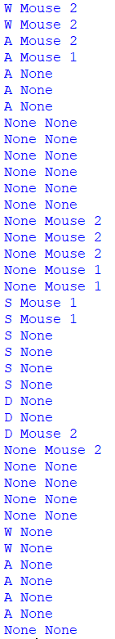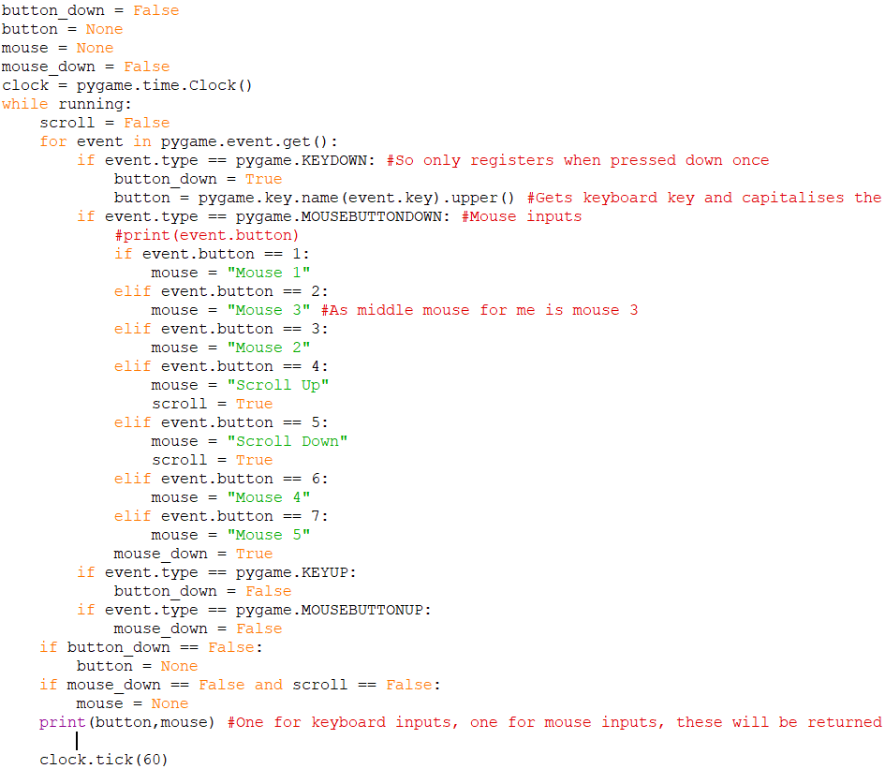

This can be one method inside the main game loop. I created a timer as this will be stored in a save file:

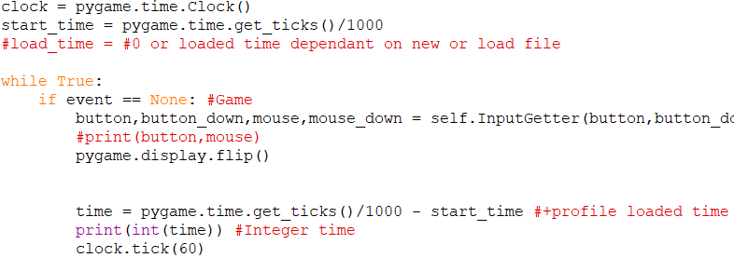

> Time elapsed from the profile being booted up

#### Camera

I added the class of walls and the method to draw the walls to the screen. I metioned before that my walls had to be drawn differently and so I got to work. The issue was that I only had 1 x and y variable which was just the place on the screen to draw, but if I want a player on the screen I actually need 3 x and y values:

1. Hypothetical Player x,y
   1. Bounds from 0 to bound of level (1920 for 32 block level, 3840 for 64 block level)
   2. Not affected by scale as nothing is directly drawn from this, but the other center x and y values are instead calculated from this with scale
2. Center Camera x,y
   1. Used to calculate where the walls are drawn
   2. Bounds from 960/scale to (bound of lvl/scale) minus (960/scale)
      1. Diagram for when a level is 64 blocks wide:

Displayed screen end

Displayed screen start

3840/scale

960/scale

0

This is always half of the screen

(3840/scale)-(960/scale)

1. Screen player positon x,y
   1. Bounds 0 to 1920/scale
   2. This is where the player is drawn on the screen, when the player is not at the start or the end of the level he will be constantly drawn in the middle but when at the end of a level he will be able to walk to the end of the screen to proceed levels

In my program:

* Pos_x and pos_y = Hypothetical player x,y (Will be value that is stored to save profile)
* Player_x and player_y = Player position
* Center_x and center_y = Center camera

For my center_x and y instead of the lowest bound being 960/scale, I realised it is instead 0 as how it works is this value is added to a wall’s initial x value so if the screen has not scrolled, the x value of the first wall is 0 but if the screen has scrolled (and center camera is more than 0) then the first wall would have it’s x value minused by the center camera leaving a negative value so it would be drawn offscreen and not visible. To achieve this, this is what I made:

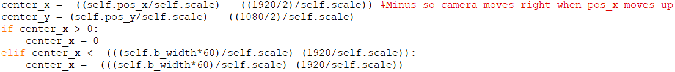

I used this variable to draw each wall:

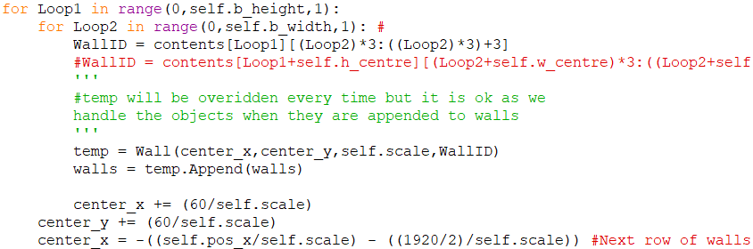

Then to help keep track of the camera and if it is doing the correct thing, I made the player’s hitbox and made it visible just so we can see what the camera should be doing (In “PlayerClass”):

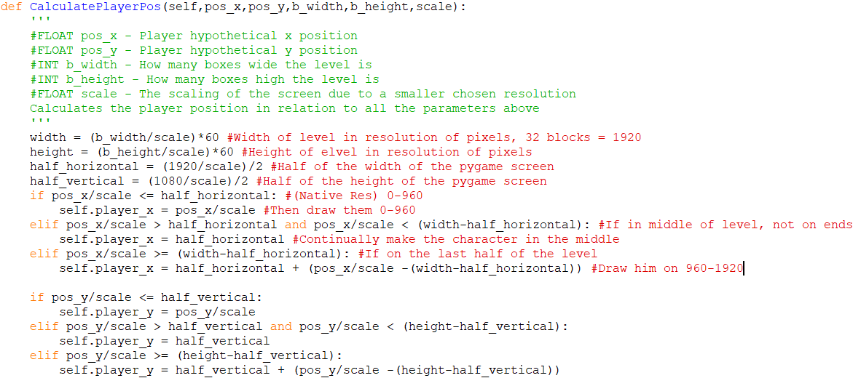

Then just draw a rectangle to the screen:



>>>

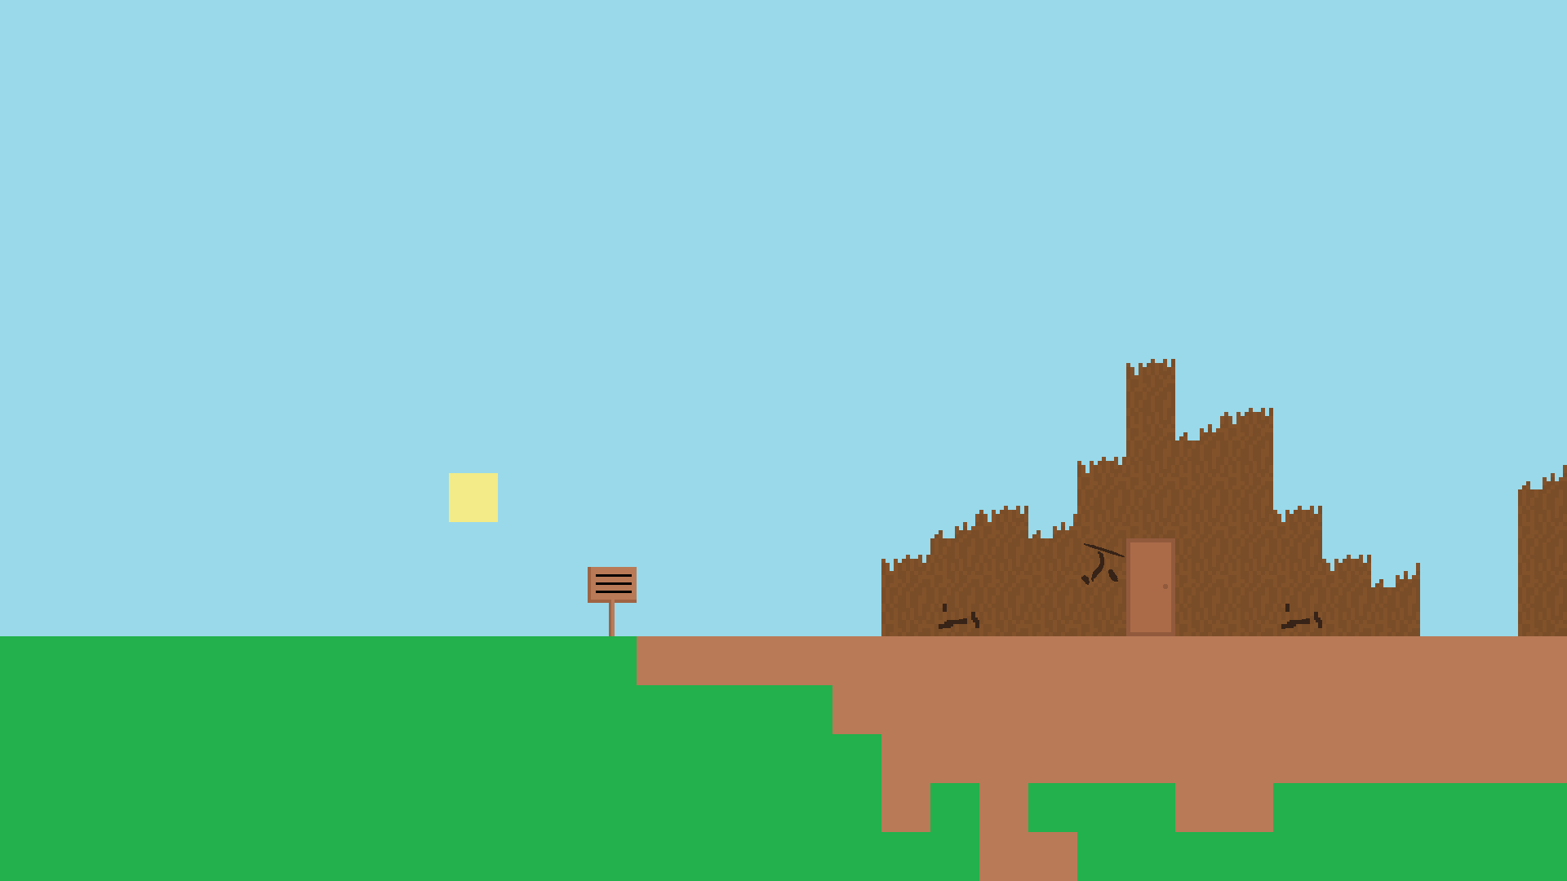 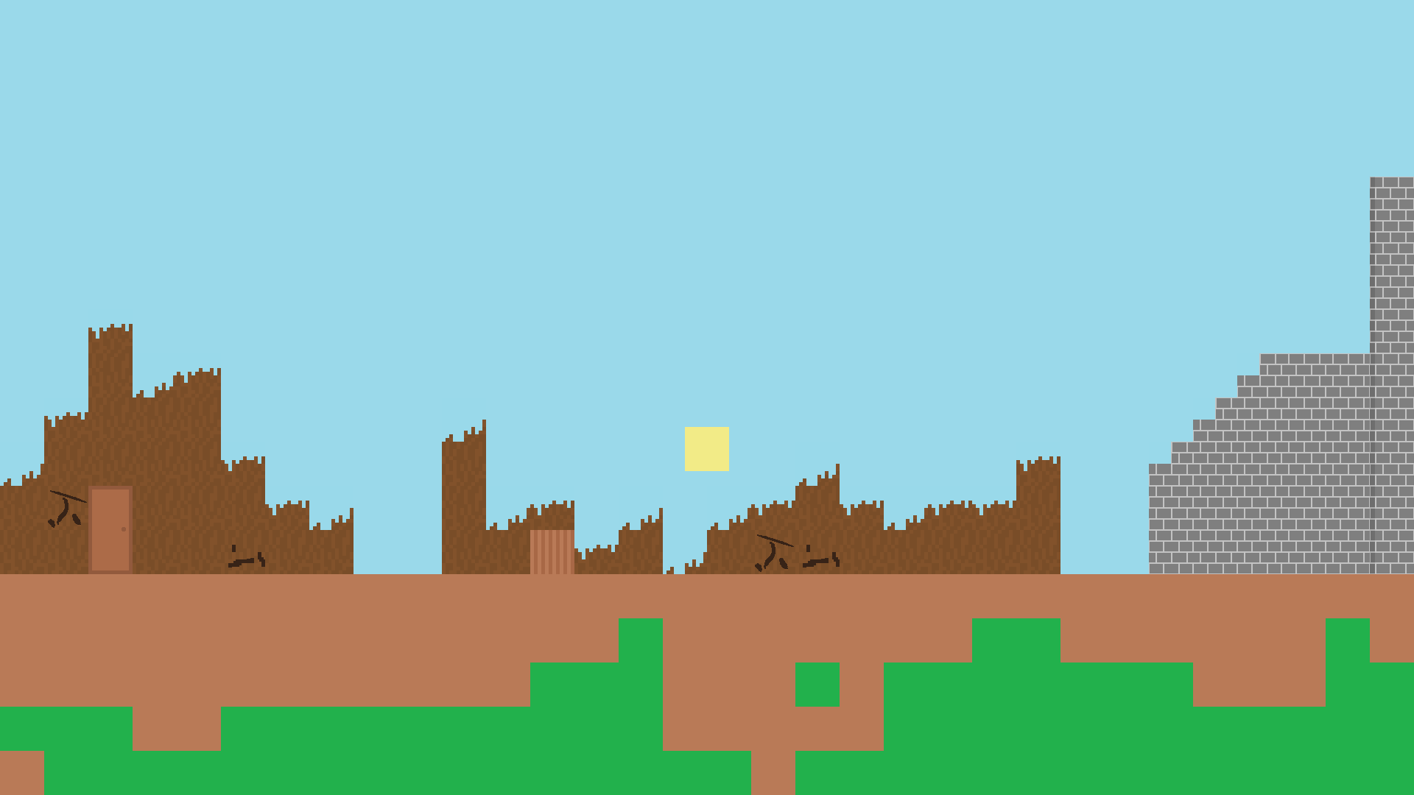

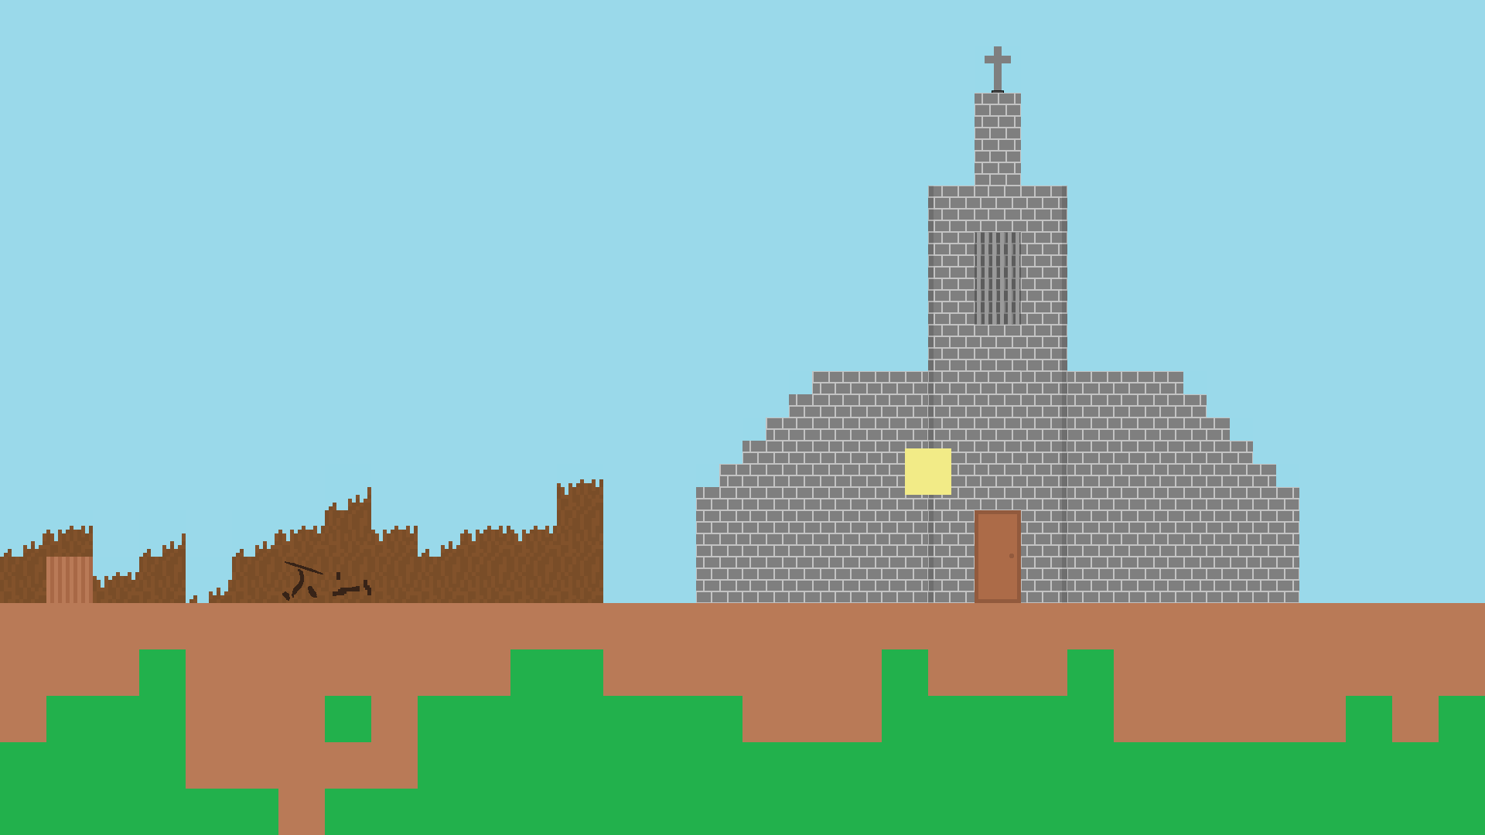 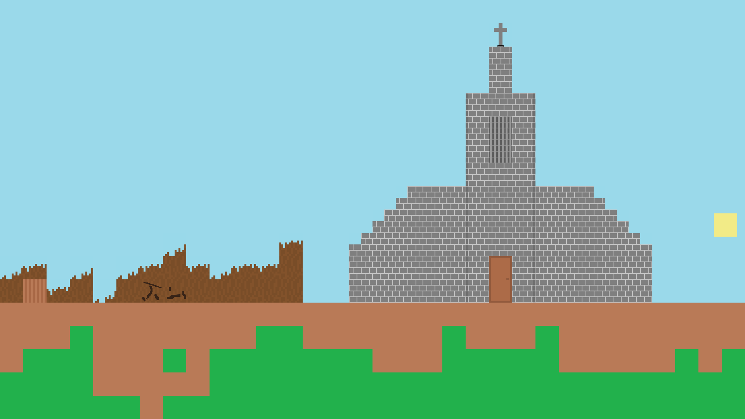

Now when I try to add the code to draw in decorations, the decorations are floating as such:

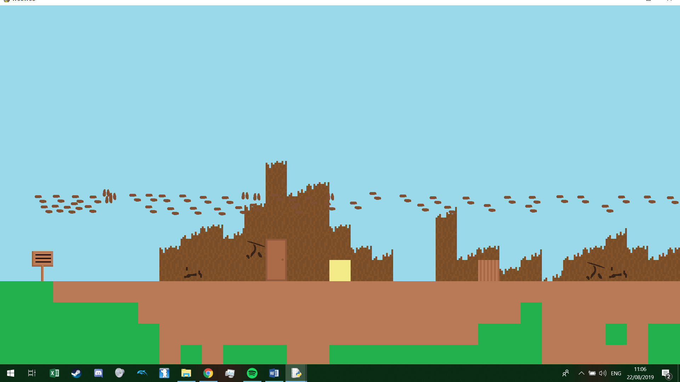

I realised this happened because when I was drawing them to the file, the x and y coordinates written were actually the position of those on the 1280x720 screen rather than using the hypothetical x and y position. So to fix this I had to go back to my level creator. I had to add calculations so that the value in the text file is one that could be scaled, and since the drawing canvas in my level editor was already scaled by 1.5 of native resolution, I had to draw the value of the inverse of that value (1/1.5) so that the new x and y position could be scaled properly:



Then I had to make sure that when they were drawn that they were divided by scale in both my main file and my level creator.

#### Processing speed improvement

Testing out my smaller levels lead to ok results in terms of performance but once I tried to run my game on my overworld screen it was apparent that the game was too slow, it took on average 3 seconds for the program to register 1 frame and this was because what my program was doing was loading the entire level and then continually mapping every wall to the screen even if it was off of the screen, and this was made even slower because to draw each wall, the program read the png file for that each and every wall for each and every frame the program wanted to draw it. So to enhance performance I did these things:

* The contents of a level was only loaded when you entered a level:

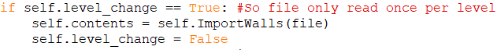

* Instead of looking to the png file every time, I created a dictionary containing every image and it would load every image once into it at the start of the game:

Before (Continually opened):

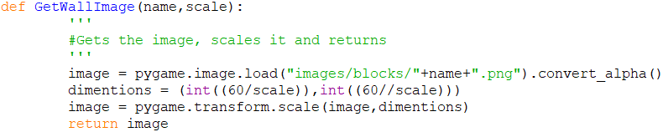

After:

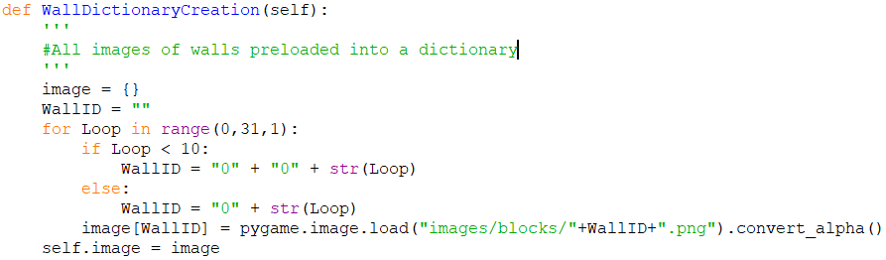

* 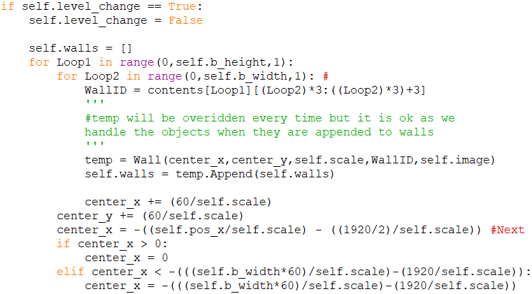Currently the screen re-instantiates the walls of a level every frame, what I could do is instead have the attributes in each object be changed instead of all overwritten:

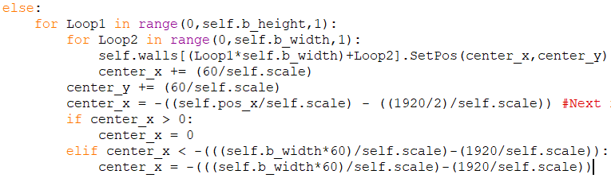

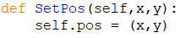

Else simply changes its (x,y) as:

Instantiates if the level has change:

* My overworld will be drawn differently to any other level, where only blocks close will be rendered such as if screen is 32x18, then walls will be drawn 34x20 with 1 wall of screen on each side:

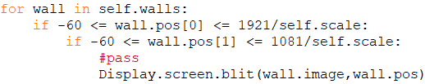

Now my game runs on 60 fps (Note printing each frame does slow the program down by a lot so without printing, then the program would be 60 frames):

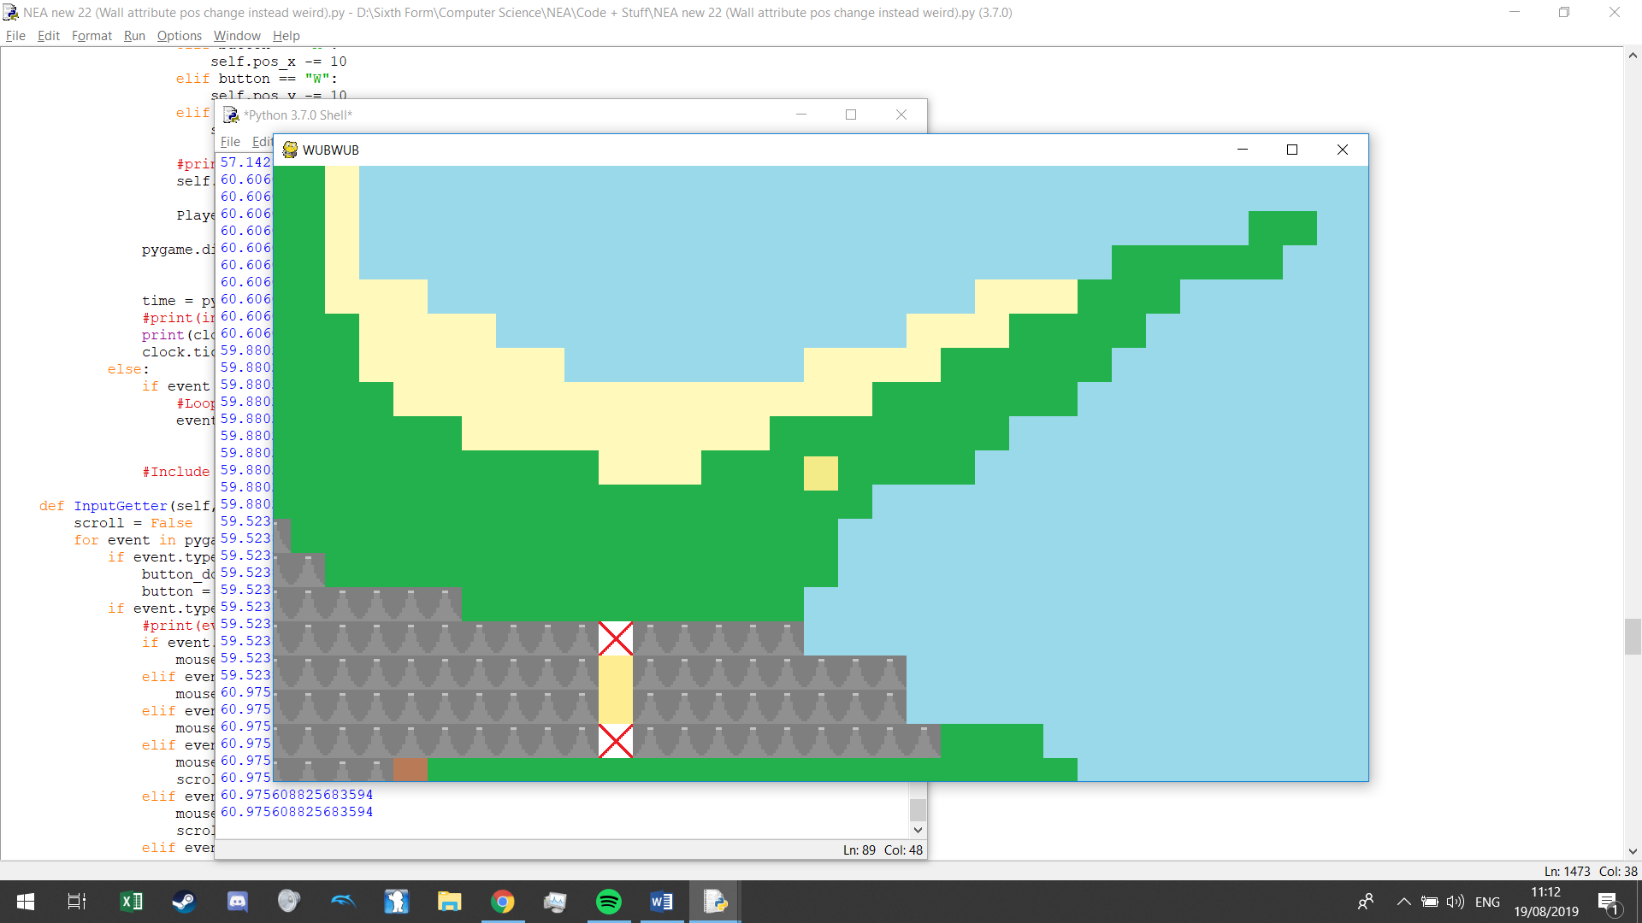

I also did the above performance fixes for drawing my decorations as well.

#### Basic player movement

I started by making a collision dictionary to contain booleans of all 4 directions and whether the player is touching a wall or not.



I started by making a new method to relay inputs to the controls database. But since I don’t want to keep reading from external files I once again made a dictionary out of this:

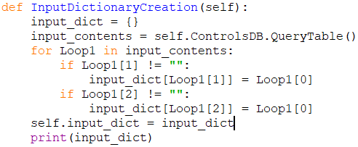

Now a button corresponds to one action:



Then I turned the user input into a command:

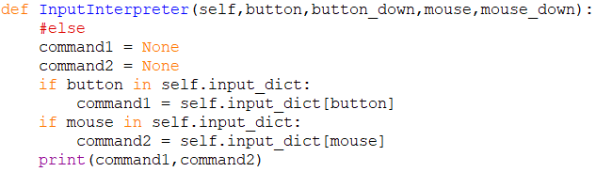

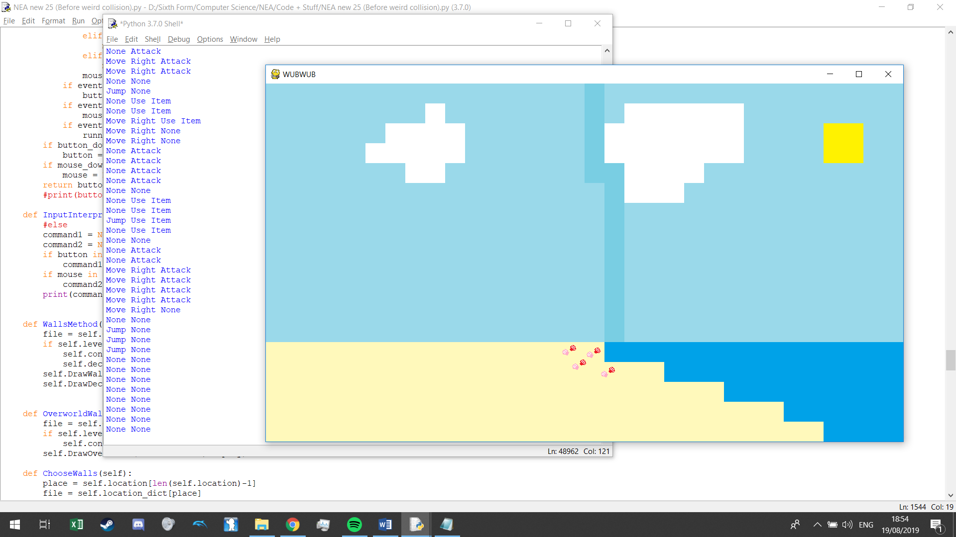

I then had to make a dictionary specifying if you collide with certain walls or not:

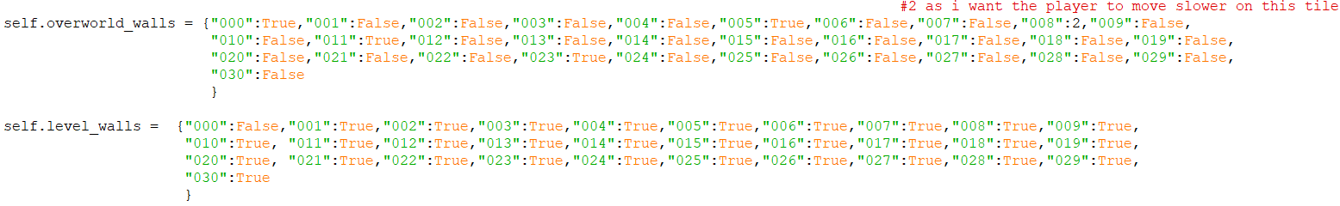

With the current tiles being:

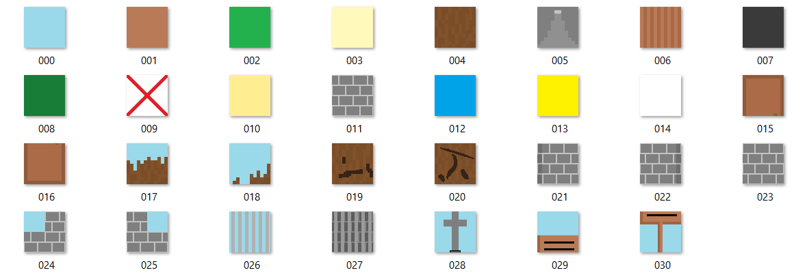

Getting collision between the player and the walls was difficult as they were both 2d objects and I could not find a way of making collision for a certain direction I did figure out how to detect whether the blocks where colliding with a player:

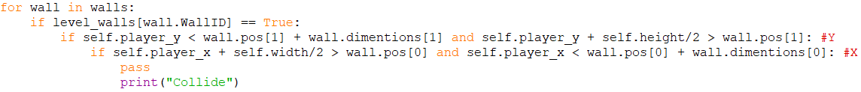

As a result of this I have decided to scrap the directional collision dictionary and instead have it so that collision will be checked for a potential move, so if the player wants to move left, the position of where the player would be after the move would be passed into this function and if there is collision, it is returned and then the player is not allowed to move to that position. My first iteration of this goes as follows:

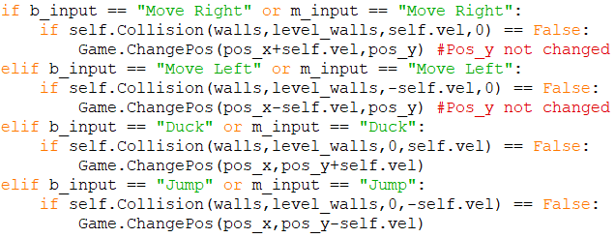

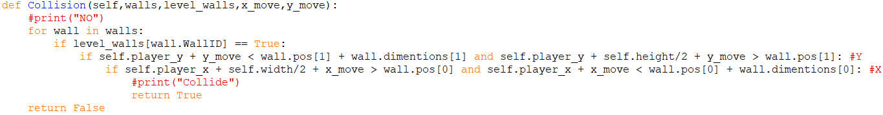

Testing this out, the block did not move when trying to go below ground which was good but then I tried to see the collision with a roof and the character went through the roof as such:

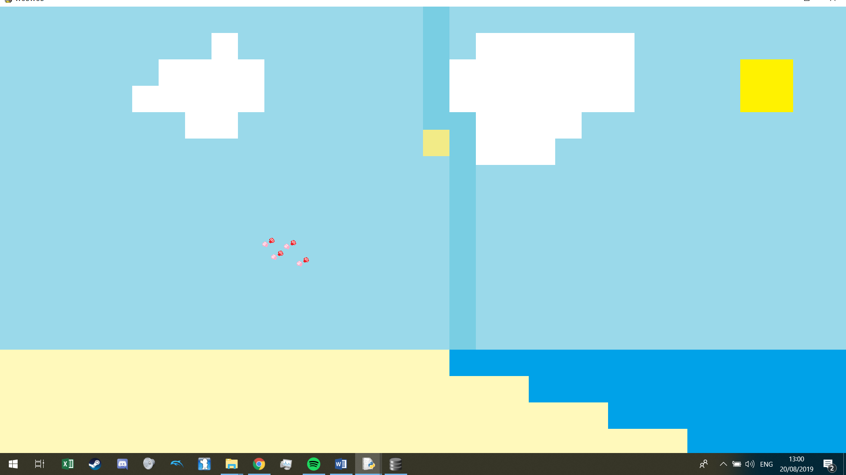

It was not an issue from scaling as I tested it out on all the resolutions. I found the issue was because the way I have drawn my player compared to the walls in the level as I drew my character from the center and my walls from the top left, I had missed collision for the other half of the dimentions:



On lower resolutions, there is a tiny gap between colliding with a wall because when you divide velocity by scale, it gives a reoccuring decimal, and since I am focusing on my native resolution I want to keep x velocity to a factor of 5 so it check the same but for a fraction of the velocity:

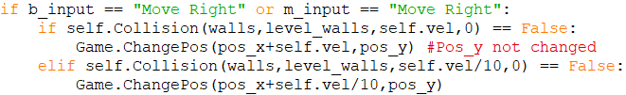

Now my character does not run into any wall. But now the next iteration of this code should include more realistic movement such as a jumping and a character affected by gravity.

I made many attempts at trying to make a working collision system on my own but nothing seemed to work as when I tried to have the program detect whether the player was in the air it would not work due to problems such as the program registering the player as grounded when he had just started jumping, or gravity would work too far so the player would sink into the ground and moving left and right would tell the program there was collision so he couldn’t move, etc.

I however did manage to settle one part of my movement and that was to conserve x momentum when the player was in the air, this was a problem because I could only take one keyboard input at a time so when I tried to have the player jump it would register the player as not moving so no matter if the player held left and then jumped he would freeze on the spot and jumped. I fixed this by adding a frame delay between stopping x movement so that if by that time the user wanted to jump, x velocity would be kept:

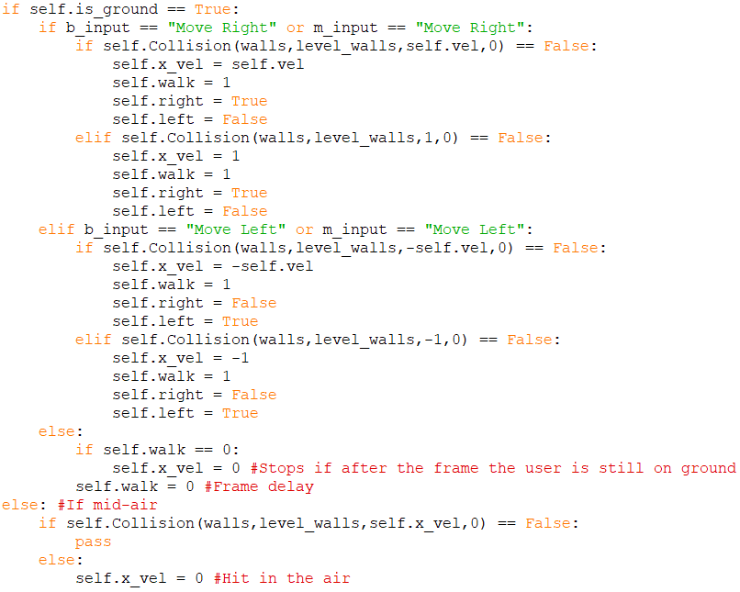

However for my other problems I had to look online for some possible solutions. When looking I rememered an old project I had created on scratch which a school friend of mine let me use a script for collision and it worked well so I could analyse it for how this is done. The part of the script handling the y gravity looked partly like this:

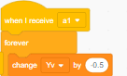

This is the y velocity of gravity and it keeps increasing if it never touches ground as if it does, this value is set to 0.

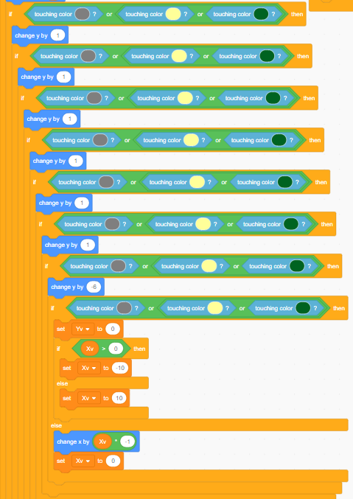

The program continually moves the player upwards if he is touching a wall, if the wall is the floor then the player will just be moved to the top and pass to the end of all the if statements. If however the player keeps going up and still is touching a wall then the player is in a ceiling or a sideways wall so the y position is reset so if he is in a ceiling then he is booted out as normal with no x velocity but if the player is still in a wall then he is in a sideways wall as to which the program then checks its velocity and boots it out dependant on that.

This part is crucial. What is happening is that the script checks whether the player is colliding with the wall due to it’s x or it’s y value.

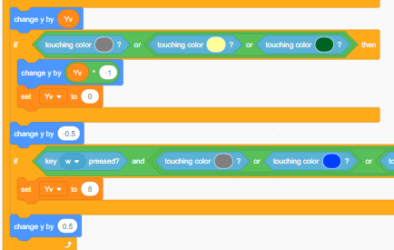

At the end of the script is where jump is detected, if the user is touching a wall and jumping the y velocity is changed

The user’s y position is changed by the y velocity, but if the user is then in the floor then change the y position back and making y velocity 0.

Also these extra y changers are just to see if there is ground below the user.

Even though this script is on scratch I can apply the same theory and logic into my python as I have a similar collision detection already implemented and finally my collision system is ok:

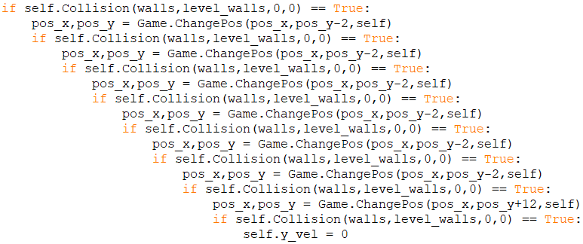

I had to make sure that pos_x and pos_y was updated so changing the pos returned the new pos.

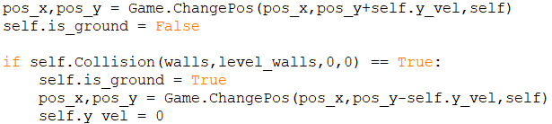

This variable will also be used to help with animation.

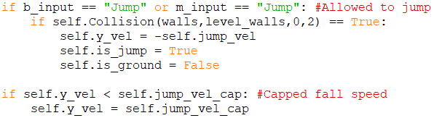

X velocity is now conserved when jumping and running but if the user jumps on the spot they cannot move mid air so want to be able to change x velocty midair but by a factored amount so if “is_ground == False”:

If no x velocity, add it to the certain direction pressed.

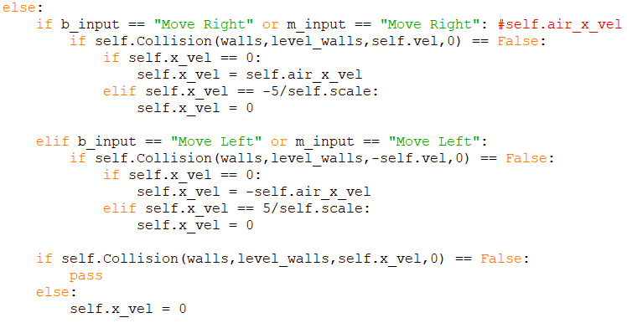

If there is x velocity in the right direction, set x velocity to 0…

Now that I have my movement for my level, I want my movement in the overworld, which will be less complex as it is just a block to block grid to move to and from:

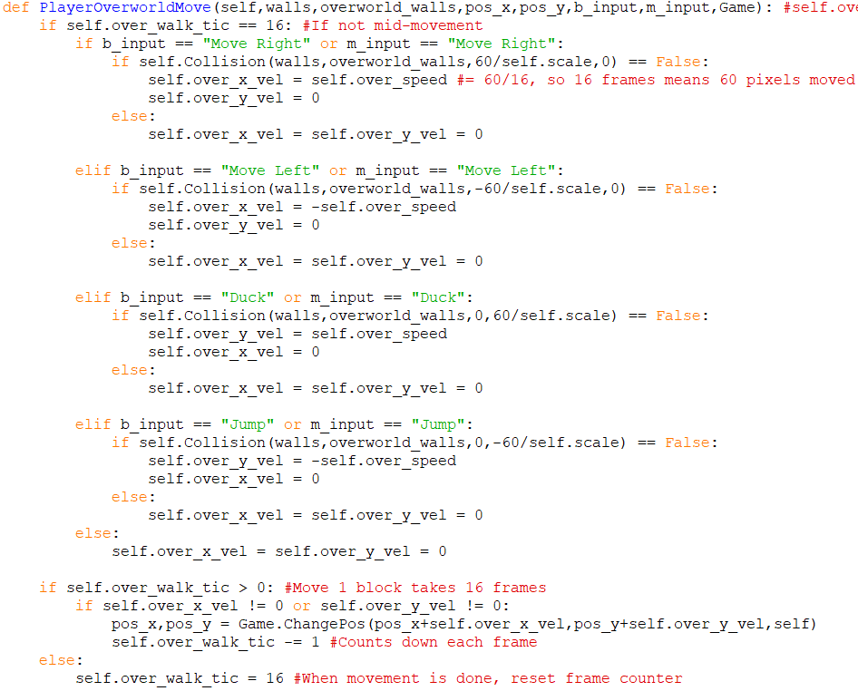

#### Level Changing

I made a dictionary containing each level that has a dictionary inside attached for the different exits of a level and has the information of where that exits leads to:

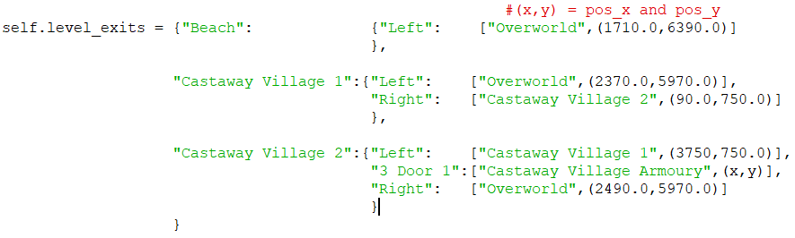

Now to work off of this I need triggers to change a level, for this I can have pos_x checked if it is 0 or bigger than the length of the level and then use this dictionary to decide the next place to go:

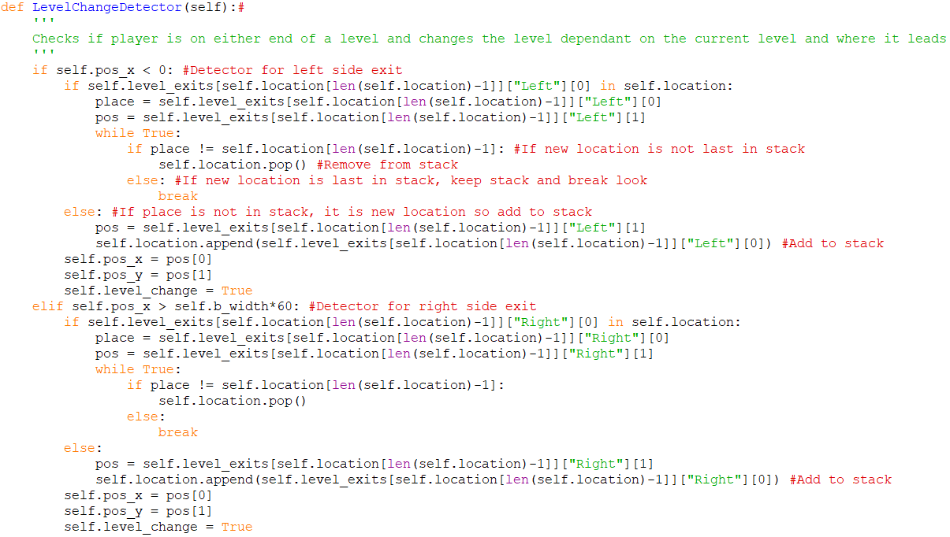

This makes use of the fact that self.location is a stack:



Above, if you are in beach, and exit left then you go to the overworld, and since this is in the stack the last item is poped only once so the location is then “Overworld” with the position updated to the dictionary value. If I were in “Castaway Village 1” and I exited right, then the program does not see “Castaway Village 2” before the last stack value so this is instead appended.

#### GUI and other Menues

First to make the life bar, it will be a linear bar but dependant on the resilience bar, the amount of damage the user can take will increase. The user will start with 10 hp and every 5 hp the bar has, a line will be drawn to sinal how much hp the user has:

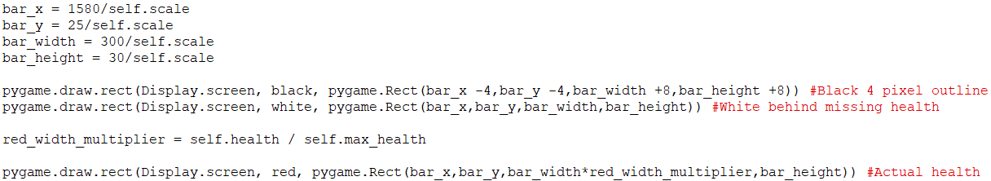

Percentage that bar should be filled



Then I needed the tics for each increment of 5 max hp:



For max 10hp, 15hp and 25hp (With 5 actual health):



That is the part of the GUI I am able to do right now so now onto the menues, since I don’t want the game to run when the menu’s are open these will be outside of the main game loop and will be considered events, but not events that will be noted into the save profile:

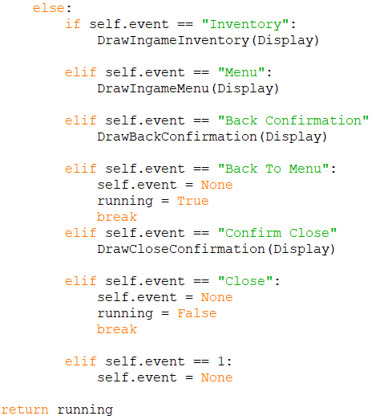

With all those menus having these possible traversals:

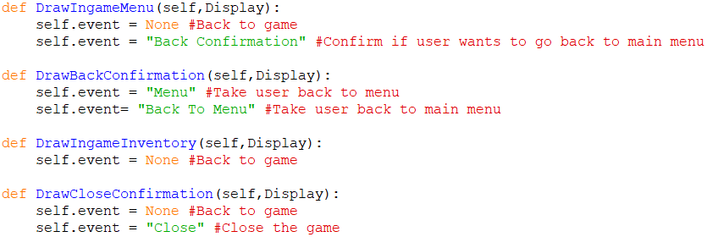

Close game (When windows x is pressed directly):

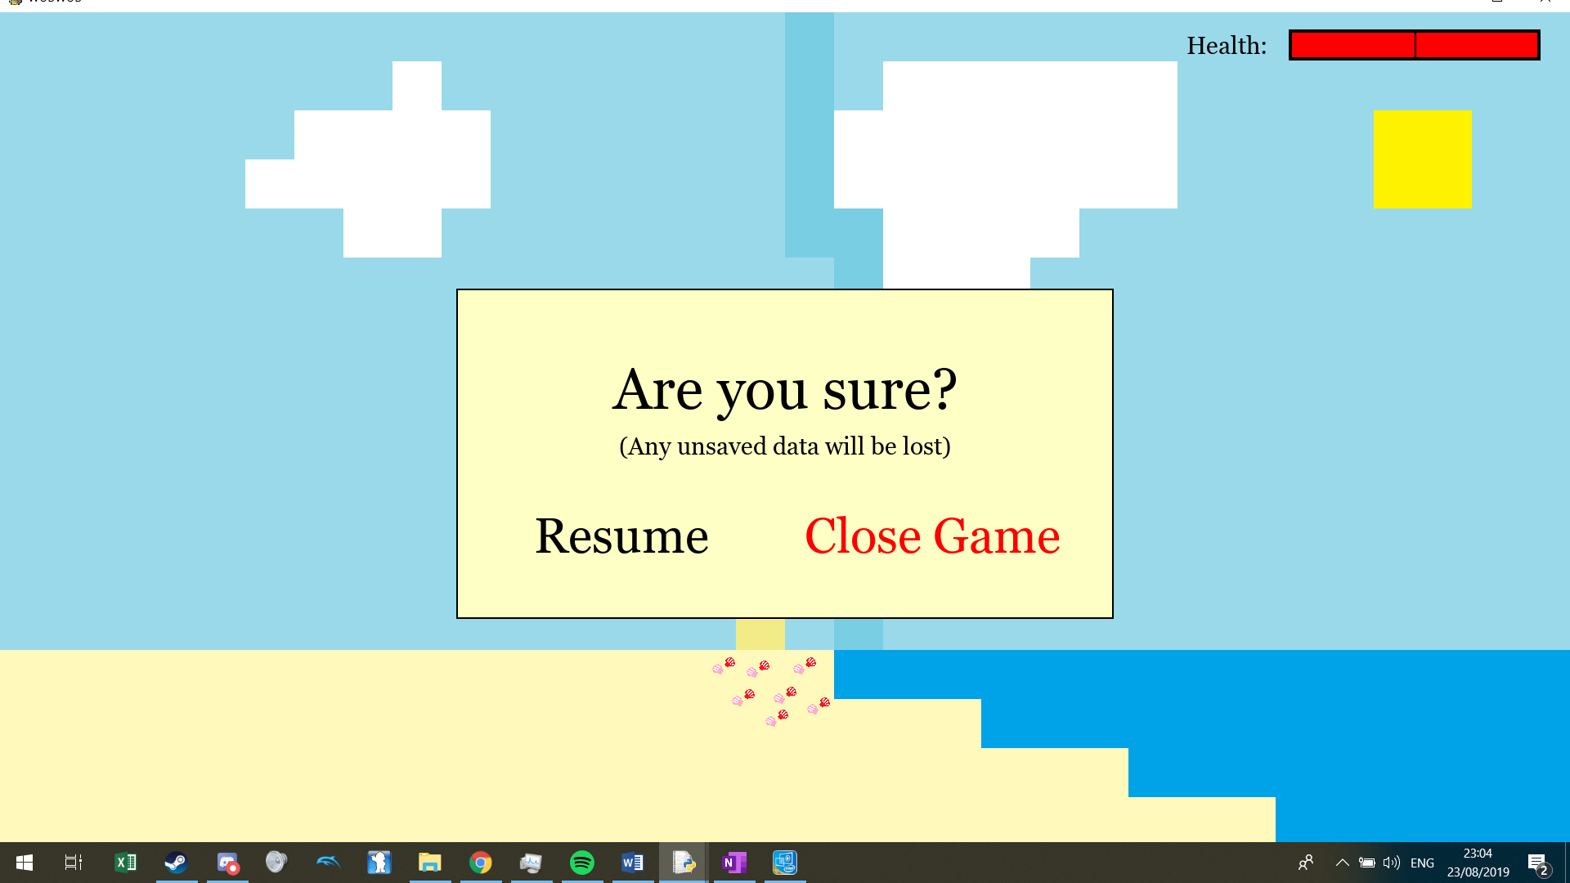

Then I made the menu (When the user pressed the button alloted for menu which is ESC as default):

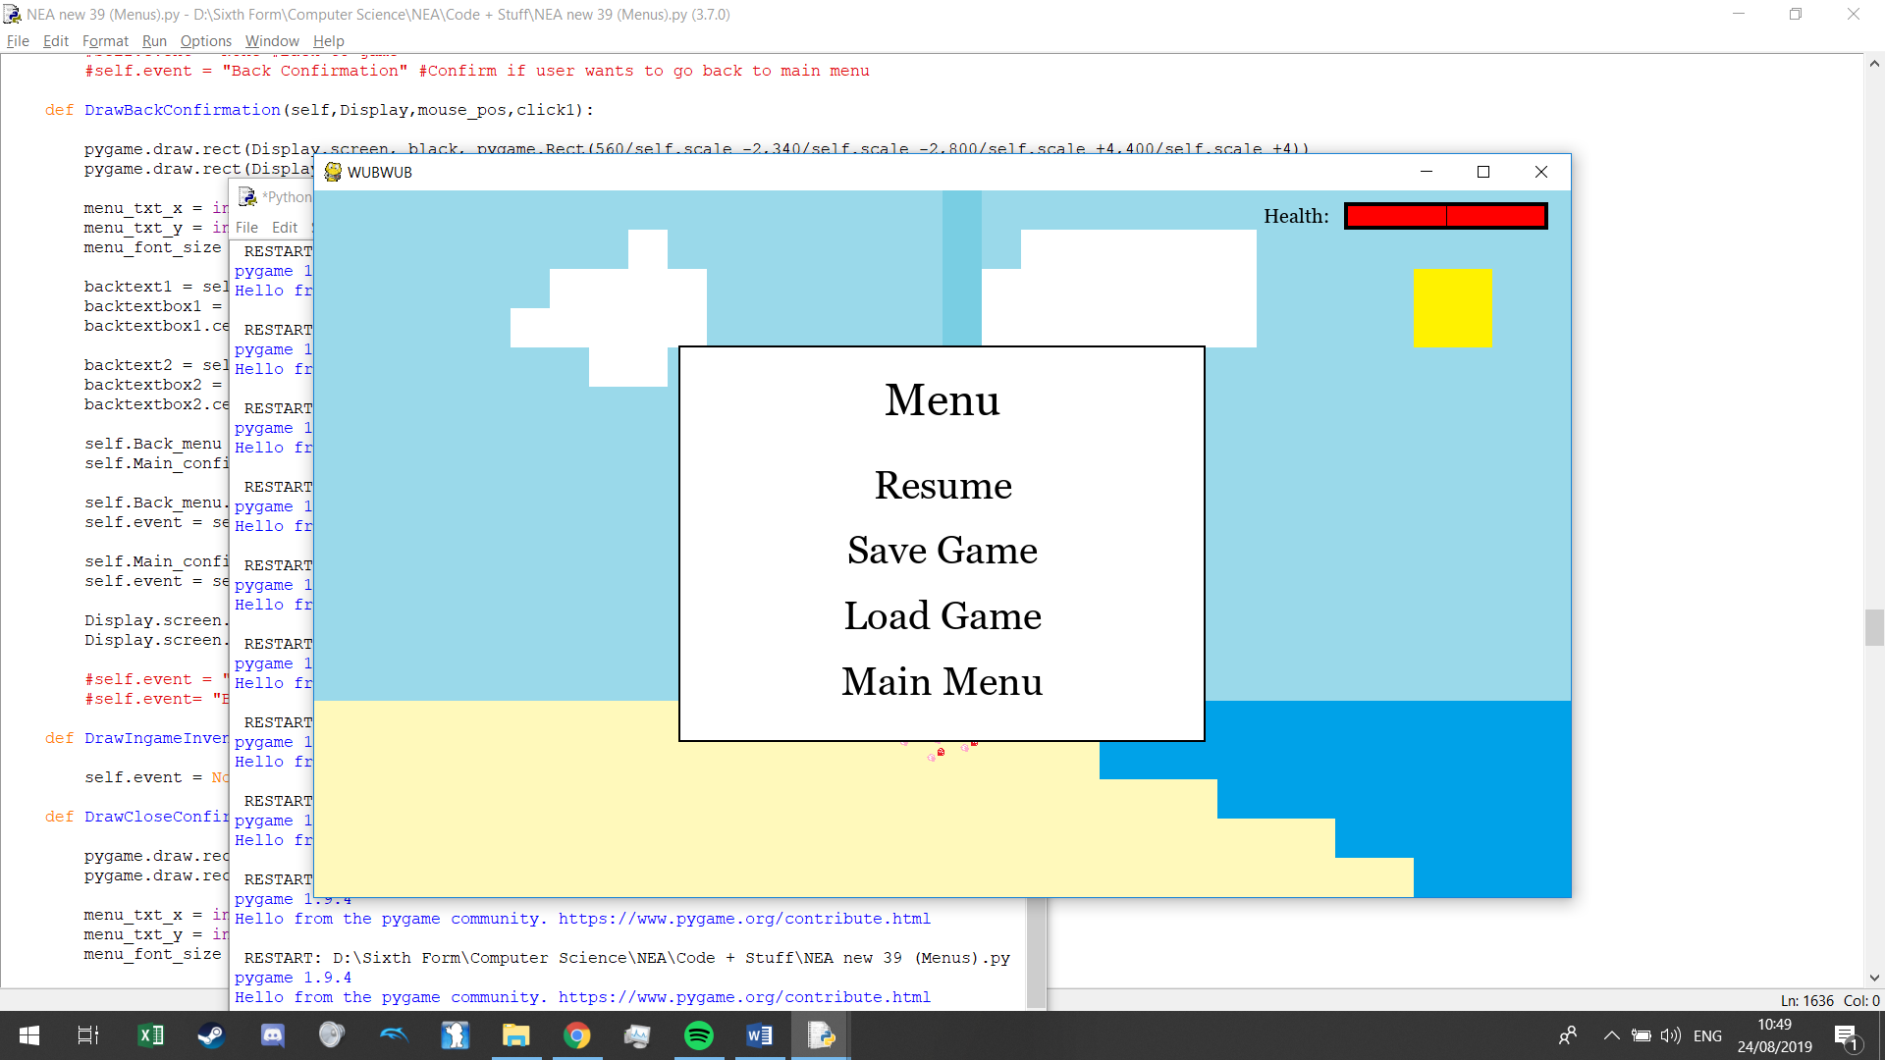

Clicking resume, resumes the game and clicking main menu gives this:

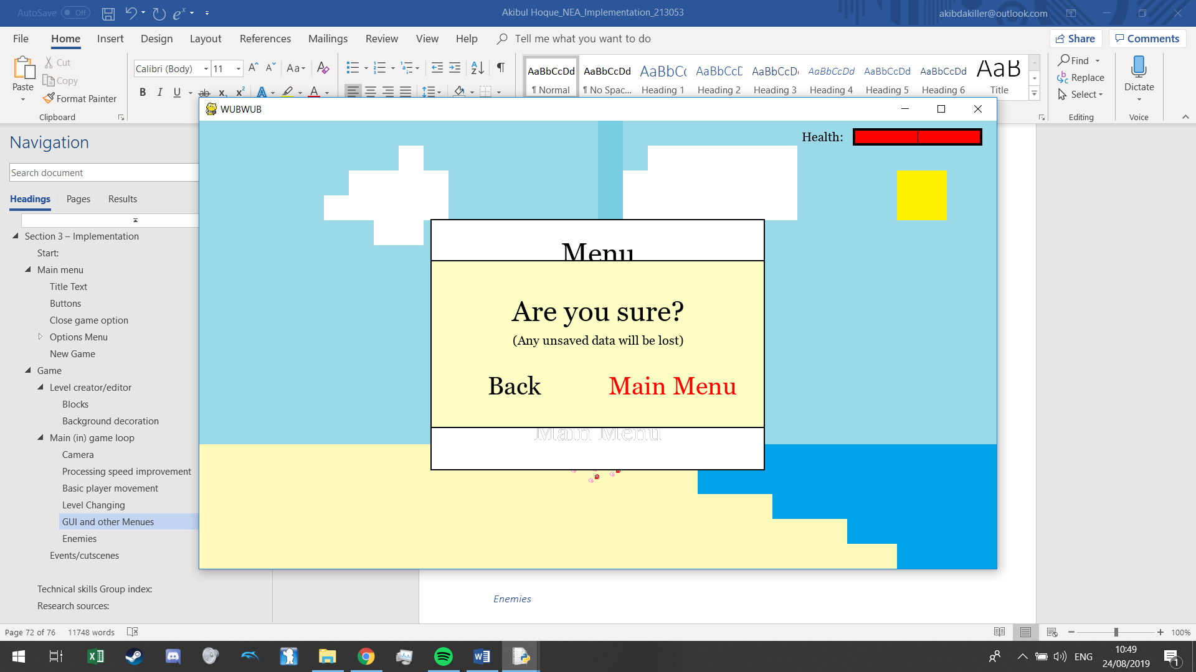

Then when saving it looks like this:

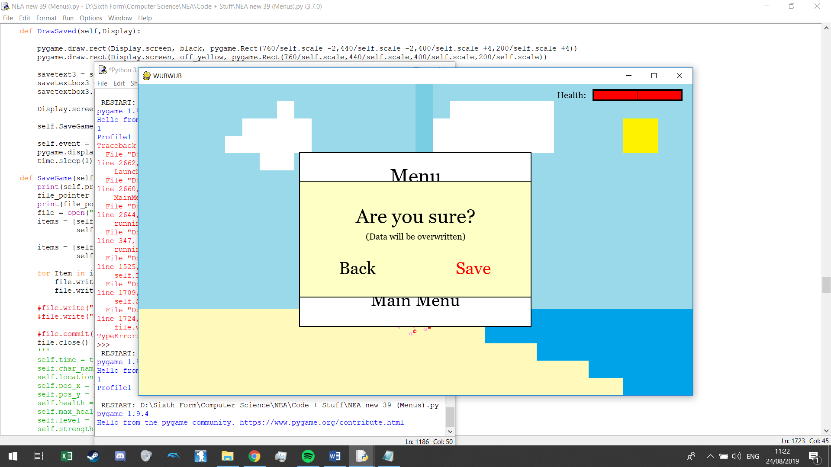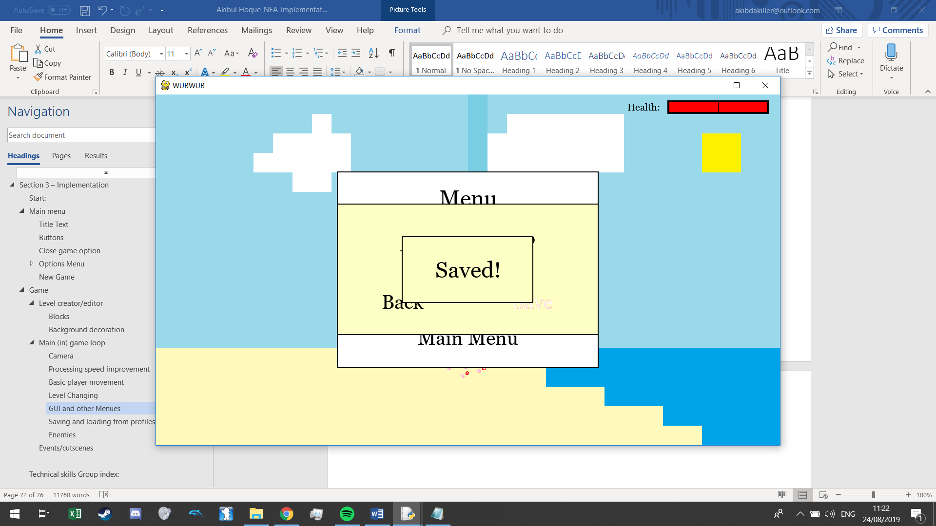

#### Saving and loading from profiles

To save to a file I write all necessary data to the profile text file. I have gone for a basic approach in this because this is not my current focus so there is no encryption and the data is just saved line by line, which will also help out in testing as I will be able to alter my game data easily to access certain parts of my game quicker:

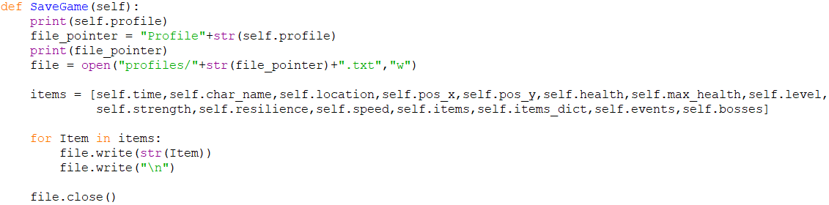

So when I save the data looks like this:

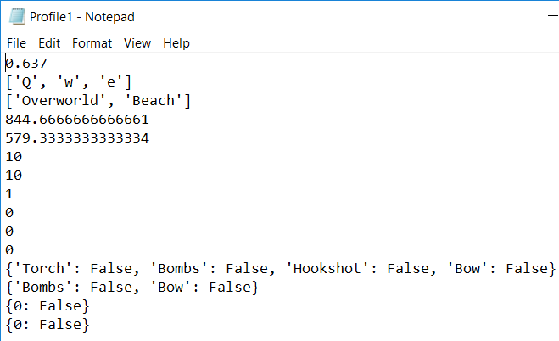

I want to be able to load from this from the main menu first so I made that menu up similar to my new game menu:

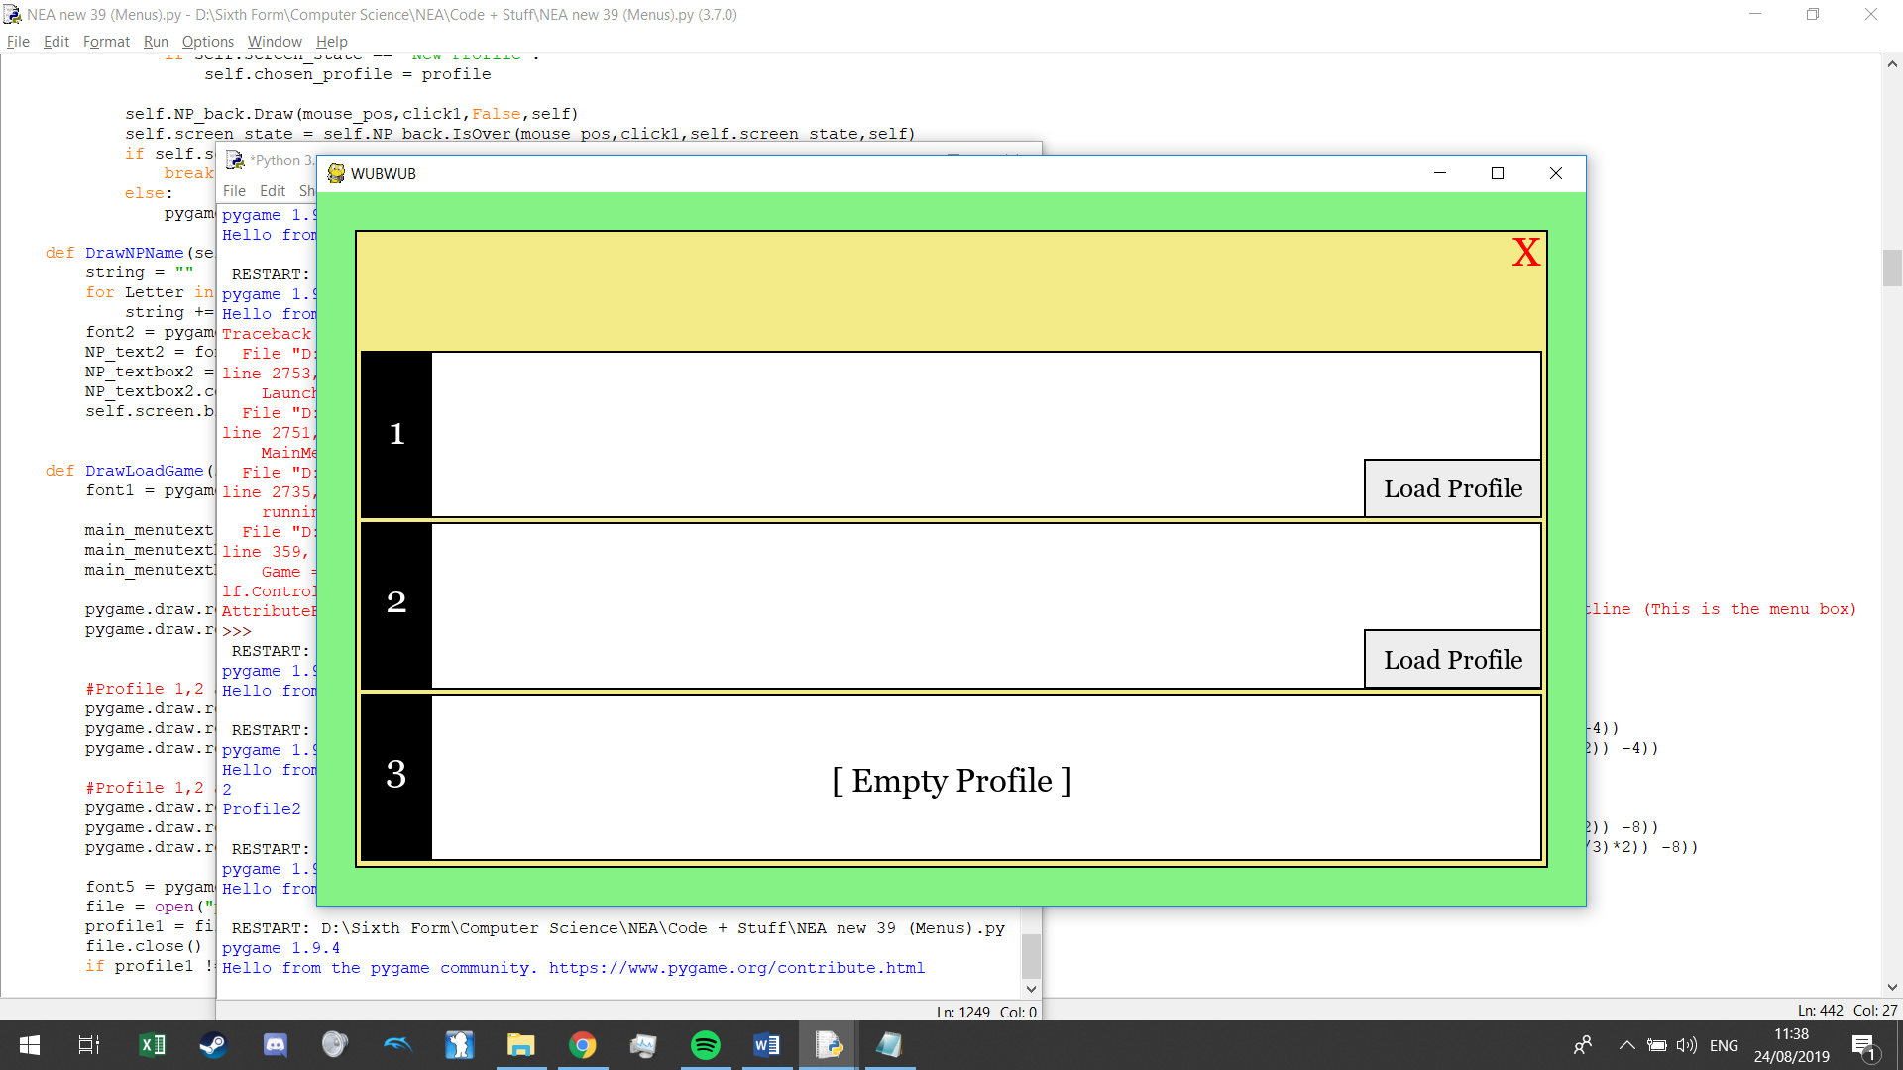

Then I need to change up how the game is started so that instead of setting game attributes to default values, to take the values from the text file instead. First the way the game class is started up is changed:

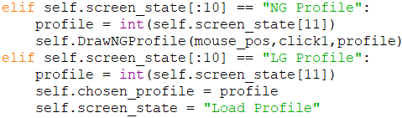

Instead of “DrawNGProfile” (Method used for user to chose name) skip it and go to next method.

Open up class, False as this is a loaded game. None as we will get the user’s profile name from text file.

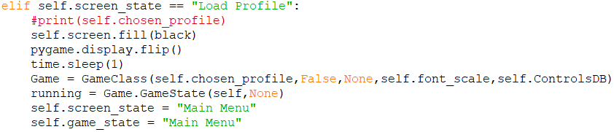

I did this:

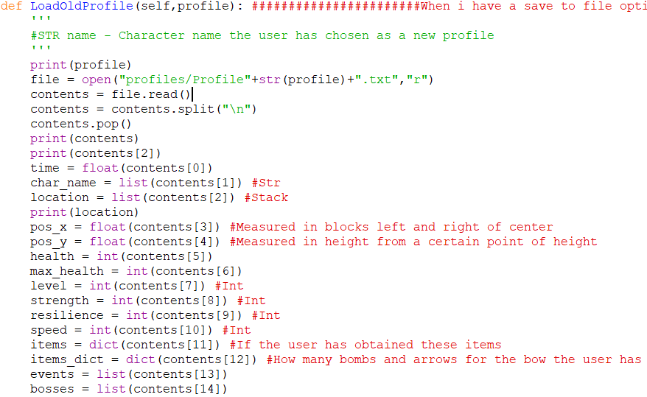

But I had an issue with importing lists and dictionaries and turning them into their data type, as using list() gave me this:



So I decided to save and load lists differently to the other items by saving them in a way that when imported they can be turned into lists:

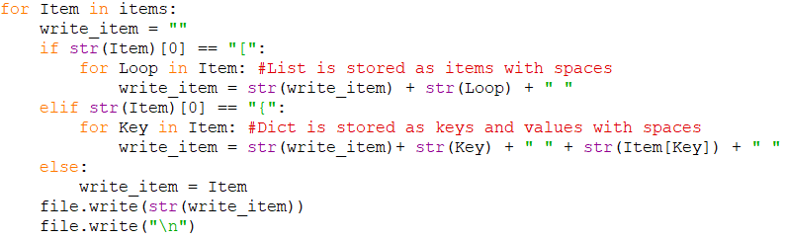

Now save files look like this:

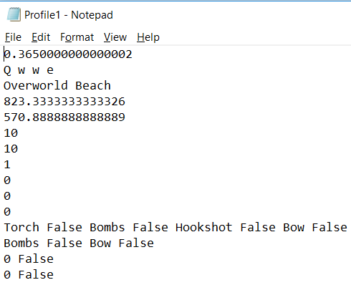

Then I loaded lists and dictionaries like this:

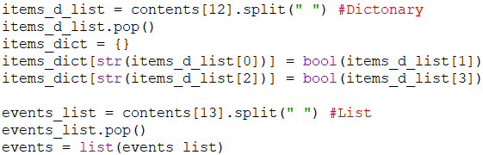

uneccessary to extend this to having loading enabled in-game so I will remove that idea, but before I move on I found a bug where you can save mid-movement in the overworld screen and when you load up the profile again, the player is in the middle of a block so they are unable to travel to certain areas or enter levels. To fix this I made sure that when on the overworld screen, that going into menu or inventory can only be done when the user is not moving:

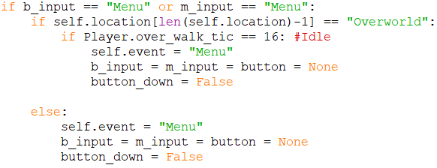

One other bug I found was that when importing string values of “False” or “True”, converting them using the function “bool()” gave me a True value no matter what, so because of this I had to make my own function that returns a boolean value depenant on the string versions of “True” and “False”:

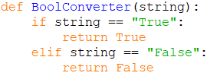

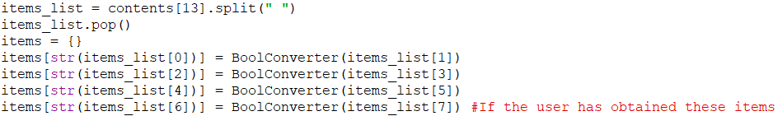

#### Inventory / Exp system:

I want the screen to be laid out like this:

Inventory

{Items and equipment}

{Level and skill point allocation}

{Confirm allocation}

For my level bar I need a exp attribute, and right now I will stick with a basic way of calculating a cap to reaching the next level. Level 1 will take 10 exp to level up, level 2 will take 20 exp, level 16 will take 160 exp, and so on so I made a dictionary of this:

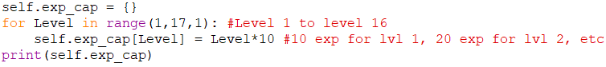



Now I can create an exp bar entirely off of this (And a exp attribute that I have created and added to the saving and loading system):



Then:

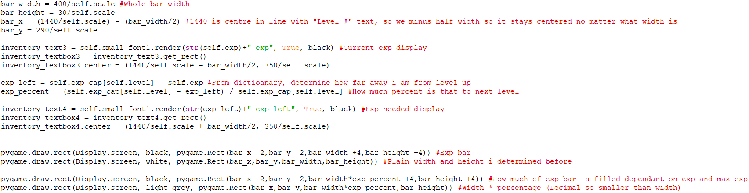

Putting in values shows the visuals work:

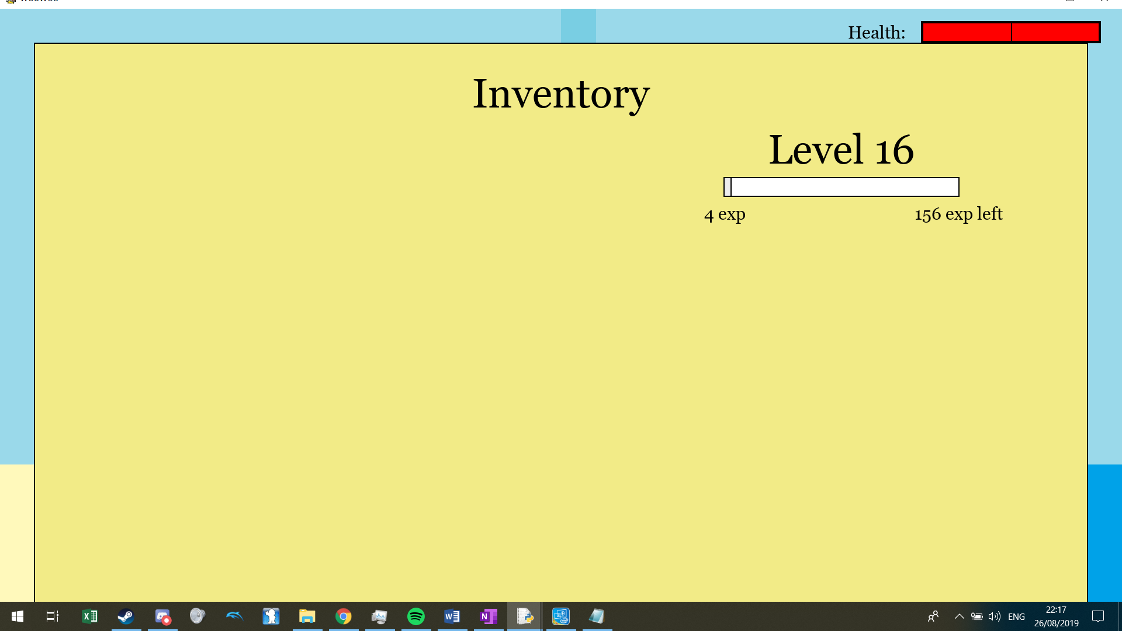

Then for skills, I want a system of changing skills and then confirm the allocation to apply changes and for this I needed a temporary value for each skill.

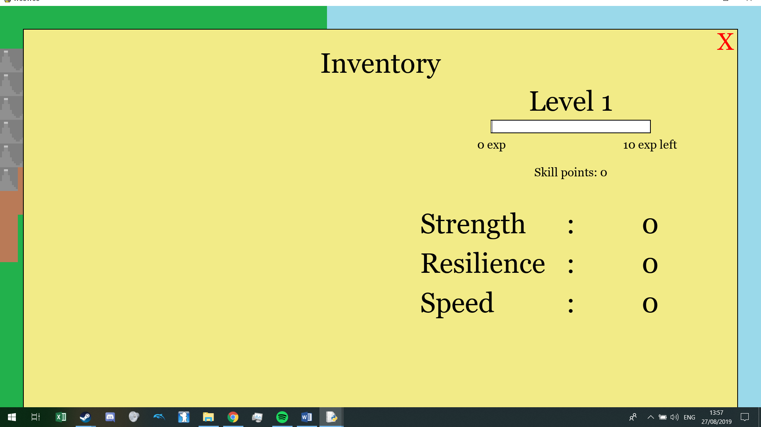

I set the temp values so they can only be above the confirmed skill points and not above 5 respectively and then when confirmed, the skill points are set to the temp value.

Then I added “+”s and “-“s to visualise this that a plus only appears when the user has skill points and the skill is not above 5, then a minus that only appears if temp is more than the actual value and when clicked gives the user a skill point. Then I added a confirmation button that only is drawn when the user has assigned at least one skill point:

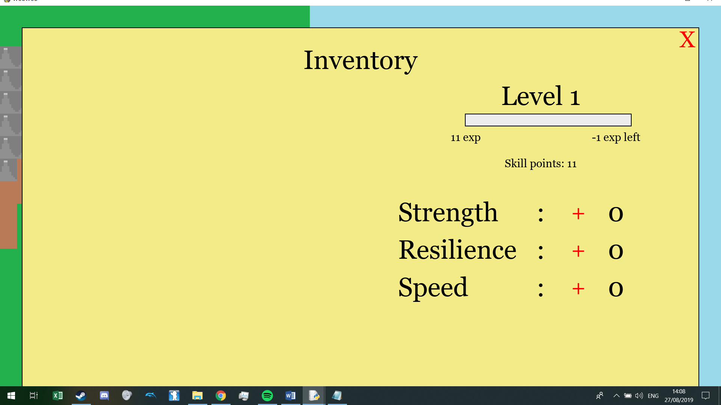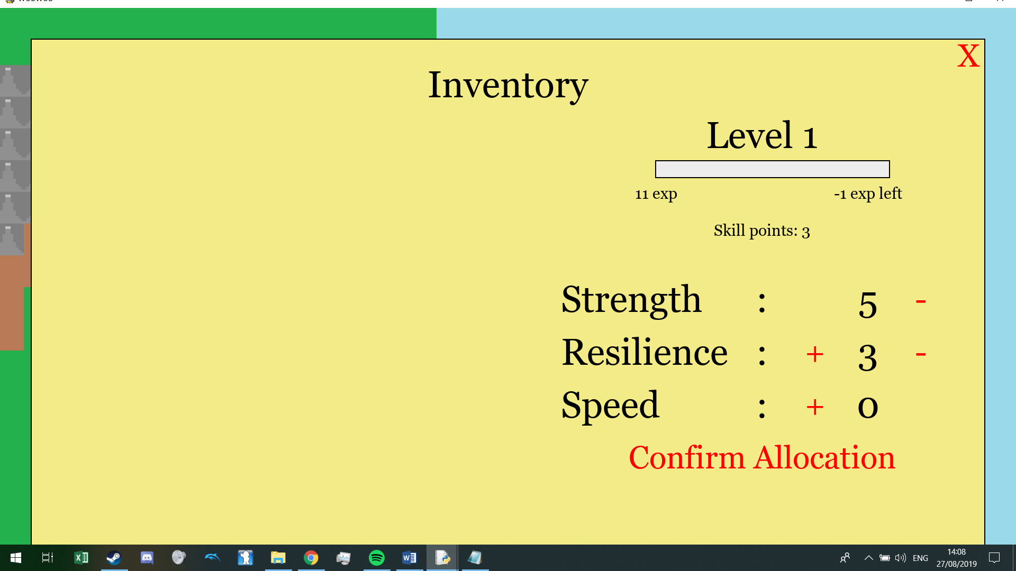

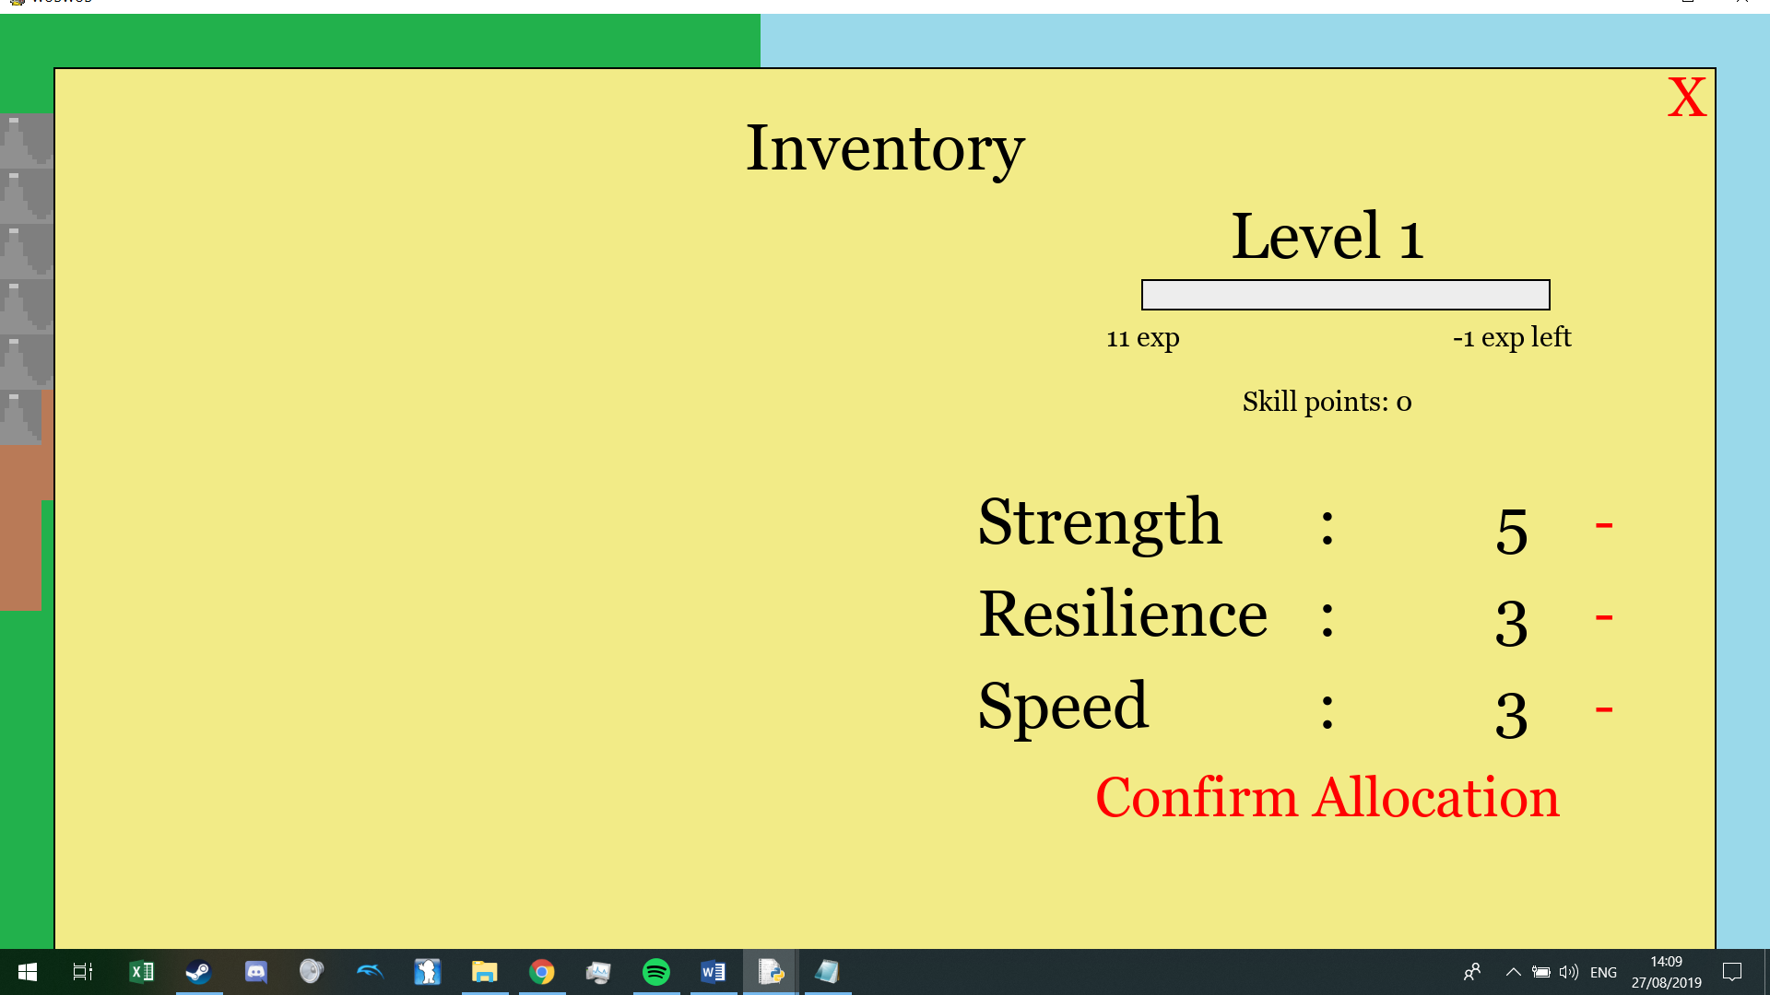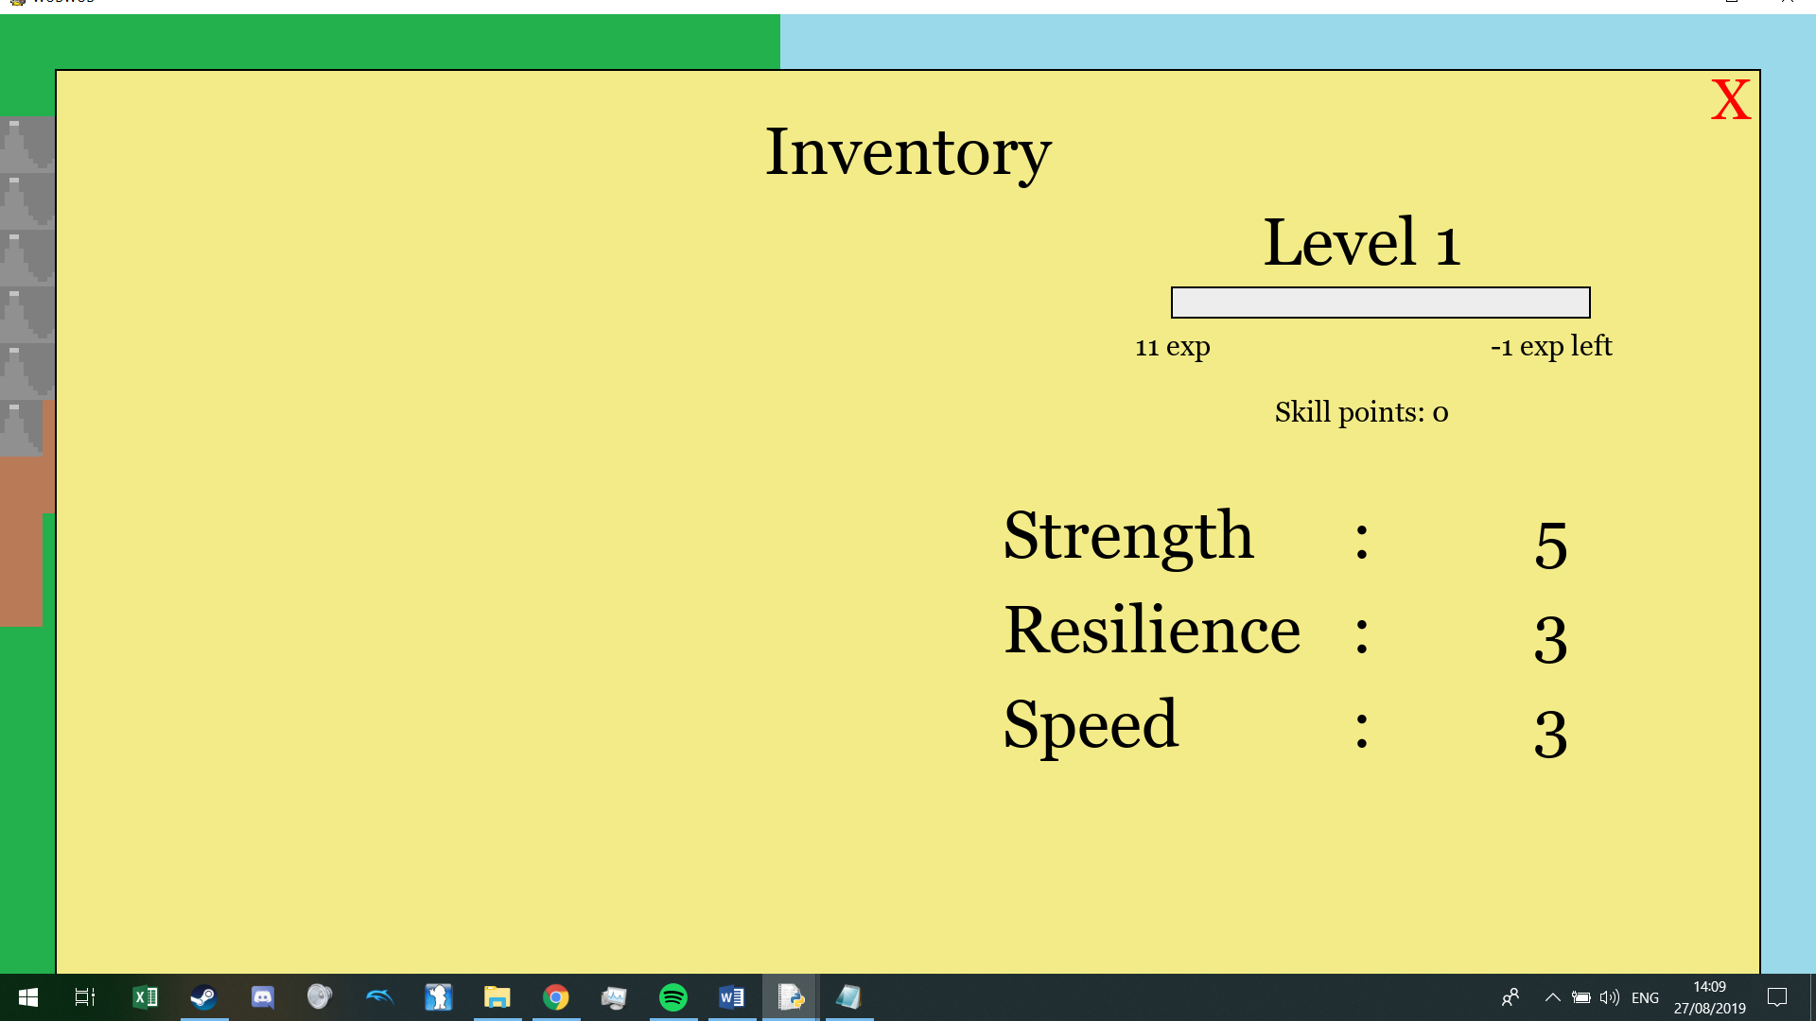

Then I added a method to allow the user to level up when “self.exp” reaches the right amount:

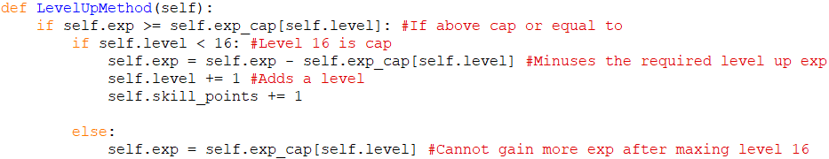

#### Inventory / Items:

GUI >>>

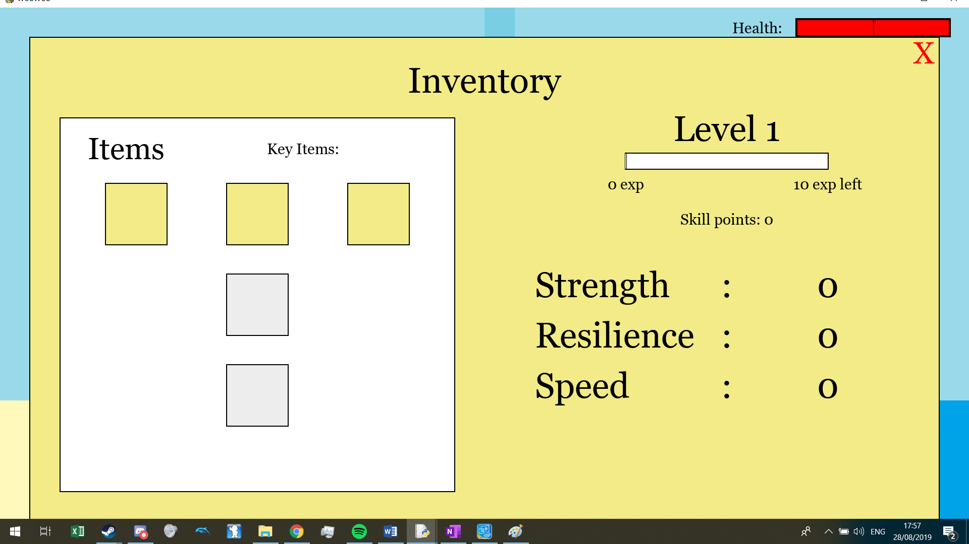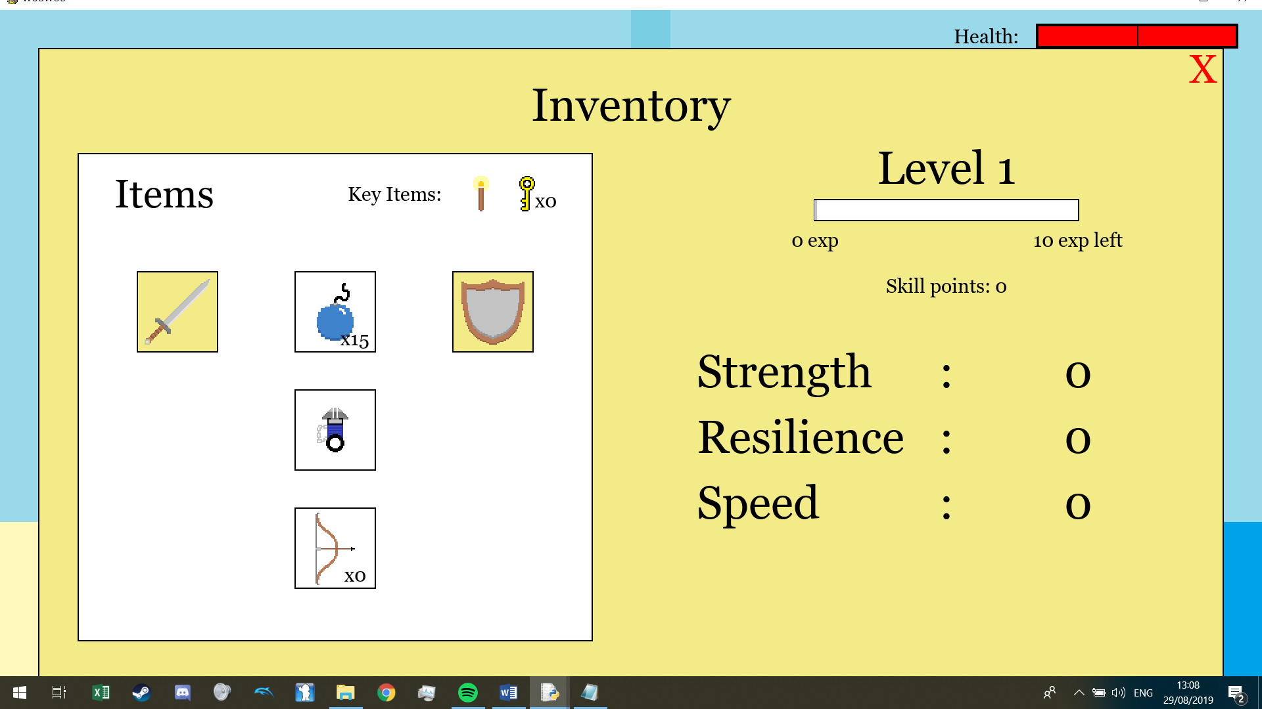

Then I need a button to be able to chose between the 3 items (As long as they are unlocked):

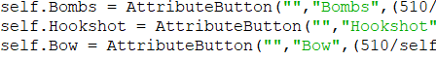

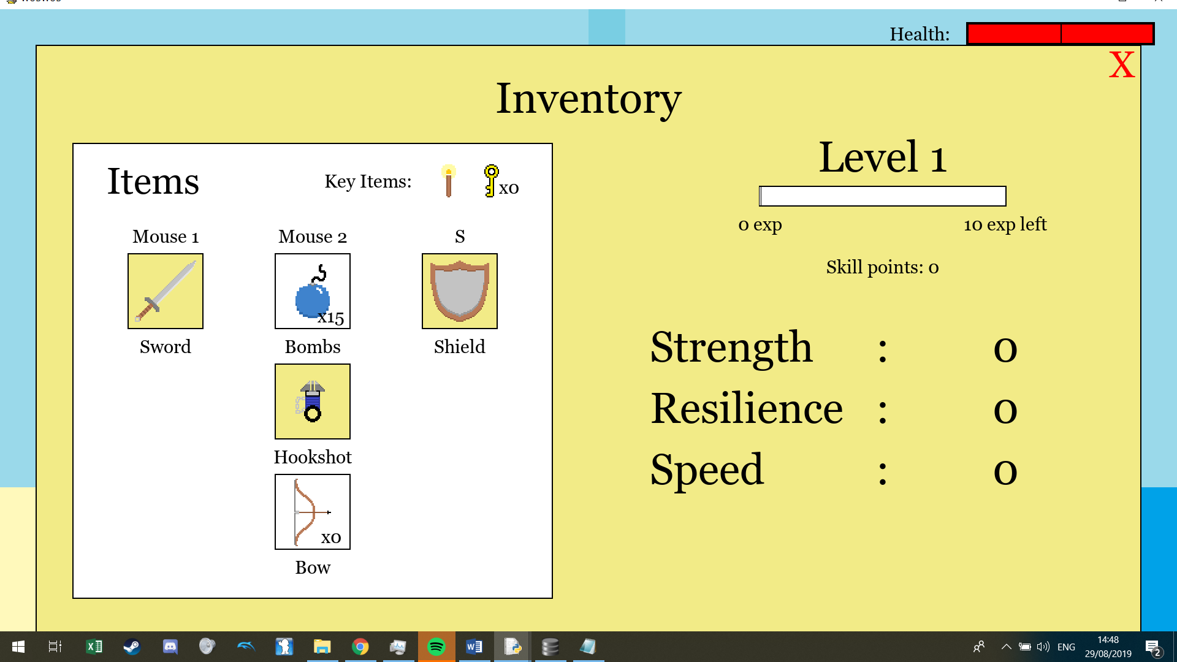

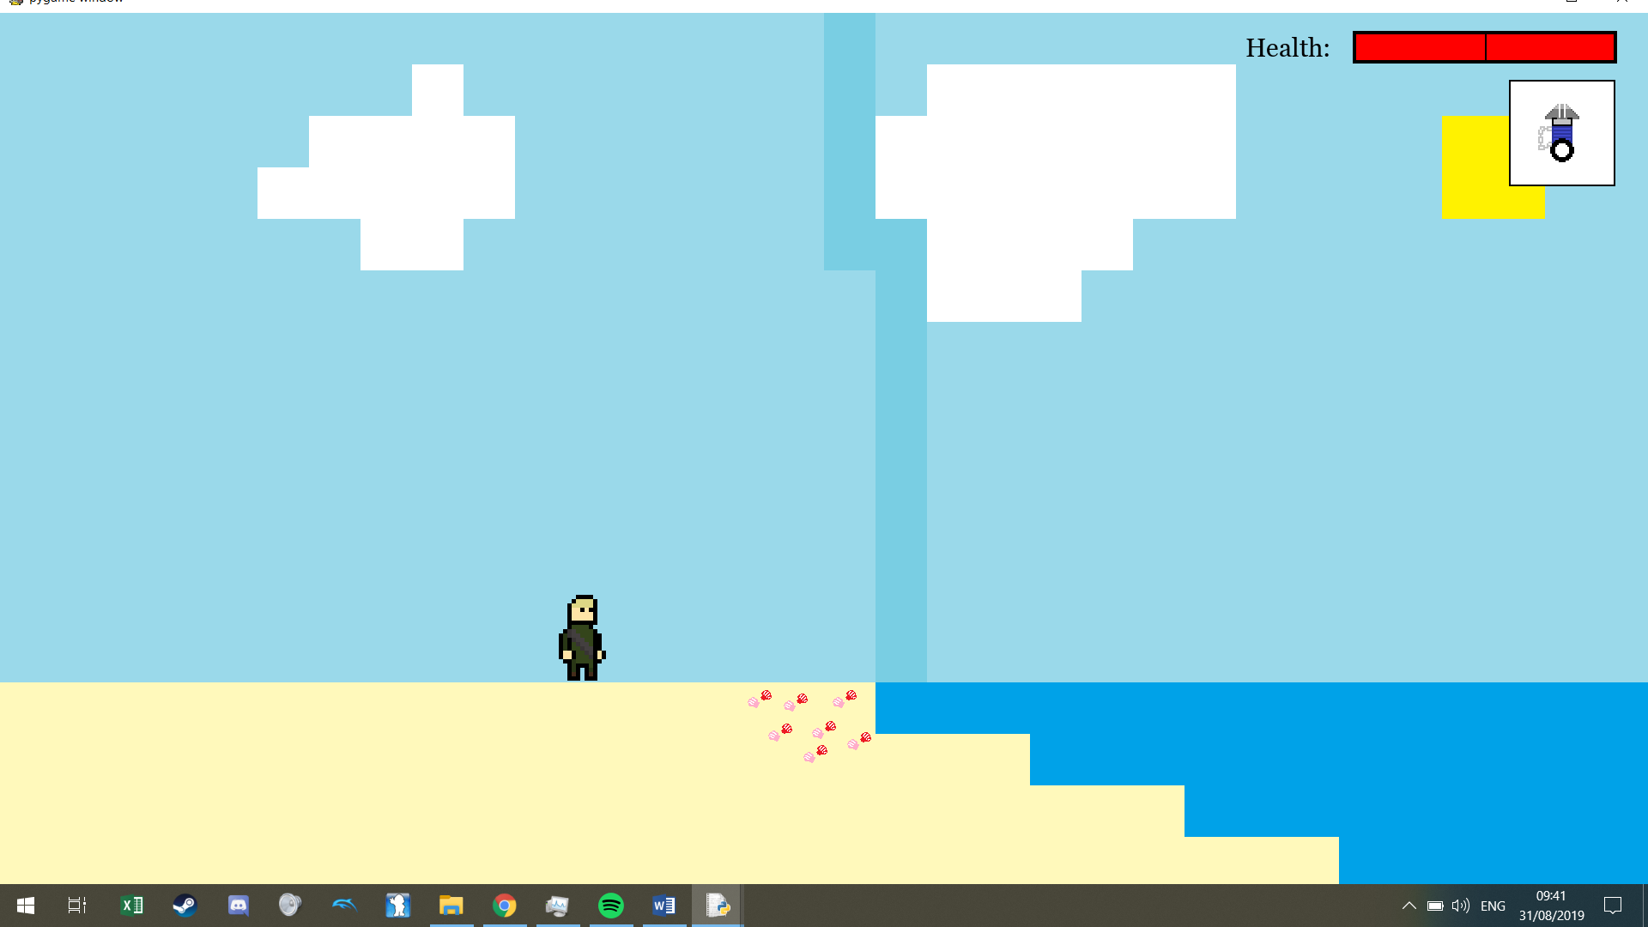

#### Player + Animation:

I got a player sprite set off the [internet](https://mostlymadproductions.itch.io/player-character-1?download). I decided to do what I did when loading my walls that being load all the frames of my images into a dictionary upon instantiation:

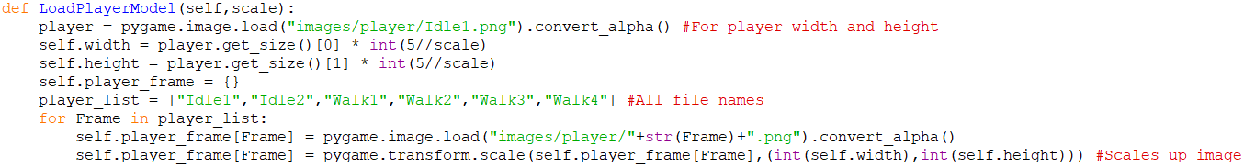

I have 2 frames of idle animation so I made this:

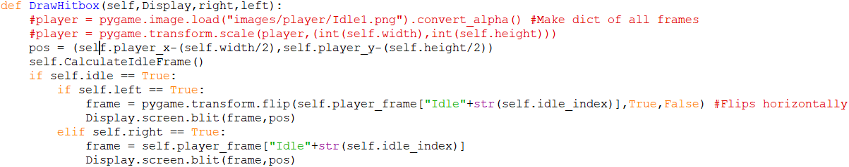

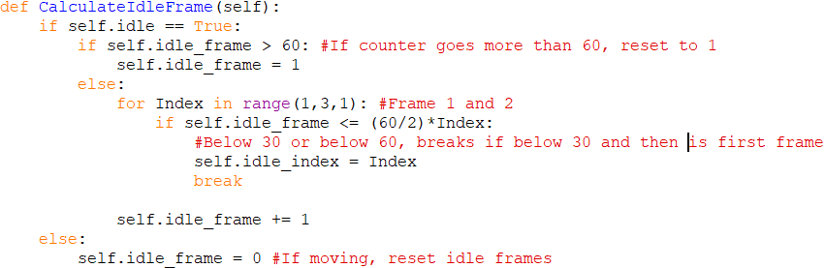

Now my character bobs up and down when not moving. For animating his movement it is a similar process:

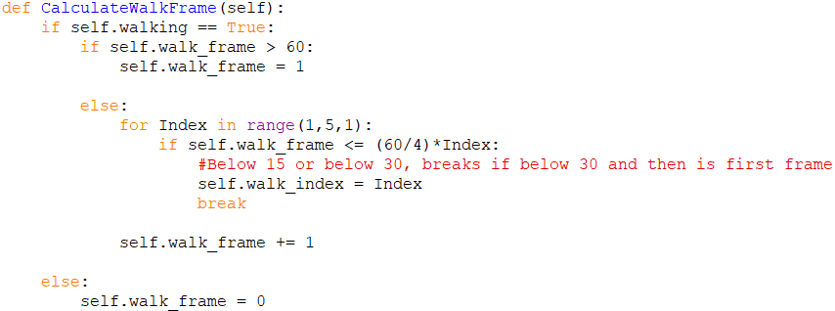

And then finally a fall animation which I used my variable “is_ground” to detect whether to draw it. Now my player has a walk animation, idle animation and a fall animation (That triggers whenever the user is not on the ground):

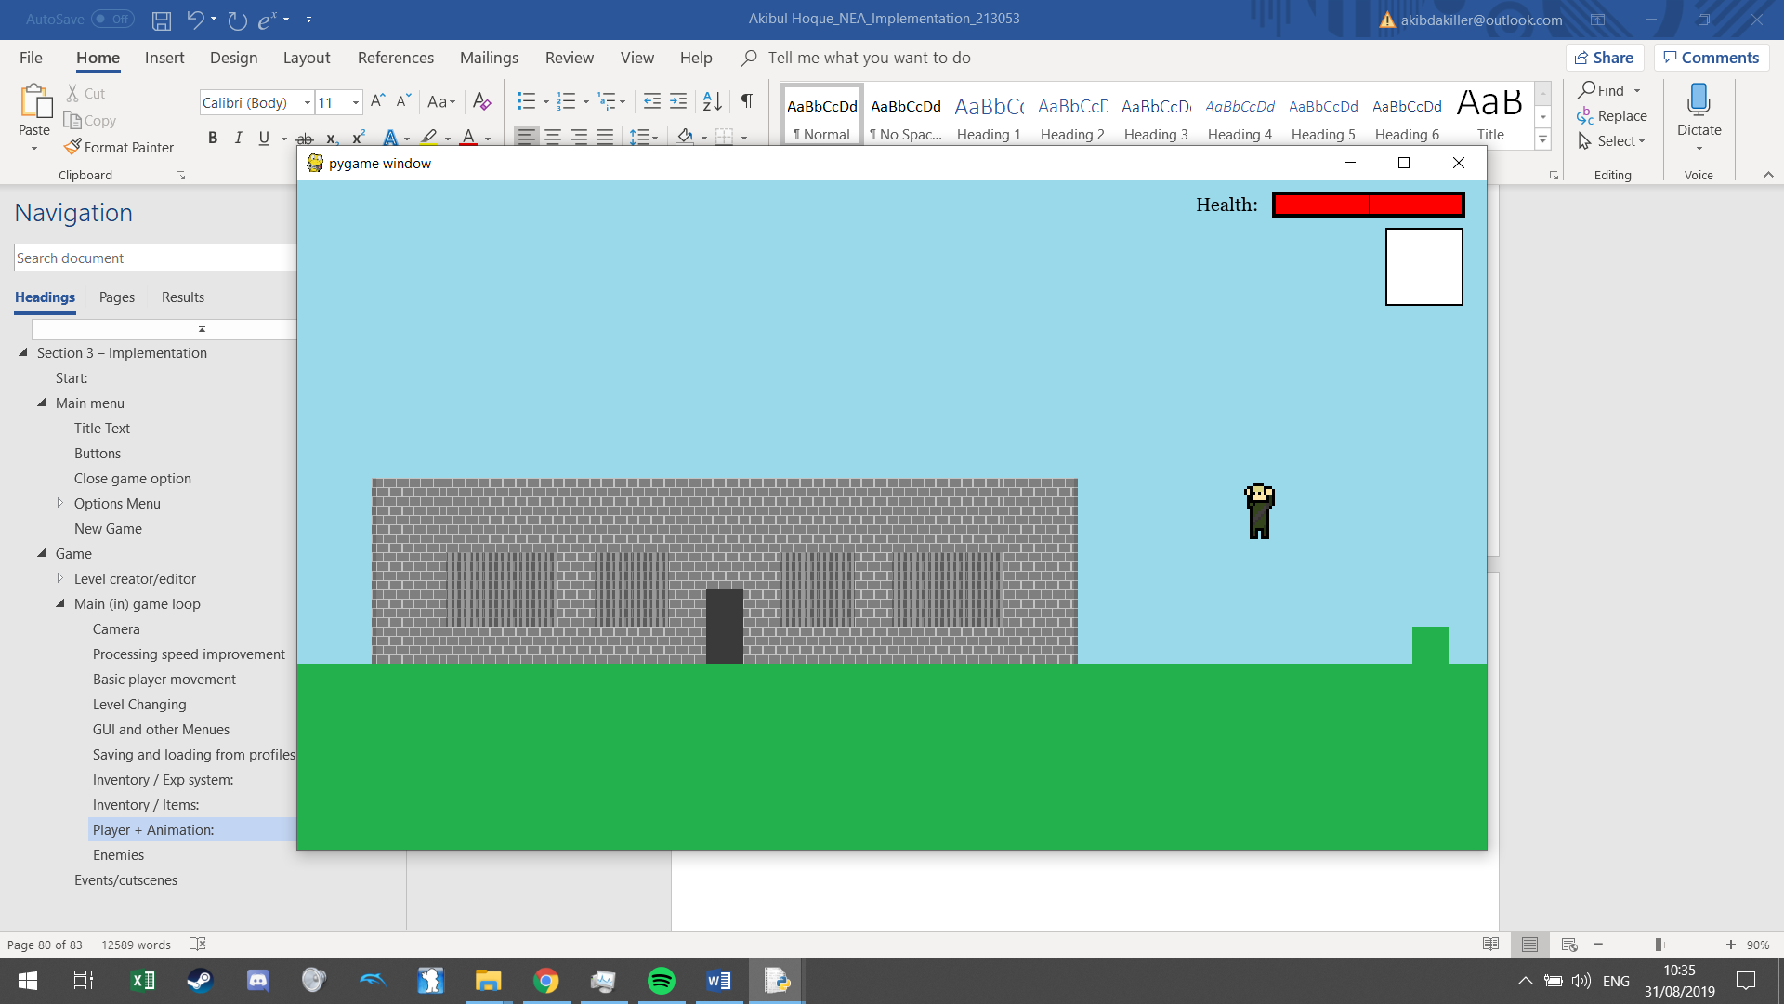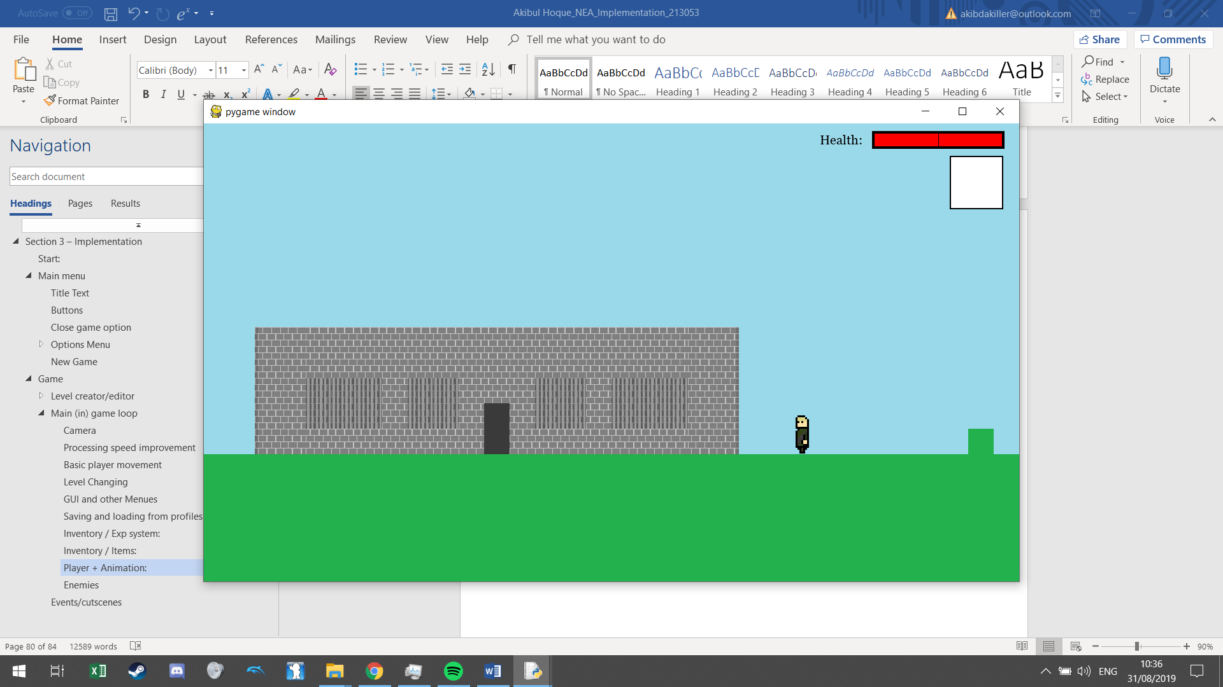

To allow the player to duck I used a lot of the same concepts I have already used so it is not worth documenting.

Store last movement thing in thing, when die pop and then re-do same action when die

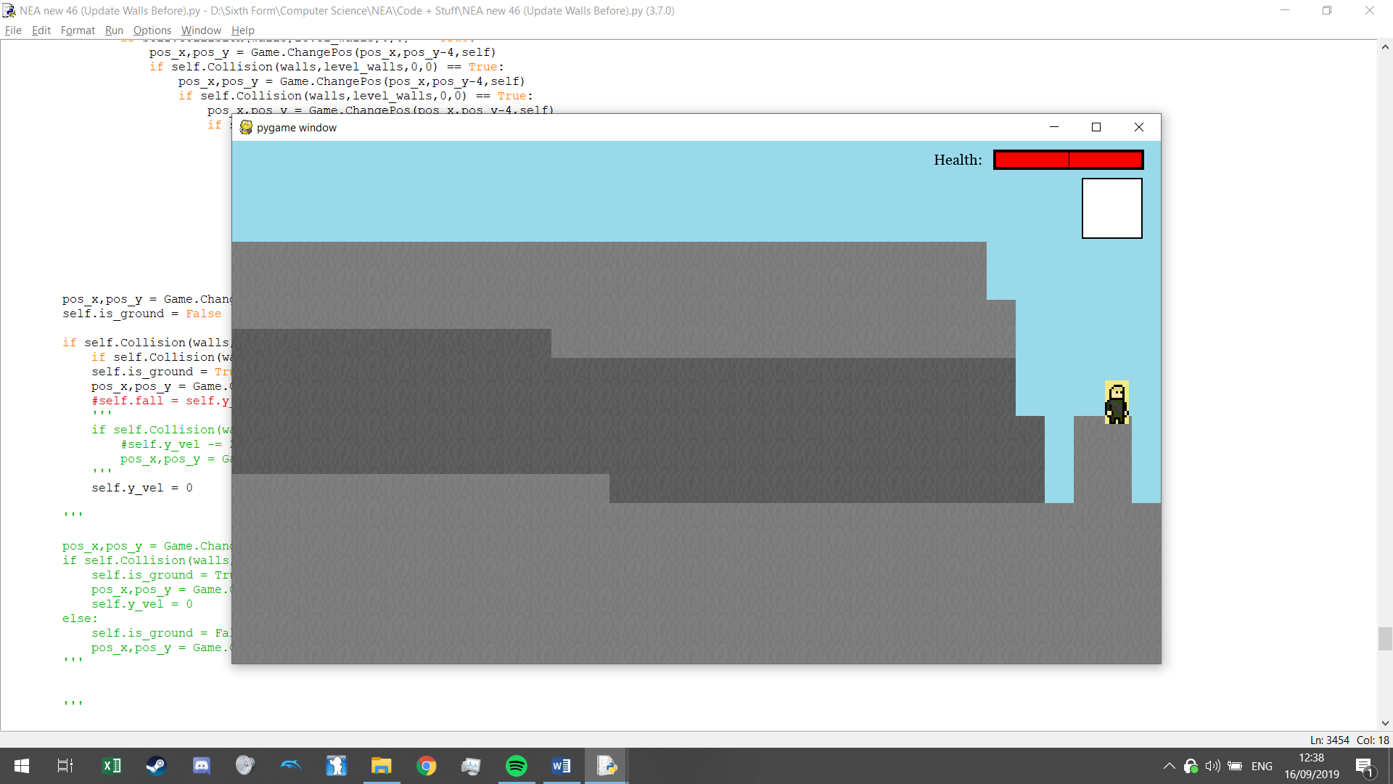

#### Enemies

I made enough levels to be able to start adding in an enemies system, but before that I need a death system.

##### Death system

For this I will need to make use of my stack for my location along with holding a variable of where the user just came from. When attempting this I tried to simply store the location stack before a user enters a level so the game has the stack for where the user was before they entered the level. This however did not work as for some odd reason as the stack would change within a loop when there was no piece of code to change it mid loop. So, I decided to instead of assigning the stack before, but to re-assemble the stack instead after:

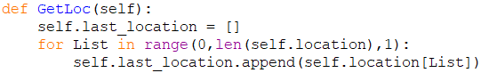

Dying will act as if you were re-entering the level from where you came from unless you came from the overworld which you are then just booted out:

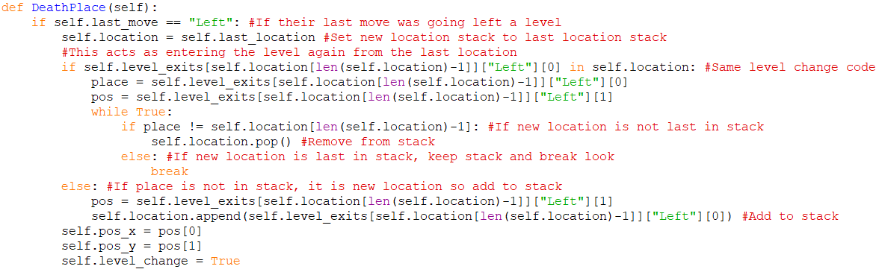

Currently this is only called if the player falls into a pit (And is offscreen on the bottom) but since it is a function, I can call it for any condition when the user’s character dies. So, I can now add in enemies

##### Enemies database

Fields:

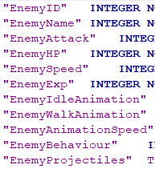

Different behaved enemies will have different methods so to do this I did inheritance along with polymorphism with class methods:





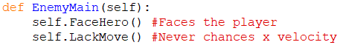The main class (EnemyMaster) will contain methods such as draw, append (To object list outside of class) as well as the define to check if this enemy is dead while the other classes will have methods such as EnemyMaster which will be the main class used in the method polymorphism. Each EnemyMaster for each respective child class will be used to call the specific functions needed for each different type of enemy:







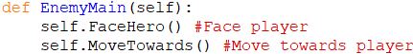



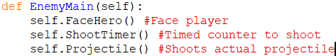



Then in the Game class where the enemies are called:

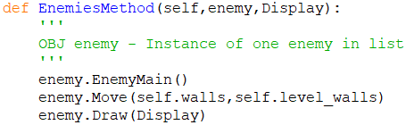

My enemies will be pre-loaded when the user leaves the overworld and enters any level and so any enemy the user has killed and the user has not entered the overworld, that enemy he has killed must stay dead. To do this however I must load all the enemies into their assigned levels once when the user leaves the overworld and for this I will need to convert my levels into a graph format and use graph traversals to achieve this affect. I made the base algorithm here and made it a recursive algorithm so there is more clarity to what is happening as well as making the algorithm rather simple:

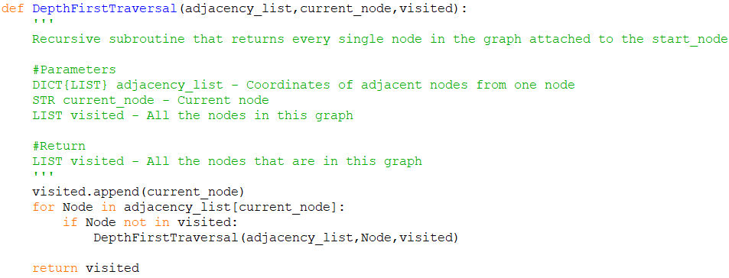

Now to convert my game data for adjacency_list into a format that can be passed into this method:

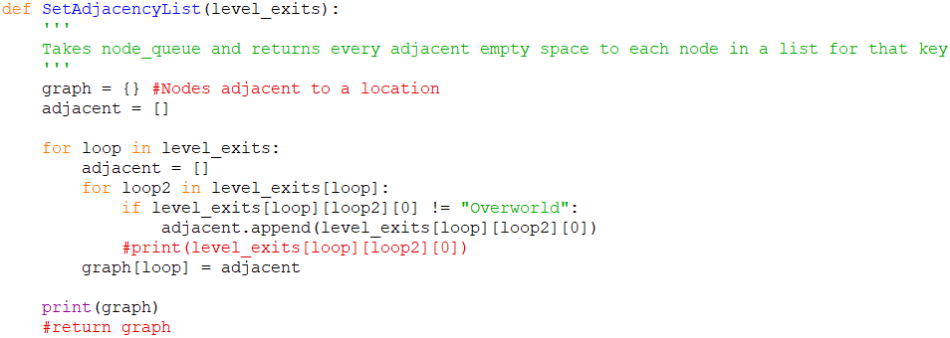

And so my levels are converted from this to this:

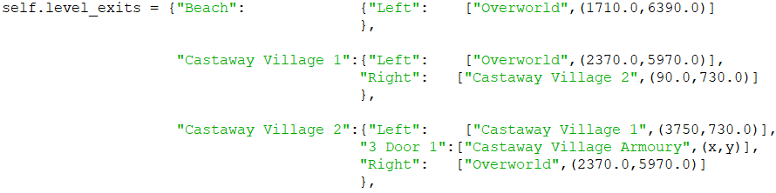

To:



### Events/cutscenes

I did not include events in my decomposition of the main game loop as it is separate to that. This kind of event will have the player’s character suspended from their control and include things such as:

* Text when a player interacts with a sign post
* A cutscene happening if a character interacts with a certain interactable
  + Cutscene being an animation used for story telling where all movements and text are pre-coded
* A cutscene happening when a player passes a certain point
* Inventory and menu (Already done)

Queue for text – If text fits and popping text that is done

Dynamic generation of objects – Text, enemies, interactables, cutscenes

List operation/handling (Search objects to determine if a cutscene should be valid)

OOP for overworldenemy

Then dijkstra’s in that class along with merge sort along with that being recurssive (Credit book but also that I have adapted it a lot as it is not just a plain array) – Dijkstra is optimasition algorithm

Recurpath using recursion

Inheritance/polymorphism under “ProjectileObject” so enemy spit, player arrows or bombs all act differently but are grouped under a separate entity in program

* Overwrite collision as bombs are weird and need a certain animation tick to have collision
* Dynamic generation of objects

Projectiles

* Dynamic generation of objects
* This one is also generated from another object that is dynamically generated

Enemydrops

* Dynamic generation of objects
* This one is also based on another object

<https://gamedev.stackexchange.com/questions/126353/how-to-rotate-an-image-in-pygame-without-losing-quality-or-increasing-size-or-mo> When rotating images in pygame

Maybe files organised for direct access

## Technical skills Group index:

From: AS and A-level Computer Science Specification Specifications for first teaching in 2015

Group A:

* Inheritance:
  + Page 12: Different kinds of buttons inheriting methods and attributes from mother class.
  + Page 20: Database file and tables in database file.
  + Page 82: Along with polymorphism, enemies will inherit different methods dependant on that enemy behaviour.
* Aggregate SQL function:
  + Page 30: Used COUNT to find how many records are in a file and then use that number to calculate a limit.
* Stack:
  + Page 41: Stack used for typing in the user’s name.
  + Page 70: Stack to represent location is handled.
* Dynamic generation of objects based on complex user-defined use of OOP model:
  + Page 47: Objects are continually created dependant on a text file and then each object is iterated through and interpreted by the program (To draw onto a screen in this case).
  + Page 57: Objects are continually generated dependant on how many items are in a text file, not limited in terms of size unlike the above example.
* List operations:
  + General use of:
  + .pop()
  + .split?
  + Len()
* Several linked database files:
  + #Defaults, even if used as a foreign key but not officially is fine
* Graph traversal:
  + Page 82: Use of depth first graph traversal algorithm to get string of levels that are connected together.
* Recursion
  + Page 82: Recursive algorithm for a depth-first graph traversal.
  + When loading enemy thing
* Merge sort
  + e
* Dijkstra’s algorithm
  + e

Group B:

* Writing and reading from (text) files:
  + E
* Basic use of OOP:
  + Page 3: The pygame screen is made into an object.
* Multi-dimensional arrays:
  + E
* Dictionaries:
  + L
  + L
  + L
  + Page 75: Dictionary for exp for a certain level.

## Research sources:

Resolution Fix: <https://stackoverflow.com/questions/39274460/pygame-fullscreen-display-flag-creates-a-game-screen-that-is-too-large-for-the-s>

SQL query fix: <https://stackoverflow.com/questions/13880786/python-sqlite3-string-variable-in-execute>

Pygame.event.wait() to get a single keyboard input: <http://www.poketcode.com/en/pygame/keyboard/index.html>

Powerpoint and code help with iterative object creation (For my walls):

**In Resources folder > PyGame_Student.pptx and also PyGame Student Thing.py**

Scratch collision script:s

<https://scratch.mit.edu/projects/21142128/> **Press see inside > Scroll a bit down and right**